Transcript courtesy of Lynn Schmaltz, with hyperlinks, edits, timestamps and pictures by Cornelius van Dorp from New Zealand.

Video link: https://www.youtube.com/watch?v=JU_kGOCIuok

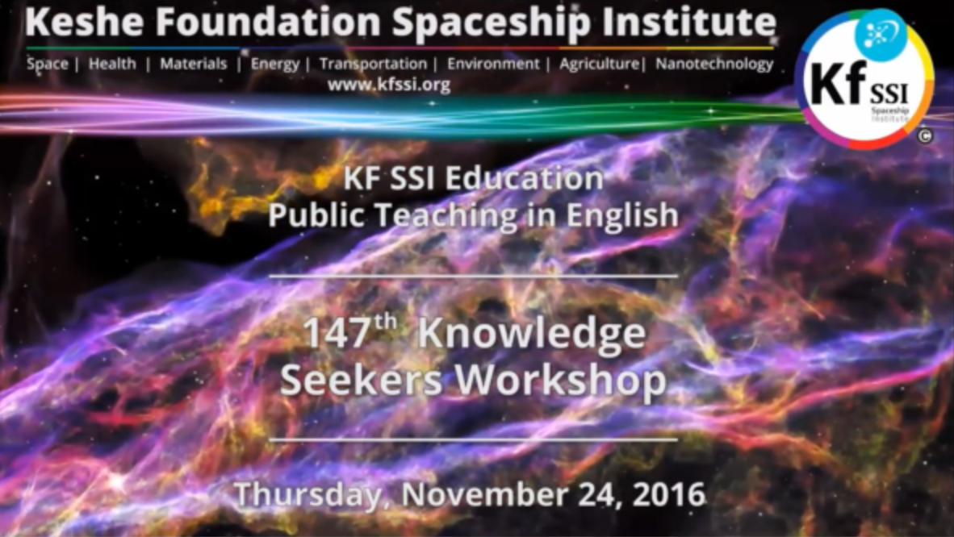

Comments from Cornelius Van Dorp
This workshop begins with the promotional video for medical health teaching with transcription below. Then there is an invitation to the private agricultural teachings as well as an introduction to a public Agricultural workshop series starting Australia this Sunday the 24th at 7pm NSW time, with Lisa and Jimmy MacDonald, and continuing on the 2nd and 4th Sundays of every month. The Knowledge seeker workshop then begins with a presentation by Lisa and Jimmy, with a recap of what they have achieved in preservation of their lettuce crop in the refrigerator for months and months, and then MK goes into the theory of how this works with different types of GANSes.
Then at about the 1-hour mark MK extrapolates from the agriculture into how the GANS works on cancer, before moving into some more deepening on what he has been teaching in the last 3 workshops on how to use Hydrogen and Deuterium to achieve what everybody has been waiting for with lift and positioning. At about the 2-hour mark, Renan joins from the Philippines and shows in a small video how he has managed to achieve lift of a plastic bag by spinning a ball on a string around his head, which prompts MK to then deliver a few more clues about deuterium and tritium, deepened by some questions from John. Similarly, another video from Patrick demonstrates how a number of GANS filled spheres in a bucket hold their positioning after a while. The workshop comes to a close with some observations from MK about the 7.8 Earthquake in New Zealand and what it means in terms of the shift of continents that has begun; the shift in NZ will allow more movements in South America and an acceleration of the process. Hyperlinks to subjects of interest as follows:

Index of 147th Knowledge Seeker’s Workshop Transcript

Beginning of Workshop

001357 Lisa MacDonald (L): Hi Mr. Keshe, it’s Lisa here.

3426 K: When you produce and use GANSes most probably if you leave the entity open because of the condition of the plasmatic, not the material, the entity will incorporate it from the environment and that is why it doesn’t rot.

5442 K: Look what you do in agriculture and how you can expand the knowledge. There is a big difference when you soak a potato in the GANS water and put it in the ground.

010234 K: The information that is coming on the medical side from universities and us is mind-boggling.

012042 K: I have done what I came here to do and it is for you to understand where you want to be in the understanding of it. Everybody is waiting for a flight system and nobody is asking the question where the flight system is and why don’t I fly?

012952 K: in the teaching of the past 2 weeks I have taught you this very carefully; the rope is hydrogen. You looked at hydrogen as a fuel.

013914 K: do not change the central mass of the core; make different balls but make it, shake it and extract what you need and put it in the center core.

014916 M: Hello I am Massa Grashid (?) from Bangladesh and I have a question regarding the relationship of a dynamic system and a static system.

015925 Renan: Hello this is Renan, I am here Sir.

020540 K: I was talking about deuterium; you have to understand why deuterium. You need stability and balance and always the three to be in conjunction with each other otherwise you create abnormality.

021910 John: do we have to get hold of deuterium in the traditional way where they make heavy water or…?

022538 R: Mr. Keshe we have a video from Patrick showing his spheres.

024050 K: We were talking about the tritium. You can create a tritium that is both alkaline and acidic.

024900 K: I’ll give you a piece of thought—a very deep understanding of the technology.

025309 K: would you like to share a video? R: yes, it is Synergie Evolution, Dominic from France.

030003 Rick: question in the Chat: Earthquakes (EQs)—in New Zealand we are seeing a huge increase in frequency and size of EQs in the last 3 to 4 weeks and particularly the deep ones that cause the shallow quakes that cause a lot of damage.

Start of 147th Knowledge Seekers Workshop Transcript

000328: Video promoting Medical/Health Teaching Workshops:

Keshe Foundation (KF) extending an invitation to medical doctors of any practice and specialty to apply to the foundation’s private weekly medical teaching workshop. This includes medical doctors, dentists and veterinarians. Scientists of the KF developed different types of plasma therapies and cures that utilize advanced non-invasive plasma technology. The weekly private medical teaching workshop educates doctors to the plasma science behind the therapies along with the functionality and operation of the revolutionary plasma medical devices. The goal of the private teachings is to apply plasma health knowledge to the profound knowledge of medical doctors. The weekly class is broadcast live over the internet through a secure private channel every Wednesday from 2 to 5pm central European time. Presently the class is only offered in English; however, you are free to bring a translator to the class. If you cannot participate in the live broadcast, you can watch them later at your convenience through a private internet portal. Every patient’s case that is discussed in the workshop will be kept anonymous and private. This includes catalogued findings and analysis gained through the patient’s health issues. Any medical doctor throughout the world who wishes to participate may do so by sending an email to doctors@spaceshipinstitute.org. In your email please state your willingness to participate in the medical teaching workshop. If you are planning on bringing a translator to the workshop, please state this as well. After we receive your email, we will contact you with instructions on how to participate in the workshop. As part of the application process, applicants who apply including any translators brought into the workshop will be required to sign the KF World Peace Treaty which can be found at the following web address: http://keshefoundation.org/worldpeacetreaty/WorldPeaceTreaty.pdf . All applicants will be required to provide proof of their education and ability to practice medicine and will also be required to pass an extensive security background check before they are granted access to the teaching workshop. Healthful plasma technology is here now, the use of which is increasing exponentially on every continent. We encourage you to come and learn about this revolutionary technology. Apply today.

********

KF is extending an invitation to experienced farmers, agricultural specialists and researchers to apply to the foundation’s weekly agriculture teaching workshops. If you fall into one of these categories and are interested in plasma technology integration into agriculture, you are invited to apply. Scientists and agricultural practitioners of the KF continually develop and apply new methods of food and fiber production, soil fertility management, plant and livestock health management, and increased farm productivity using the most advanced plasma technology that is part of the Keshe Foundation Spaceship Institute. In the teaching workshop, you will learn the science of plasma technology and its application in the field of agriculture for enhanced and equitable global food production while minimizing costs and external inputs. Practicing farmers and KF scientists will demonstrate their application of plasma technology in agriculture and the ensuing results of such applications thus deepening and enriching learning for all participants in the private teachings. Participants are encouraged to demonstrate their farming practices in the teaching workshops. The private teachings are broadcast in English live over the internet through a secure, private channel every Wednesday at 10AM to 1PM central European time. If necessary, you may bring a translator to the workshop. All applicants are required to provide proof of their educational and professional qualifications and must pass a security background check and are required to sign the KF World Peace Treaty which can be found at the following web address: http://keshefoundation.org/worldpeacetreaty/WorldPeaceTreaty.pdf . Translators that attend must also pass the security check and sign the World Peace Treaty. For details on how to join the private teachings in agriculture send an email to agriculture@kfssi.org stating that you would like to participate. Include in the email your education and agricultural experience and reasons for your interest in plasma technology. Applicants will be contacted with further instructions and details on the application process.

********

Are you ready for a cost-effective, successfully proven innovation in pain relief? You need no wait no longer: introducing the Keshe pain pad using plasma technology which is based on magnetic gravitational field interaction the Keshe pain pad and its plasma penetrate up to 3 centimeters below the skin helping to bring the body back to balance. The Keshe Pain Pad offers a natural way to relieve acute and chronic pain for both young and old. All you have to do is apply the pad on the affected area for one to two hours once or twice a day. It is made with elastic that can conform comfortably to the contours of your body. It has no moving parts or batteries and it is light weight and durable, easy to wear and easy to remove. The Keshe Pain Pad successfully reduces muscular pain, tendonitis, wrist pain, carpal tunnel syndrome, back pain, pain from sprains and strains and knee pain just to name a few. For a full list of relievable pain consult the owners’ manual or go to the website www.keshefoundation.org. The Keshe Pain Pad is a cost-effective natural way to relieve your pain.

*********

Public Teaching for Gardeners and Growers in English

Starts Sunday 27th November 7pm Sydney, Australia, time every 2nd and 4th Sunday of the month.

Teaching will include:

Basic understanding of plants/vertical people and how they work as plasma. Basic application of plasma technology for gardening, growing and environmental rehabilitation, understanding plasma and creating abundance with field interactions allows us to see the world around us as it truly is. Join our plasma discovery journey. Join us on ZOOM https://zoom.us/j/921749720

See end of the document for more details.

001036 Rick (R): welcome to the 147th Knowledge Seekers Workshop of the KfSSI. Mr. Keshe (K) of KF will be delivering today’s information and knowledge on the plasma teaching. We will have various other knowledge seekers from around the world participating as well as things develop and as you can see we have a couple of new videos as well as new public teaching for gardeners and growers. I think Mr. Keshe is ready in the background.

001225 K: good morning to you as usual, wherever and whenever you listen to these teachings that are part of the development of the technology. We try to explain more and try to go more in depth. Today we will try to explain some more technology and knowledge behind and in depth of what the science stands for. We are targeting in one direction and that is to try to achieve lift and motion. What we have done is we have accelerated the work with the innovation team and the same information that is due is to be given to others that they may develop the technology. The reality of the space technology is understanding it and applying the technology in different forms. We try to do some teaching, and then we will come back with announcements. This public teaching for gardeners and growers given in English is set up by people who are part of the agricultural team. We have seen their work before with the growing of lettuce and other things. Is Jim online that he would like to explain what this is about and how he will teach it?

001357 Lisa MacDonald (L): Hi Mr. Keshe, it’s Lisa here.

K: good morning your Excellency. How are you?

L: I’m very well thank you. We are going to start on Sunday and hopefully we can help all the people that at this stage are not involved in the private agricultural teachings. We hope to allow the general public to gain some knowledge on how to use the plasma on what they are growing and to help their environments around them.

001430 K: what is the program and how are you planning to do it?

L: each session is going to involve 3 basic steps: we are going to do a bit of basic teaching and then we will go on to some of our experiments and what we have found. The third part will be feedback and input from other people around the world and what they are doing and to help them to work with what is shown. Each week we will do that and you have the basic syllabus that people decided on. Each week there is a basic teaching on vertical people (plants), how the plasma interacts with the environment, and how the vertical people use the plasma and the general environmental plasmas, and how we can use them to benefit the whole environment. If you would like a bit of an outline, I will hand you over to Jimmy. He is handwriting something and I can’t read it.

001550 K: while you are handing him over let me explain what the vertical people are. In plasma technology, we consider plants as living, existing beings, which work through the material that exists on this planet. Instead of walking like the horizontal people that are animals, they are vertical; that is why we call them vertical people. They are actually living entities and they have emotions and feelings. They feel the same as we do in the plasma of the plant. And so, if you heard about the vertical people, it doesn’t mean people who are standing up. It means vegetation and that is what we consider them.

001638 Jim Macdonald (J): Hello Mr. Keshe. What we will be doing over the course of the next couple of months is a very basic overview on how this plasma technology applies to agriculture and how people can start using it in their gardens for their roses or veggie patches. It is to encourage people to play with this in their gardens and in nature and to get back in touch with nature. Then we will do a bit on the seeds and how the magnetical rays coming to earth interact and how these interact with the plants. We will focus on the amino acids for the plants and how that works. We will go into soil biology and photosynthesis; these are all the topics that we will be covering over the next couple of months.

01745 K: can I ask that you introduce yourself and what you do in agriculture?

J: We started probably more than a year ago following your teachings. And for a couple of years we have run a lettuce and micro radish aquaponics farm and we have been using your technology and doing various experiments with it and trying to understand how the plants work with this new technology. That has been our background for the last couple of years.

001833 K: before that how long have you been in agriculture?

J: about 5 years.

001846 K: so, you start teaching how you see that the technology can be used.

J: yes and it’s a way for people to start using the technology in their gardens and in their environments. Even if they live in a city they can have their balcony and the pot plants. It’s a way to introduce people to using the technology and understanding the plants and how the plants really work and how it’s interacting with the plants.

001938 K: thank you very much. You start at 7Pm Sunday Sydney, Australia, time, every second and fourth Sunday.

J: yes.

K: thank you very much indeed… the zoom number is there and this is under the KF public teachings on Zoom. Thanks for teaching us and I enjoy listening to your teachings on the private agriculture teachings. We are already in the process of implementing part of the findings from the teachings of the research teams where we looked at the life span of the vegetation and the GANS environment. Very soon we should be able to deliver refrigeration units that can be put in the refrigerator extending the life of the food for a few more days than usual. These things will be explained in the teaching by Jim. He has a huge amount of knowledge. There are a large number of people who do agriculture and you can join in this. This is open to the public. Thank you. Are there any other questions?

002145 J: I have some updated photographs on the micro radish; do you want me to show that?

002214 K: yes. Can you give us the background to this for those who are not aware of this?

002225 J: for the basis of the experiment I took two batches of daikon radish seeds and soaked one batch in plain water and the other batch in CO2 GANS water.

K: is that after cutting or before cutting?

002248 J: this is before cutting; I was soaking the seeds. And the whole idea was to see if there was a comparison between the seeds soaked in water and the seeds soaked in plasma (GANS) water. These were grown side by side and cut on the same day. Generally, when we cut them they last for about 12 days. That is the shelf life we give for that product. The last showing, we gave was on day 41 and we showed pictures of how the radish was still looking very good after 41 days in the fridge and I have more updated photographs on how much further they have lasted in the refrigerator. The photographs are of seeds soaked in water and seeds soaked in plasma. Day 47 is showing how long the micro radish seed sprouts have held up in the refrigerator.

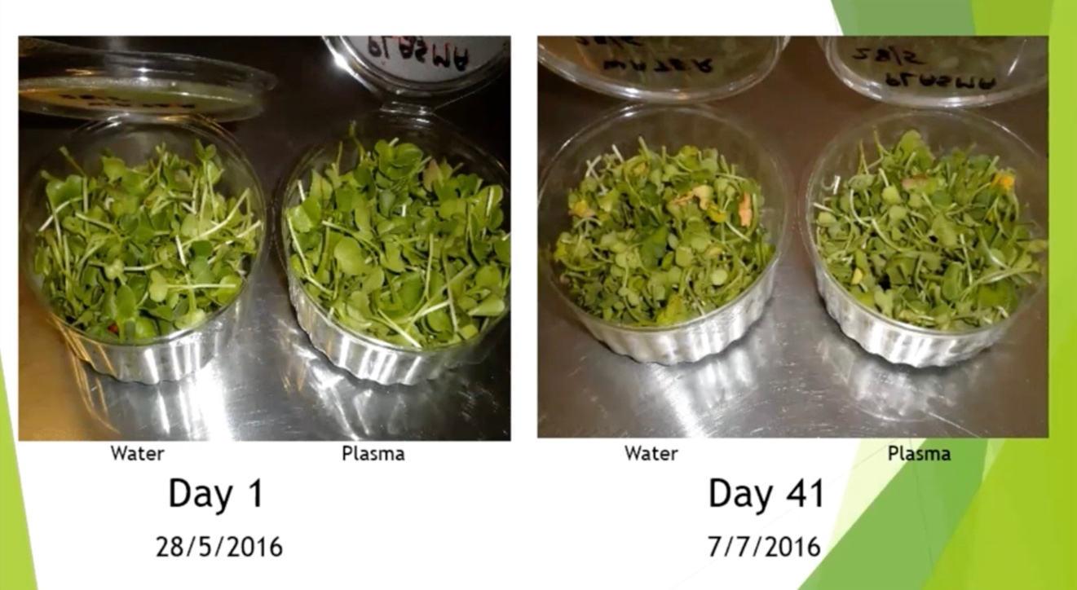

002400 K: Are they still edible at that stage?

J: They are fine in a sandwich at this stage; they didn’t smell and when you felt them they were still fine. You could possibly have eaten them at this stage.

002427 J: At day 78 leaves are yellowing of the leaves but overall only 3 grams of weight is lost at this stage from our first day

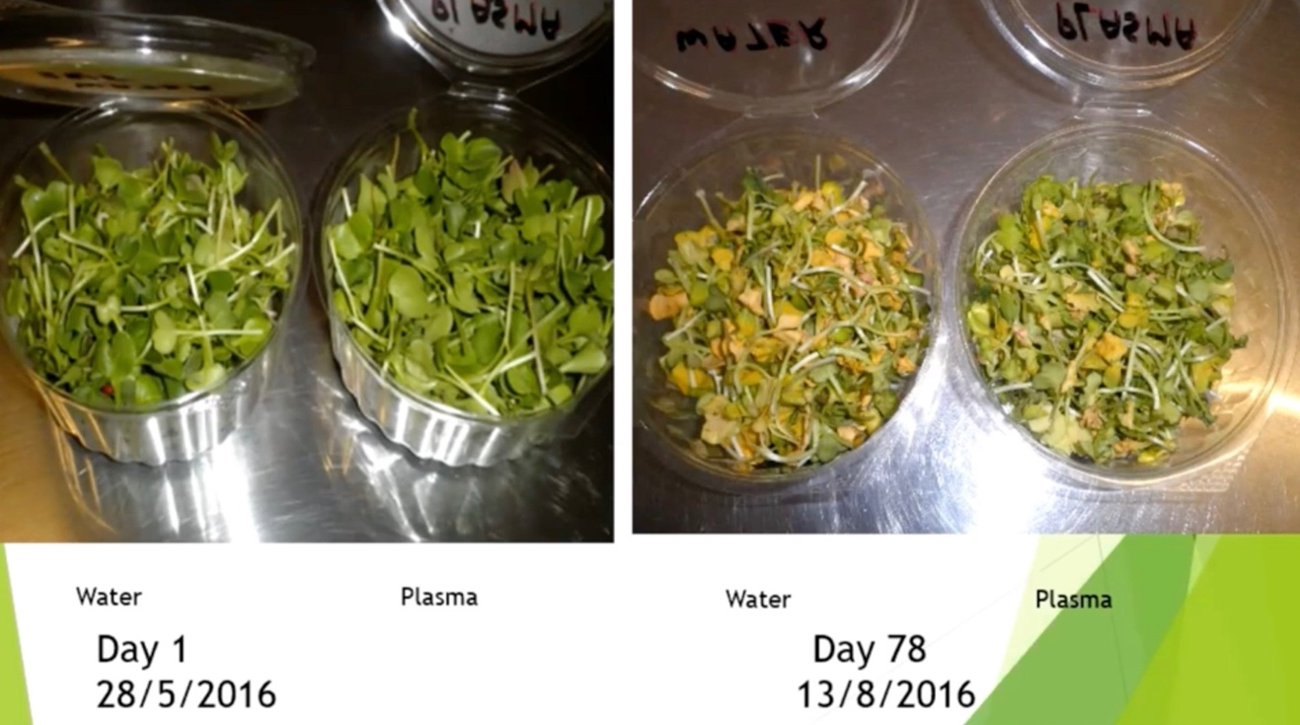

2449 J: At day 134 they had gone yellow with touches of green;

But leaves retained their shape and hadn’t squashed down as you see

in the side photo.

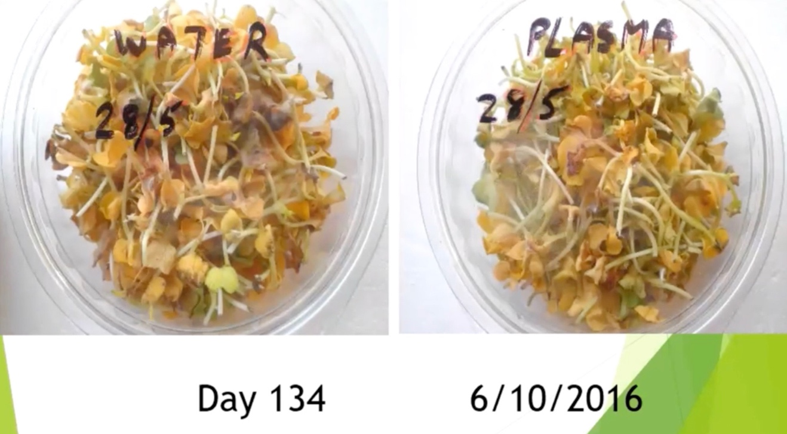

J: They looked good can see from looking at the sides of the containers and only the color had changed and they had not gone to a puddle of water at the bottom. At this stage, they were still looking very good. Only the color had changed.

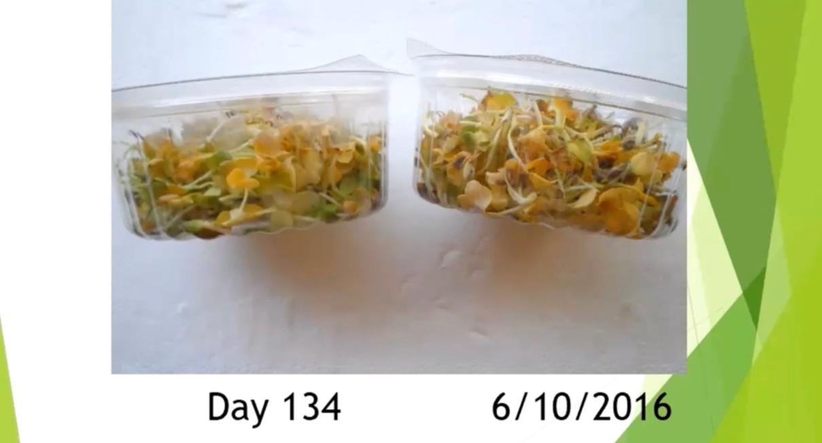

2526 J: I took some photos the other day at 180 days that they had been in the refrigerator. At this stage, they had started to degrade and you can see the yellow. There are still bits of green on some leaves.

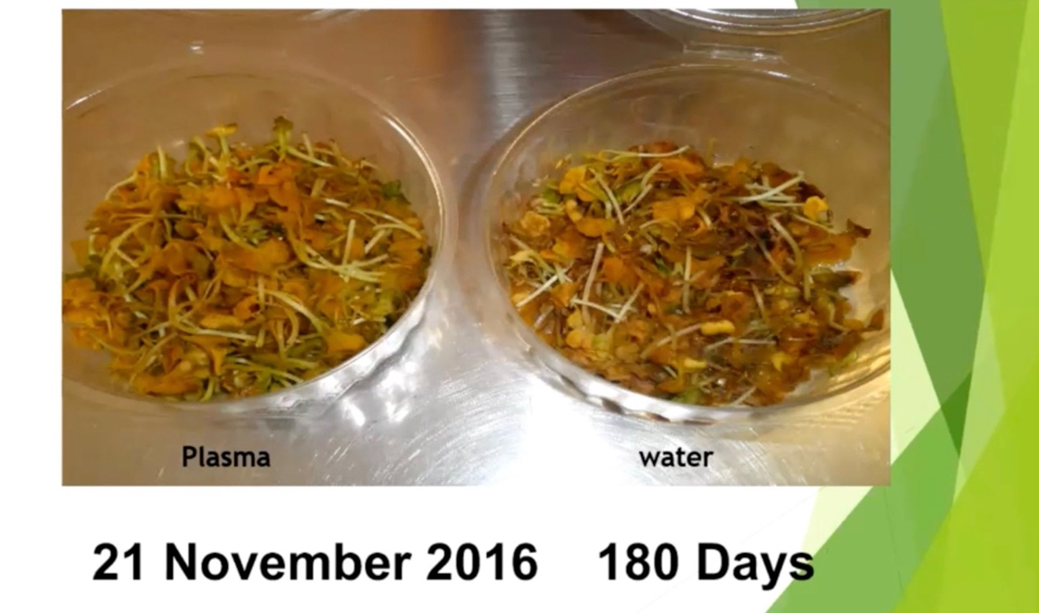

The next two photos from the slide show where they are starting to sink to the bottom of the punnet. 2555 (not shown in transcription) When we opened the containers there was only a vegetation smell and no rotting smell and no funny smells coming off it. This is after 6 months in the refrigerator. It is quite incredible.

2618 K: one of the things we have to explain between the two is that the one which is in the water and even though it is in the water from the time it was cut it was next to the one that had the CO2 on it. So, in a real condition the one in the water (not plasma water) should be totally gone. It would most probably have been totally wasted after 20 or 30 days. But because we are not dealing with the matter state condition that was inside the container the vegetation which went through the CO2 created a plasmatic field, so because the two containers have been next to each other for about six months the field from the one that has the CO2 has affected the other one which was water only. The one in the water should be totally wasted in 20 to 30 days. We are not dealing with matter state but plasma fields. So, the one on the left was treated with CO2. The one on the right was next to the CO2 and benefited from the CO2 plasma fields that were created because the two containers have been next to each other for about 6 months. The field from the one with CO2 has affected the fields from the one that was water only.

2710 K: next time in the next experiment keep them in two different sections but cut them at the same time. Separate the one with CO2 from the one that is in the water (without the CO2). This is very important and it’s one of the most important things that we realize more and more. Just because you think you put CO2 on something you think it is only the entity that is touched by the CO2. No! The CO2 expands the fields beyond the container. Another point that was mentioned by Jim was that after 180 days you do not smell any odor. This is because of the structure of the plasmatic condition of CO2 if falls into odor absorption because of the O2. The oxygen is gravitational and carbon is plasmatic strength. If you remember in the present day if you have a smelly fridge, you put a piece of charcoal in it and it absorbs the smell. You do this now in the plasmatic condition. The vegetation does not give off odor because the CO2 structure in it. You can make everything odorless when you apply CO2. It is understanding the process by which you created the plasma. That is why Jimmy is saying there was the odor of the vegetation but not of rot. In a way, the carbon is absorbing all the smells in the plasmatic structure as a part when it comes near the matter strength. This needs to be understood. In the coming weeks, we will be marketing sprays to absorb all the odors. You can stop using chemicals; you just spray and the odor just disappears. It holds up to six hours and can be used as deodorant. It has been used, we have seen it and it works. The reason there is no smell is that you have the carbon element in the plasma GANS, which in a way deters or absorbs the fields of the odor. The odor is a diamond structure of a gas. When a gas becomes a diamond structure it becomes odor. So, because we are in a plasmatic condition with the CO2 the link to the crystal structure as a gas is very easily linked to the plasma of the CO2 as the carbon end and the presence of the oxygen which is part of the amino acid of the vegetation is linked. Most likely this will rot and you will not smell anything.

3023 K: We are using this technology in a commercial way extensively in the coming weeks. We will release scientific papers with the data on this as usual. You can wash the food like meat in the plasma GANS CO2. When we take the water from it and test it in the lab we find that most of the germs are not there anymore. You can use it in conjunction with the CuO for disinfecting and holding meat. Don’t forget that I explained this in previous public and private teachings. When you create a GANS you hold a state of matter and that state of matter because of the creation of GANS and because you created the GANS in atmospheric condition in respect to the amino acid can hold on to the protein.

3145 K: I explained before that I did a test in Tehran 8 years ago. We took a spinal cord of a lamb and processed it though simple caustic and in a simple way left it open in the heat of the summer on top of the refrigerator. The full spinal cord did not deteriorate or rot for weeks. It stayed intact and did not become mushy. We have seen this with biological materials also. In a way biology means ‘living entity’. It comes from Latin. We see that the life is there and it doesn’t change. We see the GANS as a preservative and a condition of absorbing odor in the protein condition. We are running tests and this is important if you have a disaster and you don’t have electricity. You don’t destroy the bacteria but you reduce them drastically. The culture plates show this clearly. There is a need when you come to the degeneration of the amino acids of vegetation and meat. You need to consider production of nitrogen and this will allow a lot of flexibility in those of you who do run these tests. You will find if you leave the container open you will have totally different effects than a closed container. Having the container opened or closed will give you different results.

3426 K: When you produce and use GANSes most probably if you leave the entity open because of the condition of the plasmatic, not the material, the entity will incorporate it from the environment and that is why it doesn’t rot. That is why it isn’t destroyed. Covering creates limitations. We have seen this with the amputation and regrowth of the toe. These are little things that apply both to the vertical people (plant world) and horizontal people (people and animals). This will be easier and you don’t just add CO2 to the vegetation or to the seed before but you add the emotional aspects of the plants to the water too. Then they are happier and they produce more. This is part of the agricultural and animal tests. In so many ways if you look at the tests passively they just show parameters of how they existed. But, it is time to go deeper into the science of understanding why and what is behind it and the reason the plants lasted so long without odor and that we can extend or reduce the life by changing the environment.

3614 K: We see wherever we use GANS materials, or the liquid plasma of the GANS materials, the life extension and growth is different in a covered environment than in an open environment. We see restriction in growth now with greenhouses. There is a real straight and clear indication now that whenever you use CO2 or other GANSes as the feeding line or change of environment there is a hindrance when you have greenhouses. Do we need to pay millions of dollars to build greenhouses and the lighting where in a way when you create the atmospheric conditions around the plants and the GANS you don’t need to turn the lights on at night or during the day. The plants take what they need from the environment 24 hours a day and they never sleep. If you have been to places like Holland, which is heavily involved in greenhouse development, and you drive across Holland at night you see different lights come on in the greenhouses because they are literally tuning the growth of the plants. They start burning gas at the greenhouse to put CO2 in them so the plants can grow better at night with the absorption of oxygen. This introduction of GANS gets away from the huge investment in greenhouses, which we see now has become obsolete. Those of you who are in agriculture in Holland, northern Europe or anywhere in the world will find out that having a greenhouse you limit the amount of food or plants that you are trying to grow. Now with creating the CO2 you extend the tent of the food for the plants beyond the boundaries of the greenhouse. BUT now the glass stops that and creates a limitation. Not all of it but a limitation of what it is going through. We see a change in the direction of agriculture and in preservation of food as well as the amount of food we need to grow.

3908 K: we are looking at research in Tokyo University now in the food elements which create toxicity or a condition for cancer. In a way, we are looking at immunization through the same process and the reality of… can we grow vegetation that creates a condition that there is no possibility of creating cancer in the body of the man? You take the energy you need. We are looking at and testing the huge problem of living in the 3rd world nations with food like egg salmonella. How do you protect yourself from it? Caroline has found a very easy solution; just spray CO2 and CuO liquid plasma on the egg when you cook it or when you bake it. You kill the salmonella. These test results have been done by certified laboratories and now we are applying the information. We see how other people have started doing this. This way you stop the diseases and salmonella. Spray a few drops of CO2 on the food. This stops all the salmonella and there is no contamination. And you make sure there is no fungus; as you notice on the photos, Jim showed we don’t see the fungus that we know grows immediately on vegetation after a few days. We don’t see any fungus and that means that the environment is totally sterilized.

4130 K: Now we work with scientists and specialists and we start looking into these things and now expanding the knowledge. This is where the change comes that will make the difference. Now you can buy meat when you don’t have a refrigerator and it’s warm; you can soak in CO2, CuO and ZnO and you extend the life by a few more days. It is not just that you disinfect but you create the environment around the meat and preserve it longer. Now you have created the same greenhouse effect around it and it is shielded and protected. This is the way it is when you fly. Earth has its own magnetic gravitational field and its own plasmatic condition. Now you protect materials.

4238 K: we have started using CO2 as disinfectant. It can be used as a system for treating burns. When there is a burn spray a few drops of CO2 immediately. In a few seconds, you don’t feel the pain. We are running trials in the hospitals in the coming days. The technology is beyond a doubt perfect and it works within the structure. We don’t kill germs; we don’t create environments for them to exist. It is the condition of our work; we are peaceful scientists worldwide, all of us, but we have to understand the science. Why does it do this? Because we know that because of the condition of the carbon and the copper that carbon links out to the odor gas. Copper links out to the line of what we call the neuro system of red meat or protein that has become what we call meat. Then there is no linkage for the meat to link up with something else that we call microbes. It has already been protected; it’s already linked up.

4358 K: Plasma technology for man’s use is perfection absolute. We challenge all the governments, health authorities, and environmentalists to come in and test. We don’t fight them; we invite them in. We have situations in different places and we try to understand how. We see now and we will report in the coming days, maybe 2 to 3 weeks, where in the hospitals we use it as air spray. You don’t have antibiotics in 3rd world nations. We spray CO2 with CuO2 on it and we stop the infection because you are creating the environment where you don’t kill. CO2 and CuO are in the GANS state and we create the linkage so that there is no room for protein as microbes or viruses to ever link up. We create a shielding effect as a defense technology. We are defending what is there. Does it extend the life? Yes, because now you create the condition that whatever is on the bed or the table is not dead. It is not without life and it still has structure and holds to itself. It is still absorbing energy to hold onto. That is why holding on to what it is and getting energy from the environment, it extends life without holding on to microbes or germs. This way we provide energy with the GANS material. So scientifically we can explain it; it is no magic.

4608 K: Understand that you are dealing with the plasma. There are 2 cups next to each other; one has water in it and one has CO2 in it. They decay the same as each other. But he is a farmer and he knows after 15 days the micro greens should turn to mush. But the one near it is the same. So, the experiment shows the effect on the material and on the environment next to it. We have to understand the knowledge and be able to deliver it in the way of understanding. We mass produce it for people who don’t understand it.

4707 K: We have a situation in KF Ghana; we have a factory and we asked scientists to join us in the production. Now we have received double the number of people we wanted. We said no problem. Those scientists can go out and teach the whole country. You can work one week in the factory and the other team goes outside and teaches. So, we work and now we have the top nuclear physicists with masters and PhDs of a nation producing and learning and then going out and teaching. This is what you have to do. They work one week in the factory and then one week they teach in the schools. Then they go out to the villages and show them. They still run a factory but our target is to teach and this is what the KF has to become. We have grown up; those who want to do damage we just ignore them. By the time they plan what they are going to destroy something we have built; we have built another palace for humanity. Learn why this is; what did the farmer do in the past? Why is there something wrong with what we do now with the new knowledge? We blocked them from abuse and selling and making things that don’t work. What did our ancestors do? We salted the meat and smoked the meat; that’s what we had. We dried the meat for us to have something later.

4903 K: Now we go to the next level of knowledge, now we found a new preservative, natural; we call it GANS. Now it works with the totality of the environment. Does the meat even when it is in pieces, and it is washed and covered around the GANS, find the balance that it couldn’t find in totality when it was part of the animal? This is where the research has to go, this is where we have to understand more and more, and this is where we have to expand the knowledge. Ignore all the negativity because those who are negative, they never made a single GANS in their life. This is the way they have to confirm their existence, they are parasites of the life, doesn’t matter where you put them.

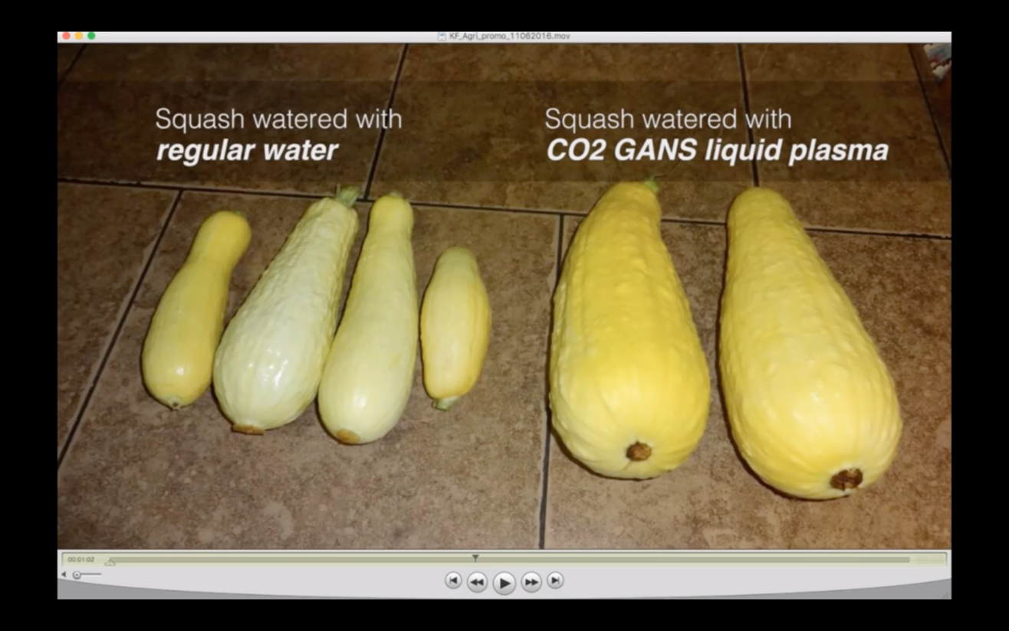

5003 K: look and work positively and understand the technology and what it can do, and don’t be afraid of what will happen if I do this or that. What happens is you bring new knowledge so come back and share it with us. A lot of people who came and shared knowledge received threats from people paid by certain people in certain countries. But we are past that point. You will see them dying of their own cancer and they will all beg for life from the plasma technology unless they have to stand their ground and be stupid.

5042 K: go in and learn. I was teaching yesterday and telling the scientists a very simple thing: none of you is wrong. It is the school of thought you bring that enlightens man and adds to his knowledge. When we go down the street we see one street lamp doesn’t light up the whole street. There are a number of lamps one after another that light the passage. We are all little lights in the street and we light up what we understand in that path. In plasma technology, nobody is wrong; you understood, so show it and explain it. This is what it has to be.

5143 K: Look into the sky and see how many billions of stars you see plus the environments that are fields passing through it. Each star is created out of specific conditions, and no two are the same. So is the knowledge of man; each one of us 7 billion. Ten new ways of interaction becomes 70 billion. That is not even the number of stars in one of the smallest galaxies. So, imagine how many more stars are in that galaxy that we haven’t found the way to use the energy and the fields of the universe. So, when we see presentations like this, by the people who do them, look beyond what you see and what has been created. What is the role of the plasma and what is good or bad in it? Bad in it will not fit in the environment but good in that it is what you need.

5303 K: you see he is the farmer and he shows us the micro radish has life. Now as a customer I buy the radish and it lasts in my refrigerator for two weeks instead of 3 days. I don’t have to buy more.

5326 K: But, on the other hand, the knowledge of man to become independent has increased. It will be very interesting to see if we take the GANS plasma of the same cup can we replicate the same vegetation energy feeding anywhere in the universe? This is what the new technology has to be and we have no choice. We are the pioneers in the frontiers that will never be conquered because the knowledge of the Creator is beyond the understanding of the man in totality. Look at the containers and when you grow vegetation in the ground and when you soaked it in CO2. Maybe you didn’t soak it in CO2 but you watered it with CO2. Look what you have done; this is very important and this is what I was explaining to the agriculturalists recently.

5442 K: Look what you do in agriculture and how you can expand the knowledge. There is a big difference when you soak a potato in the GANS water and put it in the ground. Now the fields are expanding in the ground and into the other potatoes. So, this potato creates a field with another and that one with another one because you grow potatoes in a line. So now you created this field. But now if you come and put GANS water on top you have created a shield in a different way.

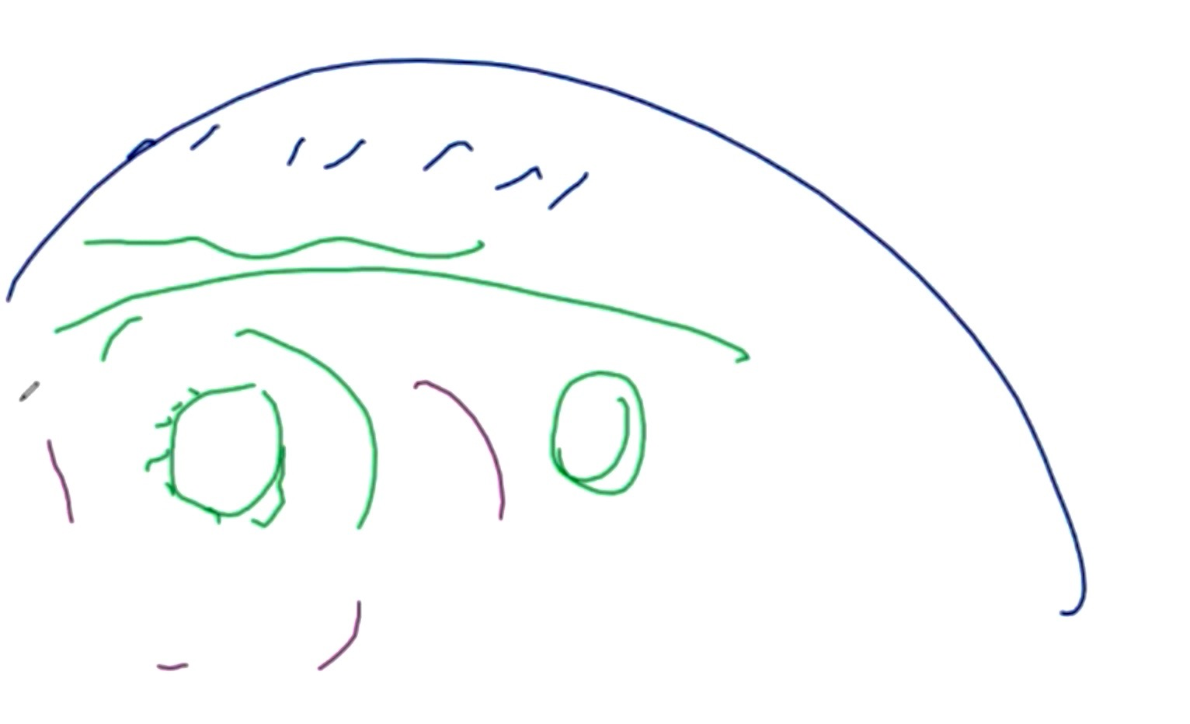

K: now the potato receives different kind of energy than when it was on its own and just soaked in the CO2 water before planting. The potato has the ability to link to the soil above because now there are two layers –the weaker and stronger—or the stronger and the weaker—and you create a flow with the upper environment. Does the potato that was soaked in GANS water behave differently in another field? Do we need to add to the understanding and the knowledge which we all know?

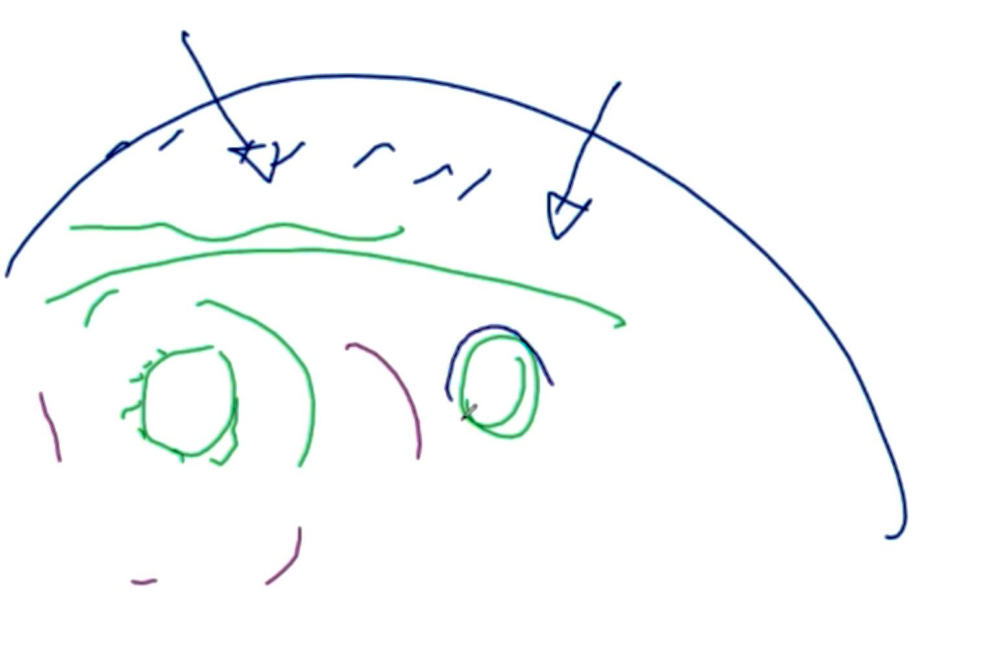

5643 K: What if we use for the ground base the simple CO2 and above the ground level what difference happens if we put some CH3 and CuO2? Now the soil is irrelevant because you have transferred plasmatic energy and this is how we expand the knowledge. What if we use for the ground base a simple GANS of CO2 but above it on the ground level we put CH3 or CuO2? What difference would this make? Now the soil is literally surrounded because you transfer the plasmatic energy. This is how we have to extend the knowledge. As I said the teaching is done. It is the application and implication that changes the condition of it and what we need. If you understood the simple principle of just one, if you look at this environment on its own what happens in the drought condition?

. 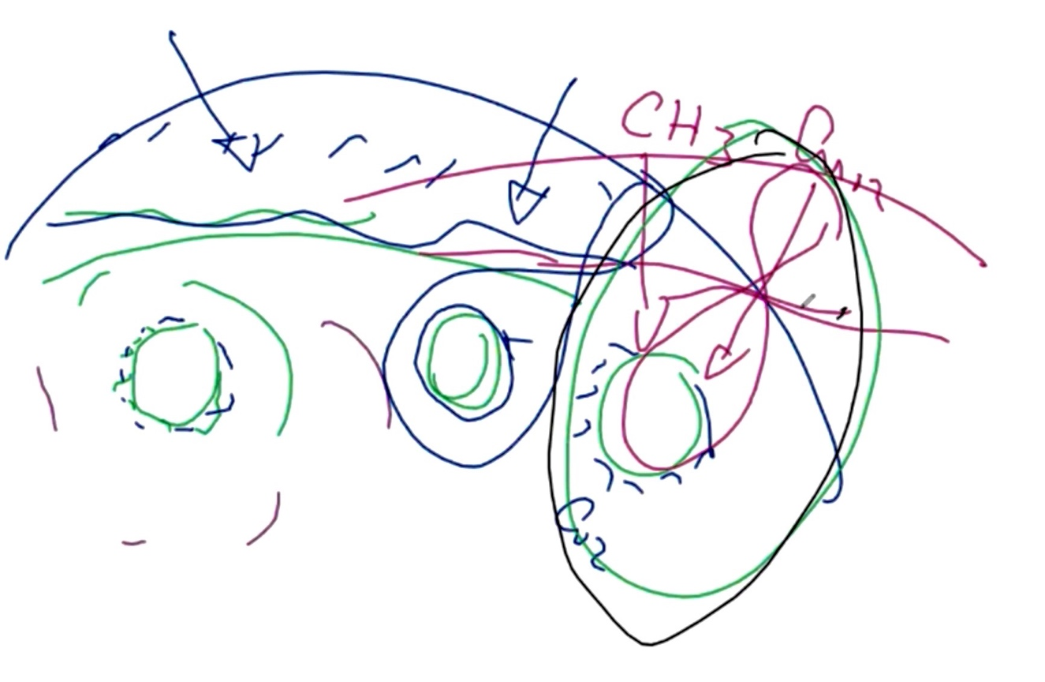

5753 K: It doesn’t matter what the soil carries. The environment and the emotion of the environment will feed the seeds and plants. (draws another figure 8 on the right)

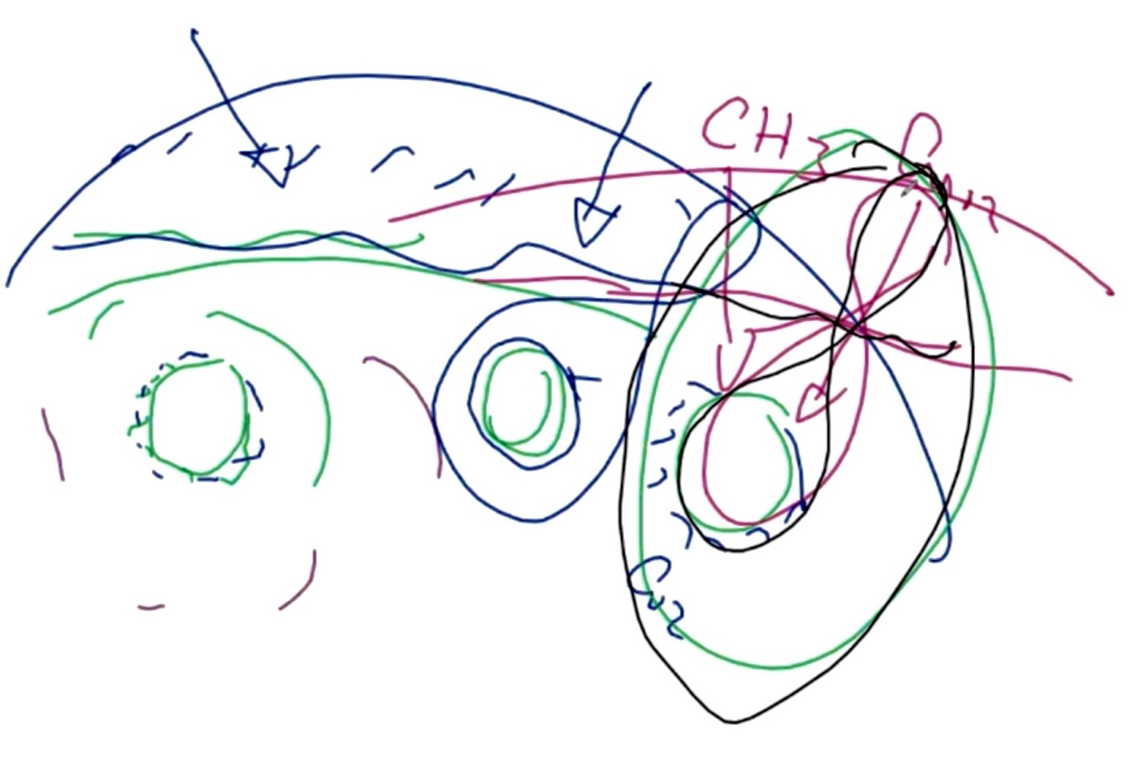

That is why we see when you use the GANS materials the water absorption and need for water reduces up to 50 to 80% because now you have made the link with the environment to the seed. But because we are very physically oriented and we haven’t put anything on it we think there is nothing happening. We have seen the two containers with the micro greens next to each other for 180 days look exactly the same. We see in the pictures you see the water GANS and it’s very simple and all of you know that GANS is plasmatic but the one without the water is actually receiving more than the one in the water as you see in the pictures where it looks much healthier than the one with the GANS. It is taking the energy totally. Extend the knowledge and understand the application and implication. Just don’t do I put some GANS on it and this is what happened.

5913 K: Always the minute you put a GANS, look at the environment you have created plasmatically when you put liquid plasma on something—do you want to give to the environment or take from the environment? Do you want to sterilize it? Now you understand your potato with the liquid plasma water already has created its own greenhouse. By putting different GANS water on the soil you create the flow and dictate the gradient difference between the two and the flow of the fields. If you become expert in it and understand it more, you can put the GANS that cauliflower needs. When there is calcium in the environment the cauliflower is fed directly and you have a different cauliflower, maybe in texture or maybe in the rate of growth. So, go further with the knowledge if you have been with us you understand it. The creation of the sun and the earth and the magnetic gravitational field flow between them does not in the interaction only give the atmosphere of this planet to us, but in the same process part of the elements coming from the sun’s radiation which are in balance to the magnetic gravitational fields of the planet, will be attracted to the planet, land on the planet and be converted to the matter state.

010056 K: so you don’t need to put a calcium GANS to it but in creating the calcium GANS of the plant you extract what is in the environment which is in the strength of the potato or the cauliflower needs. Extend the knowledge a step further. Open your eyes to the horizon of knowledge and then it becomes very easy. Understand the totality of it and not just focus on putting that GANS on the potato. What does that do? How does it absorb? Does it affect another potato? Does it affect two fields down the road? If I feed all my plants with CO2, then that (potato field) is not the boundary any more. You will find your neighbors have a better harvest and say oh I had a good year this year. But they don’t know that you already created the environment for them. Maybe it’s a bad year for them because you created the environment that what they grow does not need that. So, your neighbor has to use the GANS for his plants. We have to extend the knowledge as we don’t know these things; it is part of the evolution--evolution for man and part of our evolution of understanding the knowledge of the technology. So, when you attend the agriculture and other teachings don’t only look at the GANS and what happens; but it goes beyond.

010234 K: The information that is coming on the medical side from universities and us is mind-boggling. We don’t even know how to put it into the public. The implication of it is beyond the present understanding of the world of medicine because ‘it cannot be’. But it is, because it is in plasma. For example, in our cancer research the GANS material is introduced into the cancer cell and we see the concentration of the GANS on the cancer cell. When the cancer part of the cell, the energy that was created, is destroyed or opened up, then all the CO2, CuO2 and ZnO2 move totally to the next cancer cell. They don’t go to another cell such as hemoglobin or another tissue cell. The cancer cell disintegrates and now they all move to the next cell. This is very strange and we have never seen this. This was followed on the observation with the latest systems available in the universities. We see migration from cancer cell to cancer cell and they don’t go to another type of cell. This is a puzzling thing for the scientists. We are following the path (of the cancer cells).

010423 K: Why do they do this? Have we managed to create a condition that we can create immunization for cancer? I had a discussion with the scientists who say yes because this is the pattern of it. Because now if you look only the cancer cell itself was opened up and in that process you have to look beyond it. It is not just the GANS. The GANS has carried that field which can adjust, interact, correct the RNA and DNA and it’s a field interaction. This changes the game. Why don’t they go to every other cell? They know these cells are cancer cells and we haven’t injected only into the cancer cells. This was injected into the bloodstream of the animal and it still goes cell by cell. This is amazing and what we see opens up new (avenues). The doctors and scientists couldn’t understand it. This is what is happening. Why do they go to the next cancer cell? Has it become part of the plasmatic of the DNA that it does not fit and it needs to change? So, it starts moving on.

010604 K: These are all scientific and university research papers and we have released it to scientists and individuals who are interested. So, understand the totality of it. Why do we see people that used the injection for the cancer and do the same as the mice? They even become happier and they are more active. What we see that was opened up that was a cancer is not a cancer and is an energy that is available (for the organism). That cancer cell was made of protein and plasmatic energy in the GANS state. Now that it has changed its characteristics due to the change of the environment, it is now food to the body. Up to now man, as I have said many times, died not from the cancer but from the lack of energy because the cancer took all of it to grow. Now that we are opening the cancer the energy is coming back to the man. The energy that was killing man now becomes food to man instead of killing him.

010725 K: The game of science of biology and of chemistry has changed. It doesn’t mean that it is wrong. It is paramount that the chemistry that we know up to now is matter state chemistry and now we have to understand plasmatic chemistry, not as chemistry but as interaction of the fields which is given in the matter state as chemistry or biology. Nobody is wrong as we have explained in previous teachings. Now we have to learn two states of the plasmatic field existence. One is the fixed, which we call the matter state, and one which is dynamic, which is the plasmatic state of the same.

010815 K: this is where we have to go deeper and understand more. Now that we are considering the research in the health and cancer section it is very interesting. And it is very simple. We know that if you go back to the teachings that we have 3 types of cancer: cancer through the evolution, cancer due to accident of the physicality, and we have cancer through the emotion. When we see cancers now we have to see from the blood tests what the medical doctors understand. You look at the markers in the blood test. You look at what is elevated. Is the zinc elevated on its own? Is the copper elevated on its own? This gives you an indication. If there was an accident you hit something, and later because of that hit concentration of the energy has absorbed energy from the rest has become the beginning of cancer. The ‘evolution’ cancer is mainly from metals or materials like the blood calcium.

K: But the evolution cancer works totally different. It means the change in the environment and you see in the blood test that it has to be connected to the salts. If you see magnesium, salt, sodium, sulphur, phosphor elevation, and the salts are the backbone of the man. These evolutionary cancers using salt are very difficult to change because it has taken the process of life for 2 or 3 or 10 generations. The environment changed for your grandfather so the body started changing. Your mother changed a little bit and now you are coming into the process. You have a father from a different line, a different strain and the parts cannot match. So, you show the cancer because it is absorbing energy and evolutionary cancers are very hard. You have to go down the gene line but you can still change it. The accidental damages of what we call cancers from operations or accidents you can still interact with because all you need to do is interact with the matter. If you see the elevation of the zinc but not the sodium or anything else you understand, it is accidental.

011118 K: when you come to the emotion it is very simple. One of the elevations you see is ZnO. It doesn’t matter if you see copper, aluminum or iron, when you see the zinc in the total elevation it means the cancer is emotional. And then if it is connected to any of the salt elevation like magnesium you understand that it was embedded from the past and was passed into the future. You have made a cancer as part of the evolution cancer. So, the mother gives it to the daughter. She has passed the emotion of the hate of the man to the daughter to the right breast and has a cancer in the right breast. The daughter will have a cancer in the right breast too. This is what we have to understand of what the new technology brings us. And we have to understand more in depth the whole knowledge of the science of the creation. What do we do with this information and how do we evaluate it?

011235 K: we get the patient with the cancer and we give them what they like but they will find another place to create cancer. Their emotion tells you from the zinc level. Even when you look at the zinc level that level from the chart will tell you what is there. If you are past the maximum level of the plasmatic zinc, you are above that level you are dealing with I want to die. This is very simple. I refuse cancer cases because I see and they asked me how I know. And they ask me why I refuse them but not others. And I say because I see, sir, that you have a very high elevation of zinc, a high elevation of cesium and cobalt and chlorine and I know you plan to kill yourself in your emotion. I am not wasting my time and yours. You pretend that you are here to be saved and that is not for you or for me. The evidence is in the paper on the table in front of me tells a different story. If I try to elevate the emotion, I put more fuel on the fire. That blood test document on the table tells me a different story.

011421 K: If it is accidental it is very easy to interfere. If it is evolutionary, I will find out how to change the environment of it. I was teaching Benjamin recently that a lot of you have all gone and made GANS with NaCl, table salt. Benjamin has gone a step further and has created magnesium salt. He said I still create CO2 and it’s still white. I said yes and that he still had the nano-coat and the zinc plate and the environment created is that of the carbon in the water with the salt but now because you used a different salt, the protein on top is different, and the carbon is of different strengths and now you can have or help the ones who have problems in different directions where CO2 was not so successful. Now we understand the use of different salts adds more to creating a different environment and more ‘magic’. Up to now we had one salt; we only used sodium. Now we use sodium and magnesium. Look at the other salts. Get their GANS and then from it makes a cocktail and then we see what we can change with the evolution, if that is your plan. But we need the evolutionary change because otherwise we won’t be surviving in 3 to 4 generations down the road because the atmosphere and the environment has changed.

011622 K: evolutionary cancers are very touchy things if you play with it the wrong way. Or you can bring it to balance without the cancer. You have to understand the depth of the knowledge and the beautiful women in the kitchen and the professor in the lab in this game have the same level of understanding. You are all professors and you are all kitchen maids. In the kitchen, you can learn a lot from the GANS the way the potato is done. Find out what has happened to it. And the guy in the lab has the mouse and plays with other things. Now the knowledge is equal across. Try to understand what and where and how the game is played and not what you have been told when they say there is something wrong. The first thing they say is show us papers; give us formulas, otherwise there is something wrong with you.

011732 K: Talk to Benjamin. He says that the German way of teaching is the best. I told him I know and nobody promotes it. We have geniuses in Germany. Benjamin said that when he was in Germany going to the university and studying they said this was a capacitor. They didn’t give a formula. They said when you put this plate and that plate, this creates capacitance and this is a capacitor. And then he asks where the formula is and they say there is not one. You go and make it the way we said and then you measure the capacitance. And then you tell us what the formula is if you change the size of the plates or use different plates. It enlightens you to be what Germans are. There are no formulas. Then they need to create a formula but they have made a capacitor and they understand how it works and how much energy it gives. They learned all the understanding from the German way of teaching.

011840 K: if anybody asks you for a formula then they ask if it works I say I give this to you and it works; you write the formula. I don’t have time. Creating mathematical formulas is the chain for those who cannot think and are what I call illiterates of science and they want to stop others from growing in their knowledge. If anybody asks you for mathematical formula, it means I am ignorant and I don’t understand. Do it for me so I can copy it and say I am a genius and I understood. As I always say when God created the earth, he did not bring a scale to measure what he put in. Everything has gone together and the fruit of it is a beautiful life on this planet. If anybody asks you for a mathematical formula, you say give me the mathematical formula that God created to create the earth and then I can give you the rest of it because that’s the little bit at the bottom.

011944 K: all the teaching is done, and now we must understand more and more in depth and the deeper we go the brighter knowledge we see and the brighter future we see for mankind because now we have all started peeling the onion, unraveling it and getting to the inner and brighter knowledge. This is what the teachings will be from now on. I started teaching this way a few weeks ago because I cannot keep teaching about coils and “do this and do that”. It is you who missed it. I was telling Armen the other day in the past 3 years that you have been with me you could have flown ten times but you missed it because you don’t understand it. It’s the same with the others on the innovation team. They say you keep telling us. I will not show you how to fly. I have done my job.

012042 K: I have done what I came here to do and it is for you to understand where you want to be in the understanding of it. Everybody is waiting for a flight system and nobody is asking the question where the flight system is and why don’t I fly? We made everything and we cannot fly. You have never shown us any flight system. Any of you who made the core, the coil, the GANSes or the gas core, or GANS cores have all been so close and you never understood the flight system. I am trying to get you, the innovation groups and the scientists around us to see the flight systems. But you have to understand the relationship between each other and what connects to what and how you can translate or find parallels. This is important. If you can find parallels, then you can translate the knowledge. What you see in the matter state try to translate to see in a bigger span what happens in the plasmatic state. This is why none of you have managed to fly.

012200 K: let’s see how we have managed to lift in the matter state. Go back to your education in colleges and in the schools. Get yourself a weight. This is a well-known experiment but now we bring the knowledge and you translate it to plasmatic. Get a brick and a rope. How can you lift a 2-kilogram brick and I give you a 50-gram tennis ball? How can the 50-gram lift the 2-kilogram brick and fly with it at any level? Some of you know and if you go back to the mathematical system we used to use and we use go to what we call pulleys. But in the present world we put 2 kilograms here and we turn this around the pulleys and what we get if you get the number of the pulleys right we can lift with the 50-gram.

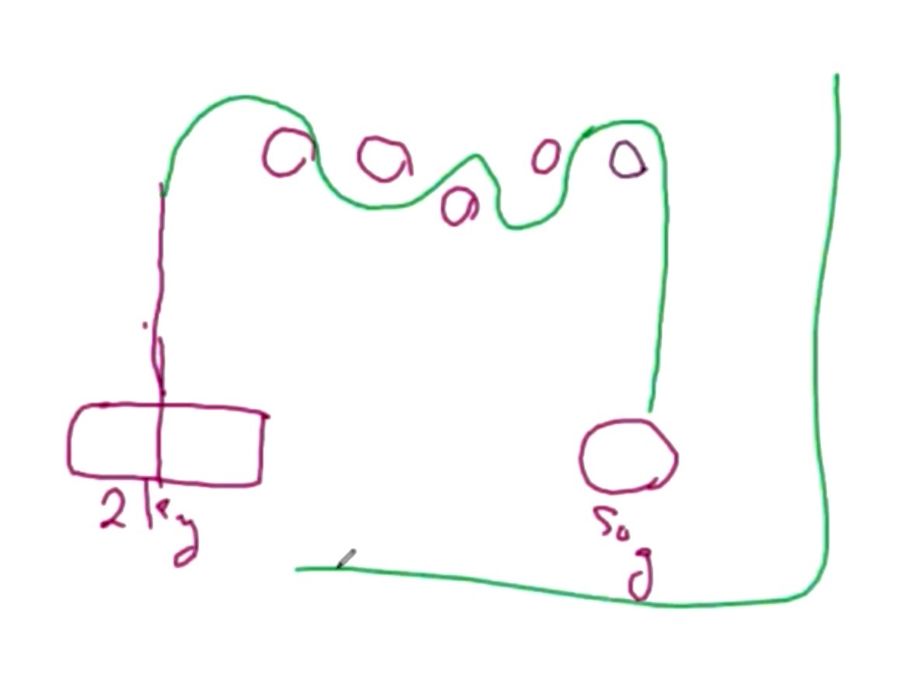

But the problem is that you have to carry this pulley with you all the time to be able to keep this lifted to a new position. Now you have moved it to here and the other pulley is gone. Look at the number of the pulleys, the position of the pulleys, the strength of the rope and everything else to be able to lift.

012423 K: we have another condition; look at it a new way and you already know this way. You have the brick (1.24.35 minutes) and you have the 50-gram ball. Most of you who are in physics know this very clearly. But now look at it differently. You have a rope and you connect the rope to the 50-gram ball. Instead of using the pulleys pass the rope through a tube where you can create motion exactly like this in the tennis ball. But the connection between the brick and the tennis ball is the rope. Hold on to the tube and start shaking the tube and do that so that it creates the rotation of the ball. When you reach a certain speed of rotation of the ball, the ball will be in the same diameter rotation, the same structure and maybe it will become longer or bigger, but the brick will start lifting. Hold this tube in your hand and walk around the planet and it will never fall. Go up on the mountains, jump on the plane in the parachute and as long as you keep the speed of the rotation there, the brick will never fall.

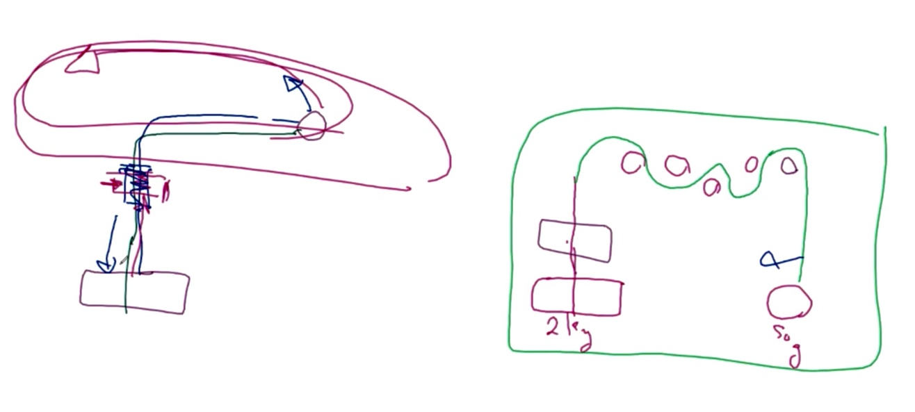

012620 K: You can dictate the position of it. The brick is a proton and the ball is the reactor. The position of the top of what I call the tube is your North Pole atmosphere. (1.26.50 minutes) The balance between the two is the creation of the lift. If you could allow the ball to fly instead of one end of the rope, anywhere around the ball at a given speed the ball will lift. You created it. But, if you have been with us and you did everything else you have done the same thing. You put the brick in the middle and you called it the inner core and you put the ball outside and called it the outer core. The speed of the rotation of the outer core (1.27.44 minutes) with the gravitational field in the center of much heavier has created the line between the fields. You have your space ship. (1.27.54) How much more do we need to teach? Sit on the chair and don’t forget with the ball you are not playing helicopter game. You are playing the field game. There is no disbursement of weight of air.

012837 K: now how many of you have been building the balls and making the cores and saying it doesn’t work? As I said to one of the innovation centers today make a bucket of GANSes. Your GANSes have to be very heavy. If you look the brick is 2000 kilograms and the ball is 50 grams; the ratio is 40 to 1. Look at the atomic structure at the weight of the proton in respect to the electron; it is 2000. Look at the distance between the upper atmosphere of the proton in respect to the upper atmosphere of the electron and you call it S1, S2. Then you create to bring in and now if you allow the tennis ball to run so fast it has created the dynamics of the second core. It doesn’t matter what is inside.

012952 K: in the teaching of the past 2 weeks I have taught you this very carefully; the rope is hydrogen. You looked at hydrogen as a fuel. I said to you that if you put aluminum in the core and in the outer core at a given ratio, now you have fixed it. Why did Armen, Peter, Douglas and the others lose their balls in the testing? They achieved it and they never understood it. The gravitational field force outside created the atmosphere that this ball could be in one of the galaxies and it’s gone. If you can make a bucket of the same GANS of CO2, keep it fixed and put it in the ball and start playing with the outer one until you achieve lift.

013057 K: You have all been in a flight mode for months and months. If you had 2 or 3 cores and the mixture, you all understood you could make this in any materials you like. In which way can I teach you? I close every door for you to be enlightened and you find another gap to escape. You never understood; maybe with this I can teach you to understand. (1.31.35 minutes) Get a chair and sit on it. Make a rope and rotate it above your head. You will see that you start flying off the chair. Your own chair with your own speed will start lifting up. I’ve done it many times. But be careful that you are strong enough and not afraid of your own actions that you might fall. It is the same principle. Look at what we have done with the coils for the past months and years. We showed you the cores with the inner core and the outer core. If you could create the heavy gravitational and constantly keep it and change the magnetical you can create any energy you need between the two.

013237 K: Some say, “You are working with a crook…blah…blah…” You never understood and this was so as not to show your stupidity; you had to blame someone. Nothing has changed: look at the structure of the cores, the coils, and the gas, when you did the GANS and when you did the star formation. The star formation is a more concentrated field. So, if you can lift a stone or yourself off the chair with a ping-pong ball at a given speed you understand it. You can do the same thing with a core because your weight will not change. (1.33.35) It is the length of the rope at the end from the top this length, because when you rotate it they become like this (1.33.48 minutes) there is no bend in it. So, the length of the rope is the diameter difference between your two cores—the gap on the cores or the coils. This is the potential difference and that is why it works. One millimeter to so many volts equals so much rpm and if you find that ratio you can all fly. If you need a 36-inch rope to fly and lift 2 kilometers with a 50 from the top of here is 36 inches. Then you can transfer this knowledge to what rpm or voltage difference you need so that you achieve the lift. You are all in space technology. Goodbye NASA. Goodbye propulsion.

013453 K: Now you can translate the whole knowledge right across from the matter state into the plasma state into transfer of voltage and current of whatever you like. (1.35.09 minutes) That is why we say certain RPMs and certain voltage can create lift. But this lift can go anywhere. Walk up the ladder and you see it is the same rotation and you don’t need to change the speed of the rotation. Now the fields are as the ball but that ball has magnetic/gravitational fields in the strength of the mass and it has created its own atmosphere in its plasmatic form and it is interacting with the brick. If you look at it, the wire is the feedback and nothing else. You need the feedback. That is why I said in the teachings when you put heavy alkaline in the center which is gravitational you look at all your alkaline and all have oxygen. Oxygen creation is the gravitational field in the plasmatic condition of this planet. But if you spread down it becomes the hydrogen property. Those who understand this will appreciate it in the future.

013635 K: so now you created a heavy GANS in the center and you put a little bit of alkaline for the feedback. But you need a line of connection for the feedback. Now you put the hydrogen inside and the hydrogen outside, because the alkaline-ness can change with the speed of the rotation. It can change with the speed of the distance between the top and pole can change. But you cannot lose the connection which is the wire, the cable. So, you made the cable by adding the hydrogen to aluminum in both cores. You made the rope because it is the common denominator. Many common denominators cannot be broken.

013726 K: So you have all the tools and enough you can fly. You keep talking about it but you cannot do it; it’s not my fault that you don’t see the light. You are blind. So, understand the translation of the knowledge and information. Those who sit with us in the NASA organization and the Russian Space Agency—I hope you got your message. I hope now you can fly in peace. And I congratulate the Iranian scientists in their achievement. Translate the knowledge and understand if you are working with the matter state, the plasma state or a mixture of the two. At the moment you are working with the mixture of the two. You put the plasma in but you contain it with a copper coil. You contain it with plastic. So now you are working with a mixture. Use one to the advantage of the other until you come to a point that layer of the copper, plastic, or the ball you had can be changed to a different speed of rotation of the plasma so that it creates the separation you want. But as for now at least you can start.

013914 K: do not change the central mass of the core; make different balls but make it, shake it and extract what you need and put it in the center core. So more or less you are about the same all the time. When you change the diameter, you will change the acidity or salinity of the outer core. Or change the speed. Don’t change everything at the same time or you have mayhem. That is why you don’t get anywhere. Change slightly more acidity into the outer core because your inner core you already fixed it. And then you see when the time comes when you start seeing the lift of the center core from the bottom to the middle. And, you will start seeing leaking water… and continue. Or you get the extraction of the water inside. Continue and change the speed slowly and see the lift. Do the same thing with the water’s current so your Magrav system will fly. Connect the Magrav system all 3 of them in a stacker and all the gravitational together with very little feedback. Don’t connect one to another. And then change the number of turns or the current flow through the magnetical core of all the three. Your system will fly.

014057 K: you will create a shielding most probably first. We have seen in research 24 plus 35 plus field expansion. Because now you dictate how far the field wants to be. Understand from now on the totality but don’t consider as matter, but consider matter as we always say as one of the strengths of the plasma in the spectrum of the total plasmatic condition. (1.41.35 minutes). Flight is imminent and it depends on which one of you wants to do it. If you want to see that it works….Renan or Armen are you in background?

014404 K: what happens in so many cases now is a lot of you who have been testing should be able to test flight. This is literally the way you can test it, the way you see it and the way it has to be. Can you try to raise Renan in the background for me, or Vernie or Flint? What you have to understand is that the composition of what air is in the ball links to the air which is in the brick that it creates a plasmatic condition because they are in the same atmospheric condition. If I change the composition of the air in one or the other, you will find the length of the rope will change or there will be no interaction. The strength of the connection is decided by the man. You can pull the brick up with a thread, with a small, small thin thread.

014553 K: If you understood this it should be very easy for all of you to start test flight. Those of you who had the GANS, who made and lost balls and you don’t see it, now you can find out where they are; now you can condense it and you have the flight system. If you understand it, you can replicate it and you can fly it irrespective of position anywhere on this planet. But, be careful you don’t lose your balls. This is why we keep on asking 5000 plus 7000 plus 10000 plus rpm machine motors. The common denominator for isotopes of carbon is between 6 and 8. Sometimes it goes in the margin of nitrogen. If you understand that the rpm has to be 6000 to 8000 and plus depending on the diameter of the separation between the two cores.

014728 K: You have to understand how you measure the atomic mass plasma of your center core. It is not by grams. It is by molecular plasmatic weight and the amount that you put in. A rough guide is to look at the carbon number of 6.19 or 6.3 x 10 to the power of 90. Then you have 10 to 20% margin of error because of the plasmatic condition and this plasma by order of magnitude is stronger in the plasmatic condition than in the matter state. You can roughly fix the center and at a given point fix the rpm and you will fly. Have you found Renan yet?

014916 M: Hello I am Massa Grashid (?) from Bangladesh and I have a question regarding the relationship of a dynamic system and a static system. In the static system the coils are used I believe to create the mechanical rotation. So, in a dual-core system, if I put instead of mechanical or electrical rotation through applying voltages, if I put the coils in the middle then I should be able to create the potential differences between the two cores without any mechanical or electrical rotation.
015010 K: yes, but you have to consider two things in the background. One is what kind of GANS you used for coating it. You have to understand that you have the separation of the nano-material. The current flow is in the plasmatic and not as a current as voltage.
015034 M: so, it should provide more advantage because it doesn’t have the limitation of electrical because I can change arbitrarily change the number of turns. So, I don’t have the vibration issues of the mechanical system.

015052 K: yes, it is more efficient. It is much faster but it is so strong it is above the matter state. You have to find a way if you want to use it for energy to bring it down to the matter state. If you want to use it for lift, then understand the comparison of the earth’s gravitational magnetic field position. None of you have lost a core yet. None of you have lost a coil when you are making the winding. If you look down your double coil, the center core, the gravitational core is another core. And every nudge and every turn on it is additional field transfers. So, if you look at the bottom of the coil, it is exactly another reactor. You have got to look at the fields in the center and here (1.52.00 minutes) and not at the copper, the turning or the nano-coating. But you made more of them.

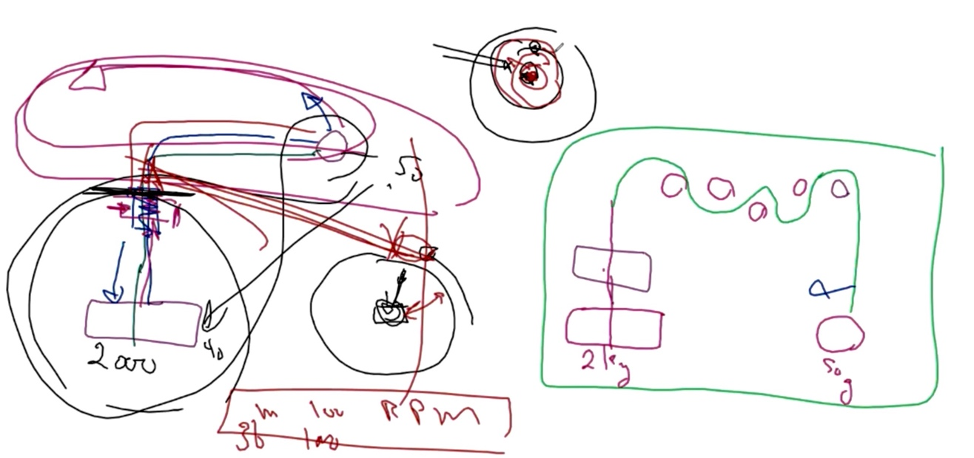
Pic 015209 – putting the red boundaries in the upper sphere in the picture.

015212 M: so the number of turns intensifies the inner strength.
K: (it intensifies) the inner fields and nobody has tapped into it. If you look at it just cut the coil, you made and look; it is exactly the same as the cores you made. In the cores, you consider what material you put into them. In the coils, you don’t; you just put something there and it has to work. You can make a coil to fly as easily as you can the core; it is much easier.
015252 M: so, it’s much easier with a coil that is my assumption.
K: flight systems in the universe use that technology. But it needs mastery to understand because every turn to the other amplifies the strength if you are using one end to feed the energy to.
015320 M: yes, if it is in a loop in the gravitational connecting, the infinity loop, if there is a relationship it should work very rapidly. The problem is that the relationship since it is non-linear is just like having…. There should be a relationship between the number of turns and the …

015343 K: yes, let me explain to you. The relationship is by order of magnitude if you understand that.
M: so, it is essentially exponential and it is increasing exponentially.
K: if you are from Bangladesh you play chess, yes?
M: not quite but I know of chess.
015404 K: you know the story of the turn by the order of the magnitude is the story of the guy who made the chess and the king asked him what he wanted. He said he didn’t want anything and the king said but you made such a beautiful game what can I give you? The man said put one grain of rice in the first house and that will lead to the next. By the time they got to the 64th block there was enough rice in the whole kingdom to pay the man as a present.

Editor note: this relates to an ancient Zoroastrian proverb that MK must have learnt as a child – which on looking it up there is some contention about whether the story came from ancient Persia or ancient India – in ancient Hindu lore the story is portrayed as the story of King Radha who liked to play chess, and challenged anyone in the kingdom. It was Lord Krishna who disguised himself as a wise sage and asked of the king the modest amount of 1 grain of rice but increased exponentially by the number of squares on the chess board – 64. The point is to illustrate the principle of exponential growth… As it says on SingularitySymposium … ‘Following the exponential growth of the rice payment the king quickly realized that he was unable to fulfill his promise because on the twentieth square the king would have had to put 1,000,000 grains of rice. On the fortieth square the king would have had to put 1,000,000,000 grains of rice. And, finally on the sixty-fourth square the king would have had to put more than 18,000,000,000,000,000,000 grains of rice, which is equal to about 210 billion tons and is allegedly sufficient to cover the whole territory of India with a meter-thick layer of rice. At ten grains of rice per square inch, the above amount requires rice fields covering twice the surface area of the Earth, oceans included…. It was at that point that the lord Krishna revealed his true identity to the king and told him that he doesn't have to pay the debt immediately but can do so over time. That is why to this day visiting pilgrims are still feasting on Paal Payasam and the king's debt to Lord Krishna is still being repaid.’

015433 M: thank you that clears up a lot.
K: it needs a wise man to see. This is what you do when you create voltage current through. But, nobody has ever picked up on it. And I always put it in a nutshell and if you understand it you can control the plasmatic field. A lot of people… if you go back on the internet you see what I call the donut flying system. The donut flying system uses a coil system. It is very common. It’s like if you have a Rolls Royce and you have a truck, it’s another flight system.

015519 K: those of you who understand the coil system in the future will build a donut. The donut has a lot of advantage. The donut space flight system has a huge advantage. But it is very, very hard to control because it absorbs too much energy and flying it is much easier because you can tilt it much easier and you always fly by tilt. You always fly by tilt; flying vertically is very, very difficult. And the beauty of it is that it creates a donut field so you can actually fly through very intense fields like what you call Neutron stars. Donuts are one of the best ways to fly. You can change the flight mode system with 6 and 12 coils the way I have shown you before into a donut very easily. You have to understand there are 2 ways of doing a donut. You can create a donut …. (draws in red on upper right centre of white board)

015650 K: you have a donut this way. With a donut, you look at it this way as a donut or if you look at the bigger donut you look at it this way. Here you create the field on this body, this side and here you create the field on this side. So, you play the field’s interaction. And the donut shapes are amazing to fly with. Try it. What you have to do if you are using the coils is to connect the gravitational to a different power supply and the magnetical to a different power supply. You still see your coil fly. If you got the mixture for the nano-coating right, you will see the coil fly. But make sure you have no attachment to wall as a power supply, you have to be on a battery drive, because the minute it takes hold the whole structure starts rotating. Initially it usually vibrates to the left because it tries to go anticlockwise. And then it finds the balance, its source, and it goes directly. It is one of the pleasures of space flight. Don’t forget in the donut the center field sits in the center. You can more or less use the atmospheric condition of the universe to create what you like and your backbone sits right in the center. This gives you the energy and you decide what you bring from it. It dictates your speed. It’s an amazing flying system.

015925 Renan: Hello this is Renan; I am here Sir.
K: Hey! Thank you very much for coming back. Can we see your street demonstration from a couple of days ago with your weight as a sack of sand?
015940 R: give me a minute to get the video.
K: OK you will see it working. Let Renan show and then we will talk to Armen. I wanted to know if you want to show how you are going to lift with your chair up.
Armen: it’s 2:00 am.
K: go back to sleep.

020104 Armen has tested this and it works and Renan has the video of it and it works. Translate the knowledge and you will understand it very easily. You are all in the flight mode; just translate the knowledge in the right way. Translate the knowledge in how it should be, not what you would like it to be and you will fly. This is important because this puts what a lot of you have been trying to fly out of the equation in what you wanted to achieve and how you wanted to achieve flight. With this way, we can now open the books of the universe. With this way, we can extend it. We can see how far we can go and how you can expand it. Now you will understand why people could not see the flight.

020306 Mawson from Calif: in one of your teachings you mentioned that there is a universal GANS for every single purpose in the universe from creating matter, to the lift, to the energy, medical--one single GANS that can cover everything. Could you please explain that?
020344 K: the GANS is deuterium. Deuterium is a balance condition and when you use it you have to back to the essence of the understanding of the physics of the whole structure. Let’s see this video and then I will explain to you about deuterium. Now you see how all of you can fly very easily.

020430 – Video plays…

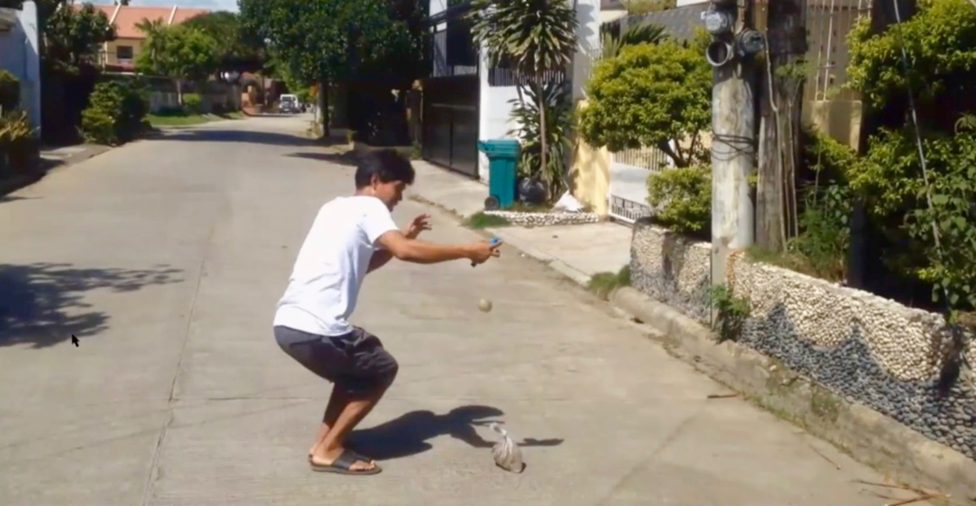

020512 MK: If you look, the (plastic) bag hardly rotates. Now you see that this is very easy. Now you see that you can all fly!

020540 K: I was talking about deuterium; you have to understand why deuterium. You need stability and balance and always the three to be in conjunction with each other otherwise you create abnormality. (Clears white board) OK. Now if you look at the deuterium and understand the totality; you have the neutron, the proton and the electron. The Neutron is the central gravitational part, which means the system is stable. You have the 2nd part, which is the lighter proton and then you have the electron which in fact uses the infinity loop.

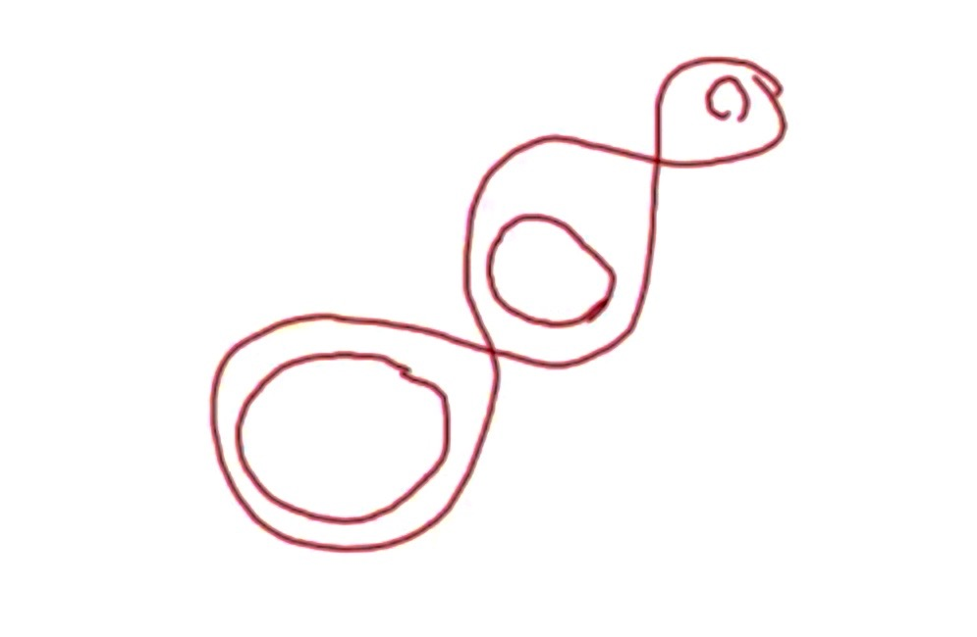

020713 If you notice I have made gravitational positioning. (Draws blue arrows) What you can do if you manage to push the electron further in or slightly further out, look what you know in physics. You have S1, S2, and S3. (draws bands going out) Now that you know that you can connect and condition the gravitational positioning, then how you can control it and allow it, this electron can sit and have the property of all or individually in each of the rings. 2.08.13 minutes. In the center you have the proton and you can produce anything you like. Would you like gold, copper or helium?

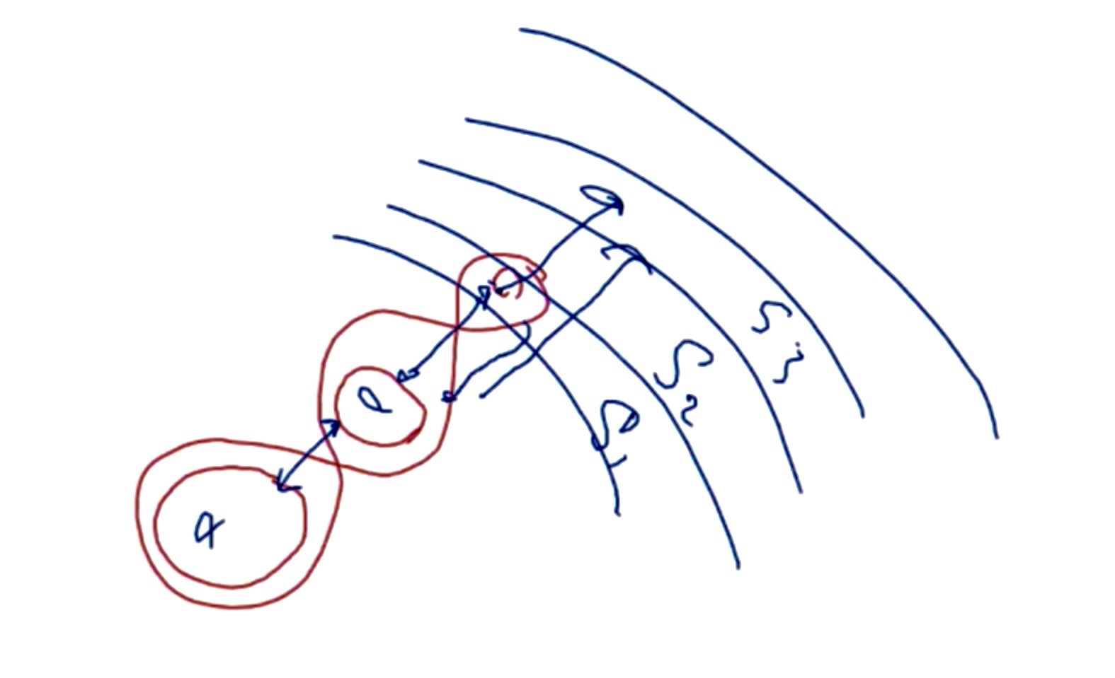

020832 It is the magnetosphere strength that is dictating the manifestation of the property of the element, not the entity of the proton or the electron. Coulombs barrier is gravitational magnetic field balance. If you are hydrogen or smaller according to the strength between the proton gravitational magnetic field and the electron or the neutron. The neutron is the center and if you look it goes back to the same thing, the 3 fields’ manifestation of the tangibility. (draws a coulomb barrier based on the GM field bands)

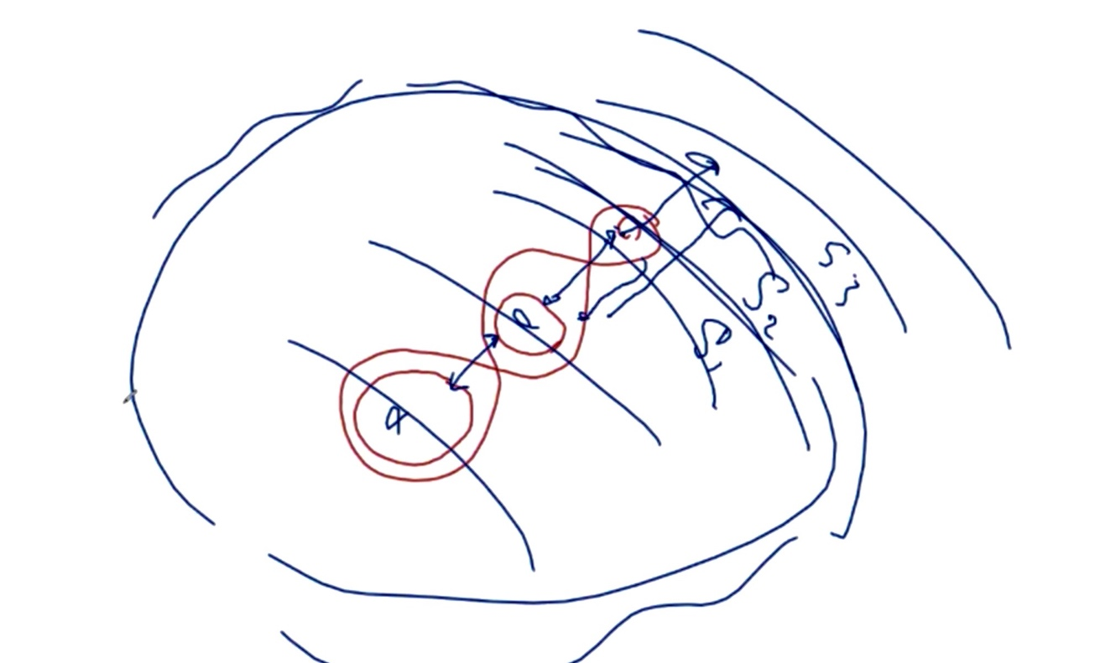

020940 K: if you play with deuterium you are always the winner. If you want to work so that you can make elements very quickly, you go to tritium. There you have a spare ‘guy’ somewhere and with that ‘spare guy’ you can dictate to create a condition of the elements much faster. Now you play these two together (spare guy and neutron): birds with birds and dogs with dogs. (2.10.13 minutes)

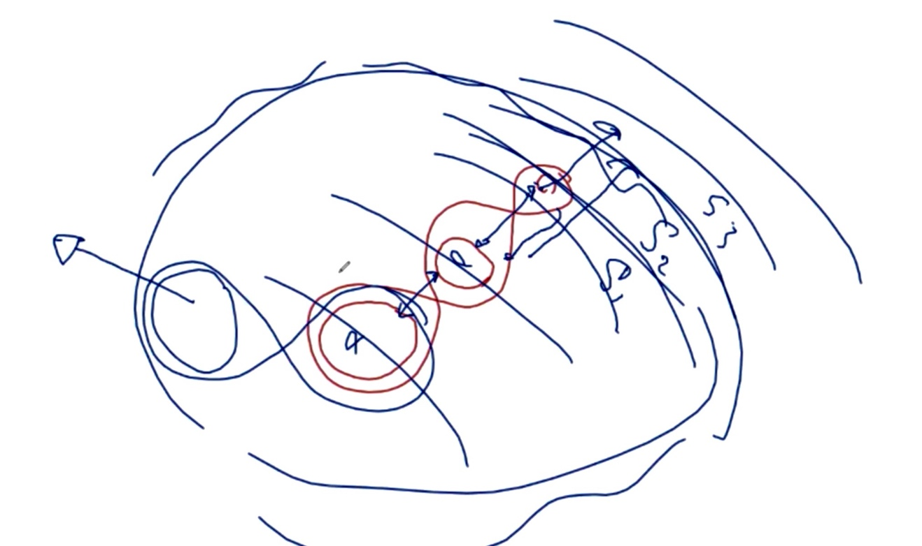

The heavier which is the neutron always dictates the condition. It doesn’t matter how big Saturn is, the sun is the center. In plasma physics you go by the order of the magnitude of the plasmatic mass. So, we look into deuterium and you can build it yourself; you can make deuterium anywhere in the universe. You can do it with the 3 layers if you understood the lift which we explained how you measure the core. You make a 3-core layer and you play the deuterium. Then you can create anything you like and any condition. In this environment here, in this gap (between the proton and electron), you work with megawatts. In this gap (between the proton and neutron) you work with mega megawatts. In this gap, you work beyond your imagination.
(2.11.34 with the ‘spare guy’)

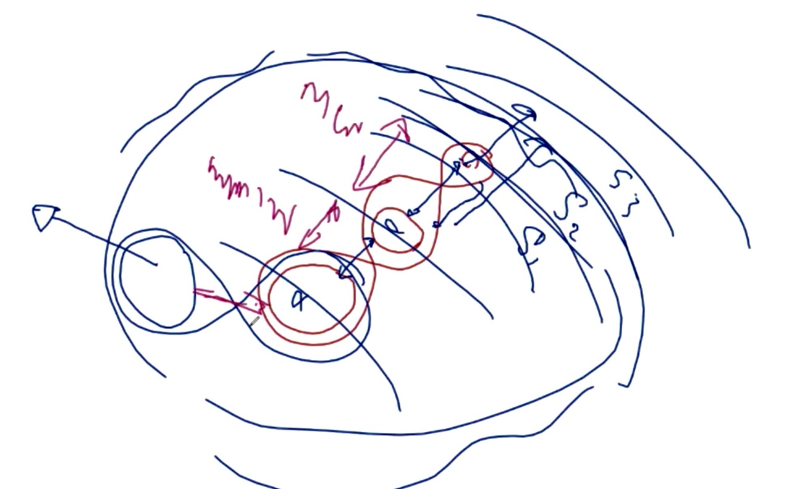

021138 K: don’t forget we put this thing down as what we call the Neutron, Proton and Electron. In the reality of condition this guy (neutron) is rotating itself, this guy (the proton) is rotating itself and this guy (the electron) is rotating itself. And at the same time this one (the proton) is rotating around this one (the neutron) while this one (the electron) is rotating around this one (the proton). A lot of times electrons actually go to the center of the nucleus exactly like meteorites do. They get pulled in and they push out. It is part of their energy process. Sometimes they pass through the center of the nucleus. And then you find out this chap (the electron) rotates on his own in this direction (towards the ‘spare guy’) and then you will find out there are times that proton rotates totally opposite. It happens a lot in deuterium. To keep the balance the proton is sandwiched in between and is forced to change the direction of the motion. These are the atom structure man has no understanding of. But you can use this for a huge amount of production of energy especially for instant transportation. You keep the gravitational field of the environment in respect to this (electron), but you change (the proton) and you can be anywhere instantaneously as long as you keep your center core always fixed.

021343 K: this is the way we have to understand the technology. I always refer back to the tape you used to play. We have made it so simple that we use the matter to create nano-materials with the GANS and the binding is so strong because they all have the same common denominator element. It applies the same to the plasma because the neutron in the center of deuterium, which holds on to the proton and to the electron must have a common denominator gravitational magnetic field. If it doesn’t it becomes a hydrogen. That is why we see so much hydrogen on this planet. Because, if you look at more or less the structure of being between the oxygen and the nitrogen, or you look at the structure between the nitrogen and the carbon, the discrepancy in the amount of energy is big enough to create the proton and the electron but not strong enough to create a neutron to get the deuterium. When you confine certain gravitational magnetic field (in paused)? In the hydrogen (2.15.21 minutes) in very, very specific conditions, which can affect the gravitational magnetic field of the oxygen, you end up with heavy water. That is why heavy water is very rare and you need to hold it to control it. The environmental magnetic gravitational field within the center within the structure of the inertia, which forces the creation of deuterium.

021555 K: and then, on the other hand, we do the same thing for the creation of heavy water. Look at the places where heavy waters are produced. In Iran, we have a natural abundance of it because of the structure and because of the mountain ranges and the gravitational fields sit in the plates and in time you find deuterium we cannot find afterwards when the geological structure changes. Any other questions?

021655 John: I would like to go back to when you were talking about keeping the vegetables and the refrigerator. GANS water could be used in the mortuaries to preserve the bodies especially in tropical climates where they deteriorate very fast.
K: yes and you can use it to kill the smell.
J: exactly yes, especially when the family is there and the smell is very strong. You could get rid of the smell.

021740 K: any other questions? Does anyone want to add to the knowledge?

021810 Rick: Patrick mentions in the Q and A that he has some plasma sphere experiments border on what Mr. Keshe is talking about.
K: what? If he has something to show us let us see.

021910 John: do we have to get hold of deuterium in the traditional way where they make heavy water or…?
K; you can produce it yourself. Deuterium can be produced very easily if you work with nitrogen and carbon. You push it not to become helium but you create a condition within the salt content that it creates deuterium. It is very easy to create deuterium. Go back to what I said; it’s the environment of the earth that dictates the creation of deuterium and heavy water. So, we change the condition. Let me explain something that takes us to more detail. I was teaching this recently. (clears white board)

(2.20.37 minutes) We explained that the life on earth is created out of the gaseous part and the physical matter part. Then you have the liquids which come as part of the gaseous part. In fact, I was explaining this, if you look at the oceans on this planet these are actually the cooking pots and the solid matter is the pot itself. You put nano-coated copper and zinc and you made CO2 and you got amino acid on it.

022138 K: Now you understand why you never finish. If you go back in the understanding and if you have water which is trapped in the gaps of the physical structure (2.21.58 minutes) and then you added the water into it and then the condition is that this environment has a ‘say’ on what is inside and the conditions change the light water into heavy water. So, what you have actually created is the fields inside (2.22.23 minutes). Does this field dictate what we absorb from the cosmos because we attract it and the fields of it matches and brings it to it? It has the strength from it and so now we understand why we produce so much oil and what they call ‘fossil fuel’. I wonder how many dinosaurs would have had to die in the past millions of years for us to have oil at 80 million barrels a day!? We have done an estimate and we produce something between 20 and 30 million gallons of oil a day. Day in and day out this has been done for millions of years. Part of it is getting washed through hurricanes and the waves on the sea leads to the creation of new animals.

022334 K: This continues the new creation because of the condition that the amino acids in the path go down to become oil. It is given the condition that it can create life and new animals are created. If you pick up the picture of millions of years ago and of today, the parts of the animals that were created, the new ones of what I call the evolution of the life of the planet are the ones that come up are the new cancers as you call it. The old cancers have changed and this is what we find in the body of the man. So, you will find that this planet produces 20 to 30 million barrels of oil every day because the beauty of the sun is that it does not finish. It is always coming and it’s a natural process of interaction on the facing side of the sun we produce a fair amount of amino acids which are at the strength of the higher order and you produce amino acid again on the back side dark side because of the strength so in the totality we create a spectrum of oils. Depending on what structure is inside we call it light or we say we found a new one that wasn’t there before because we change the magnetic field that we create parallels and dark cavities. Water can change into oil exactly like water gets created inside storms that never came in through the walls of the earth. The same structure as the potato exists (2.25.30 minutes).

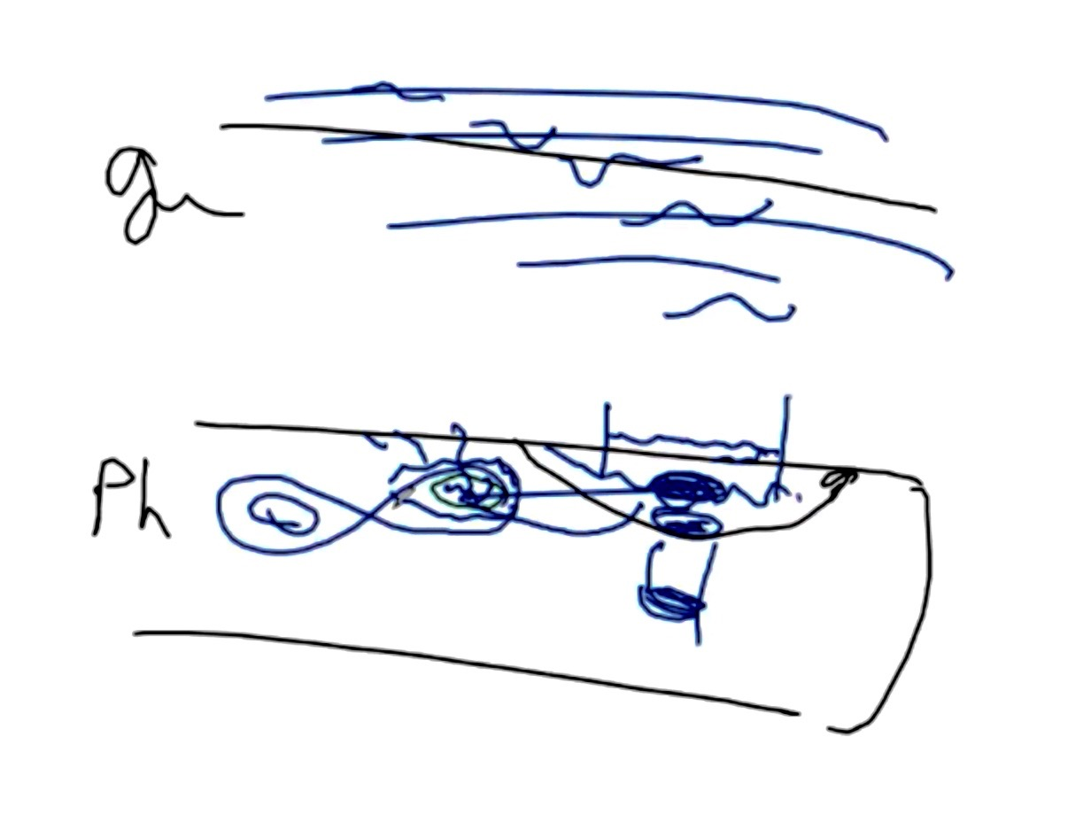

022538 R: Mr. Keshe we have a video from Patrick showing his spheres.
K: have you checked it and are you happy to show it?
R: yes. It will be fine.

2.26.01 – 2.31.21: video plays showing small spheres being influenced remotely by a pen

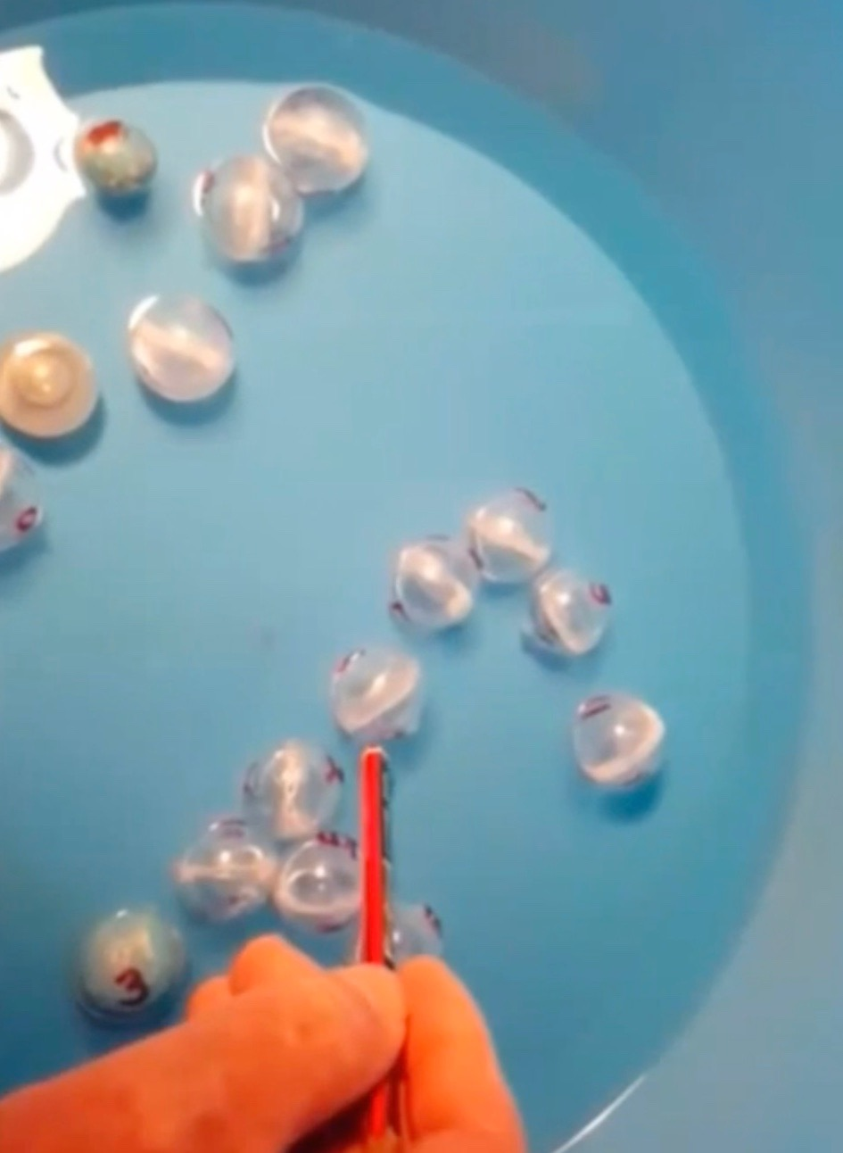

023200 Patrick (P): I wrote a bit of a summary on what the experiment was about. I’ll read it and I’ve done a couple of these experiments. The spheres have several days to consolidate the fields. The fields have grown in strength and have a lot of resistance to being pushed. They don’t like being knocked from their position and this is noticeable to the touch when pushing. However, when enough force has been invoked they will move and the fields will break. When new spheres are introduced into the pool they show very little resistance because the fields haven’t had time to consolidate. When pushed, the momentum carries them quite a considerable distance. These freshly introduced spheres have not had opportunity to find position. Within 5 to 6 hours they start to ‘lock in’ and they start to develop resistance to movement. What I have learned so far is that it seems that the extreme alkaline and the extreme acid seem to be the strongest of the fields.

023350 R: what were the various spheres you had there? You had them listed 1-10.
023412 Patrick: it’s 1 to 13 now and I have lead, neodymium, bismuth, rare earth, aluminum, copper… and that’s copper negative… CO2, CH3 negative, acid, alkaline, CH3 positive, and CuO positive. And, of course, I have my own DNA. (2.34.38 minutes). I am just trying to work out how many correlations and different fields and what sort of reactions the fields emit.

023500 R: you also did some magnetic tests with a magnet on these?
P: yes, I did and I showed that on your plasma workshop and I didn’t make a video of that. I didn’t say anything about this the other day because …

my alkaline sphere that I was standing a bit away from, I thought it jumped by itself. I thought I was imagining things. I moved it back and it did it again. But I haven’t been able to repeat it since. Twice it moved by itself; the first time I thought I was imagining things, and the second time it moved about 30 or 40 millimeters.
R: you mean 3 to 4 centimeters?
P: yes, horizontally out of the water and hit the bottom of the tub and it made a noise that I heard. I couldn’t repeat it so I couldn’t film it.

023700 R: You don’t have a GANS of Mexican jumping beans in there, do you? P: Hahaha yeah! – I can’t prove it and I couldn’t repeat it so…
R: Aahh yes! The one that got away! What do you think Mr. Keshe?
023723 K: What do you think Mr. Crammond? You are a master in these things; why do you think it flew?
R: well maybe it was like a fish in an environment it didn’t like being in and it tried to jump out of there. Maybe it was an acid is in an alkaline environment, if you pour acid into alkaline, you find the liquid that jumps and splatters and even explodes.
023800 K: it’s the gravitational position and there was CH3 and that is the giving. When you give, you have to find a position in respect to what it is taking. That is the CH3 because you became the ball and you have to look at the ball and the fields of the ball.
R: does it build up to a point and then it just let's go …?
023822 K: yes, if it is trapped by the others. You have to find a position exactly where the structure is the same. If the balls are in the same position and the fields build up to a point, then it has to find the Magrav positioning. It has to find the CH3, which is what we call acidic and magnetical. So, why does it move? Why does it find distance? It means the field which is giving out has to find its balance with the others that are giving too. It’s like two north poles put next to each other. If you look at the ball and it was moving, most probably it changed direction and motion. And in the direction change and direction motion the fields are trying to find the balance, it jumps up. Was it on the outside boundary or was it one of the balls on the inside?
023932 P: it was one of the balls on the boundary and it was when I first set it up and I don’t think the fields had a lot of time to establish and consolidate.

023946 K: we have seen this with the bubbling GANS with Douglas about a year ago. In your case, it is horizontal but it takes the shape of moving. It’s the Magrav system because it’s the fixed amount and they try to find their position. So, what it means if you look at where the structure is, the field of that many balls is magnetical. Because then it has created a magnetical field in respect to the others and they have to find their position. You change the strength of the magnet so it has to find… this is how people lost the balls when they were testing. You create that condition; this is why you put gravitational or alkaline with acidic if you understand this transition of the alkaline.

024050 K: We were talking about the tritium. You can create a tritium that is both alkaline and acidic. But, you can create a condition for it to become alkaline by introduction of the next neutron or what you call tritium in the matter state. By changing the position or the direction of rotation of the 2nd reactor or the 4th reactor you dictate the field strength. It is exactly like what you create as amino acid. The separation of the fields or the reactors from each other is dictated off the positioning. This goes back to what we called 129 Tesla test. Armen got the mixture so precise that it was perfectly controlled. We didn’t touch it. We didn’t need to touch it. But every time we changed the environment, it responded according to the environment. So, you have kept the structure the same.

024208 K: you can do a lot of tests in water and the best way to do it when you do it like this is to change the salinity and see the change. If you change salinity or the alkalinity of the top, and not what is inside of it, you will see a lot. But the disturbance should not be that it disturbs the water. If you can add it without doing anything, your balls will start moving around.

024242 R: I got a message in the chat that there is a video from Fransje who has been in the reactor group; she has a video of an apple in a pot that rotates in some GANS water. That may illustrate that point…

024313 K: yes, this is what we say; part of the teaching is sharing knowledge and this is where I started with the tritium. (Back to the drawing with the oceans 2.43.34 minutes)

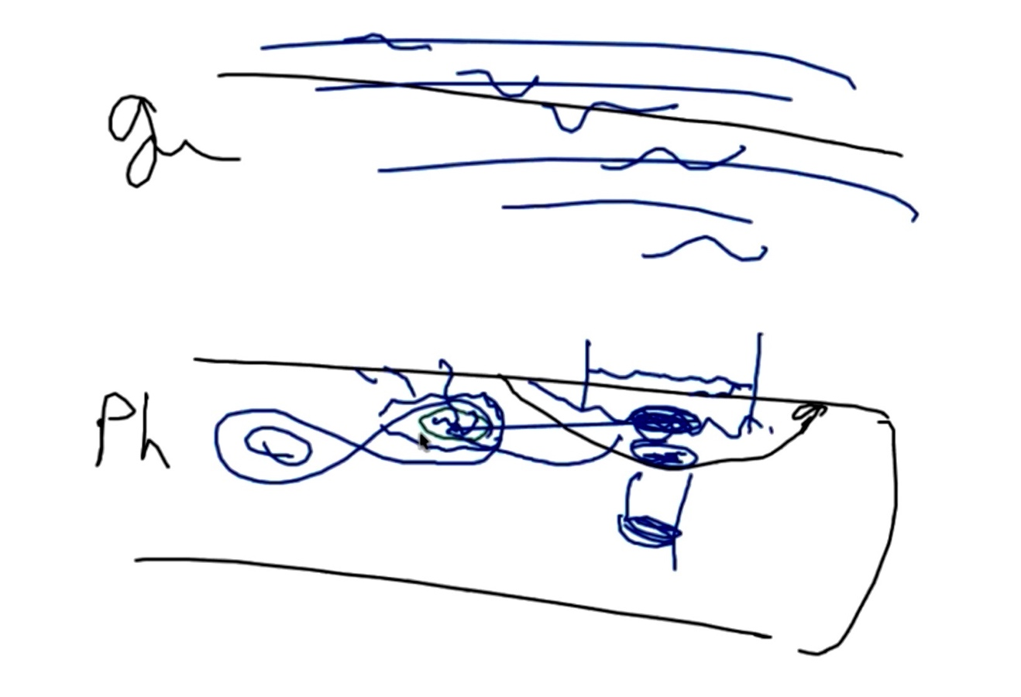

What we have done here is that you have the gaseous part. And here you have the matter or the physical state. The oceans according to their salinity create different proteins on the top. Those proteins allow different fishes to live in that environment. That is why we cannot find certain fish in certain parts because the gravitational magnetic field created by the salinity of the water and the environment of the container dictate what kinds of protein are from the environment. Here we get the creation of certain fishes. It is the salinity which dictates it. If you look in our systems when you make a container, it is the same copper, wire and zinc and we change the salinity or salt, we create the same thing, but different materials. (2.44.34 minutes)

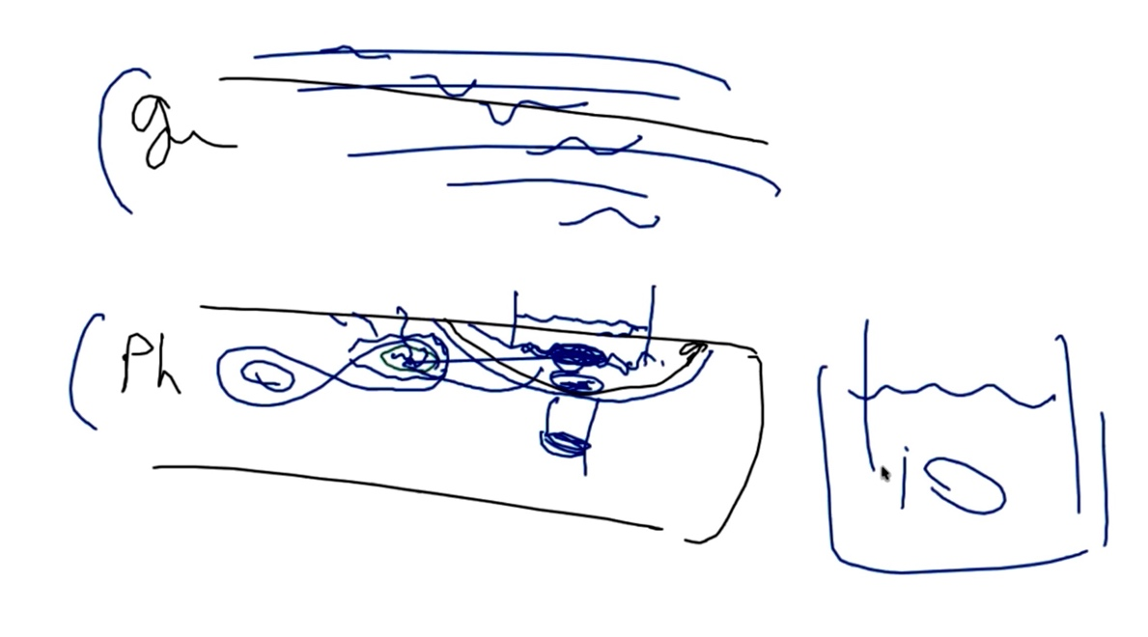

024433 K: What has happened is that the matter here if you look at it is this way. Above this way in the atmospheric is the condition of the environment of the earth when we put a salt container here we change the field here. (2.44.50 minutes)

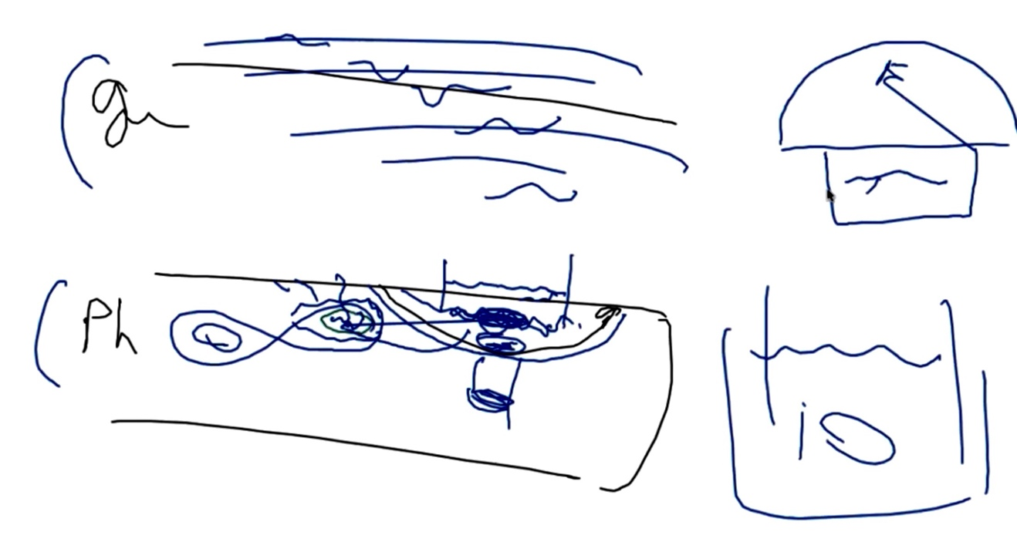

We just changed the condition and now it is not nitrogen and hydrogen; now it is sodium and chlorine. That is why here we can create different materials. By conditioning the environment, you produce different fields. This is something none of you have ever looked at and this is the reality of where we sit. You change the salinity and you change the environment. In fact, these two are fixed (2.45.31 minutes) but the protein absorbed here and the type of carbon absorbed here is different.

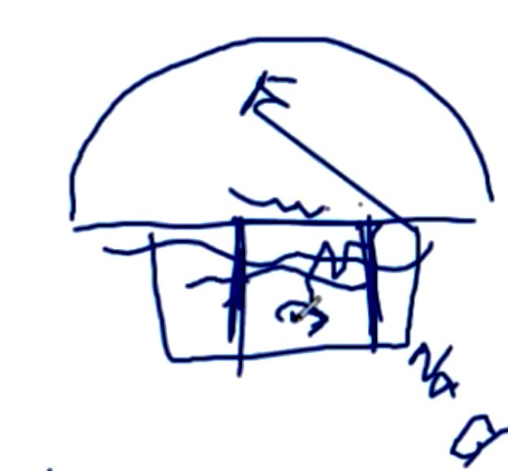

You change the salt to magnesium or potassium or whatever and you change the environment. Now you are in position and you are the creator of the condition. That is why we see in the container here the balls position themselves. If you could keep the balls in a given condition with the amount of materials you put in there, the zinc or whatever, then look at the bottom. Have you created any GANS from it? Is there any layer at the bottom that is different? Are you producing the same condition as the others?

024610 K: What about if you sink one of the balls, hold it at the bottom, and see if the others react to it. The creation of the condition now is in our control and that is what I understood from the very beginning. This is the atmosphere of earth and I create the atmosphere of Zeus here. So, I get the same things but I get the other strength of planet Zeus. This is what a lot of you have not understood. Just change the water or the salt or whatever. The salinity has given condition as a different property and absorbed different amino acids, you have created a new environment. You can replicate in these containers the condition of the planet or the system you want to go into or come out of. It is the beauty of it and this is what we have to do to open the knowledge so that it is understood in a simpler way.

024722 K: all you have done with your container is to create a new environment. The new environment creates new materials or you can replicate the materials you want at a given strength. If you understand this, then you understand that you can create in the same container a condition where only gold comes to the bottom. You extract any gold material, which is at the strength in the upper atmosphere of earth to the sun and above. This is what you have never understood and I keep going back on it and one day somebody will jump on it. Peter in Austria went one way and just got carried away with it. But when he put the ball opposite the other two balls you have fixed the condition. It is the same here and if you find the right nano-material mixture, one of them has to be nano because then it dictates the fields you can create gold in the bottom.

024823 K: You can create calcium. We do a lot of calcium. If you look at a lot of GANSes, you have a solid GANS of calcium if you test it. Where does it come from? It could be in the water but it means now that water has dictated the condition of absorbing calcium plasmatic fields, which cross over. It doesn’t stop once it starts producing. How much calcium is in the water? I have done that for months. You still collect it.

024900 K: I’ll give you a piece of thought—a very deep understanding of the technology. (clears board) We said that we put an orange and took the taste of orange in the water. Just explain that gravitational magnetic fields of the environment above earth dictate what we are collecting. The salinity in the water is as I said, as Benjamin does magnesium salt and he still gets CO2. It has different effect and Benjamin can use it for different things. When you are enlightened you see more. But now go back to the mobile salinity walking on the planet (figure of man 2.50.09 minutes). If the earth through the salt water was creating life, then certain different materials were being absorbed. For example, do we use energy of the cosmos as calcium to produce our bone structure? The answer is yes.

025046 K: that is why we have different bone structure in different parts of this planet. 20% of the food we eat comes from cabbage, meat and potatoes. The rest comes from universal cosmos. It just comes in so it has to have a need for it to be absorbed and to be given out. So, our bodies are not just made from the matters; they are made from universal energy. And if you understand this then further on you will understand that you can connect with any entity in the universe through the same channel the way you did in the two cores by having hydrogen in one and the other.

025140 K: when you put the bucket and you put the balls and change the salinity see if the balls are moving and part of it becomes more compact. You change the environment and you change the new field strength. And if you create a certain salinity you will see all the balls jump up and down on a frequent basis because you change the environment and that field dictates different positioning in respect to the ______; the content in the balls cannot change. (2.52.12 minutes) And, in response to the environment they start moving their position.

025222 K: this understanding of the salinity in the body of the man will come to home and in deep space because you absorb so many different kinds of energies that can create conditions that the man will go through rapid evolution according to the environment he is in. If you look and change your salinity and keep a photographic copy of all the balls and their colors and shades, you will find that in different strengths they become different shades because they have to reveal a new dimension in strength and structure. Otherwise they have to take position to ________. (2.53.05 minutes).

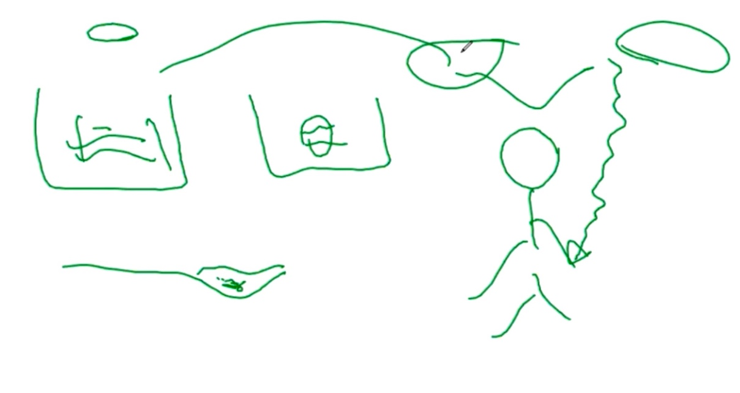

025309 K: would you like to share a video? R: yes, it is Synergie Evolution, Dominic from France.

025335 D: It is from Francie, because I organized a small conference and she came to share what she found and I have this video from her. …
R: I am not seeing anything. OK, now we see something. (2.55.07 minutes)

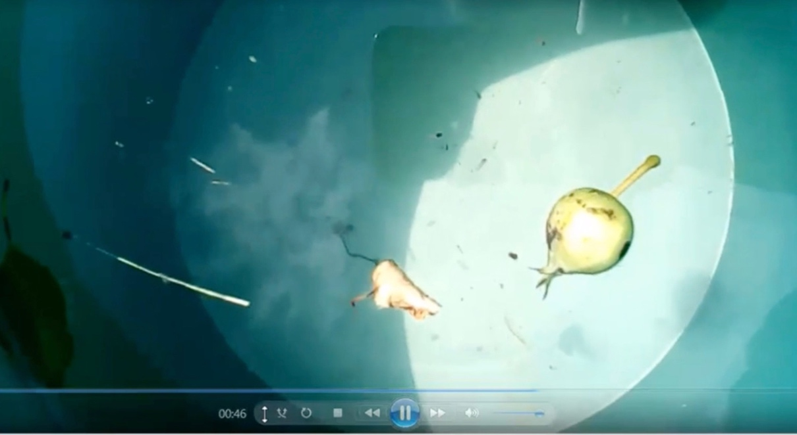
(Video is played twice of an apple rotating clockwise in a bowl of water)

025511 D: she just put liquid plasma and CH3 and put the apple in it and she shows it is rotating. She tried to put it another direction and it went to the same direction.
R: so, it just continues to rotate?

025724 D: yes. I will try to share some explanation for people who asked me. I know Francie tried to put this in a different place. Maybe it is relationship to earth. I don’t know if she is online right now.
R: she is not online. Francie has been on the earlier workshops with the everlasting meadow battery out in the field. She has also done work with her car to increase fuel mileage with coils and GANS balls in the car. She says that it works and she has given several testimonials on the testimonial site of the KF… OK… we are back to Mr.
Keshe… Several questions have come up and one is on the solid-state power unit, the generator.
025909 K: we are still developing it and hopefully in the next few days we should be able to show it and go into production. The development has gone on and now there is additional development. Once we start to make casts, it will cost a lot of money to recast it. Then we get to the point that we say it is the point to release it. We will show it in the next week or two and then we will go to mass production the way we did with the Magrav systems. We have to develop the next stage and release the new generators.

https://www.youtube.com/watch?v=JU_kGOCIuok

030003 Rick: question in the Chat: Earthquakes (EQs)—in New Zealand we are seeing a huge increase in frequency and size of EQs in the last 3 to 4 weeks and particularly the deep ones that cause the shallow quakes that cause a lot of damage. Over 60% of our population lives on the Pacific coast line and is also at risk for Tsunamis that appear to be increasing as well. Some of us are trying to prepare ourselves and warn others around us and the media is starting to make gentle noises of the danger. Could Mr. Keshe please assist us with an update as he sees it for the region of the Ring of Fire?

030100 K: We explained for the first time about the movement. Someone sent me a link a couple of weeks ago. They had put it on their own video sections on the internet. So, millions of people are aware when we talk about the earthquakes. A scientist recently told me we thought of everything except the moving of continents. There was nothing that we thought was happening. What you explain to us, explains a lot. We see the separation and there is alarming motion with NZ 2-meter shift. Go back and look on the same video about South of France and N Africa and for the first time we are seeing EQs in Morocco on the Spanish and the French side.

030213 K: It is normal to see high activities going to Christmas. It is the time when all the changes of the last season with new changes coming into position in the earth will bring in the new changes. What we have seen is in line with what was expected. If you listen to my recordings in the past year regarding NZ and Australia, you will see these events were predicted. The problem with the NZ move is that the pressure went directly to Argentina and that is where the problem sits. Now it is like sitting down on a pin and somebody pushes you back. That pressure will now create a separation and that is why the move has been that way.

020322 K: On the same pressure on the backstroke of the Argentina/Chile side there is activity. There we will see a lot of activity very shortly on the Panama section and then we will see the possibility of a huge release around California if we are correct. We expect to see 8 to 10 plus. There is one snap and it is the sound of the breaking. This can happen in the next few months or next year. I expect a massive EQ in Iran that is imminent. Will it happen in the next 8 to 10 weeks? There is pressure in Italy and we may see huge gaps across Italy and another island like Sicily will be produced. Italy will break in two in the center. We were expecting this. The EQ in N. Africa and a very few in Central Africa in the past few months confirms the push from the South American continent, and as it is getting pushed we see the 2-meter lift in New Zealand.

030513 K: we are talking with Japan on a daily basis. The EQ last week brought huge problems in Tokyo and this will carry on. We have seen the EQ cause problems with Reactor #3 which was shut down and is now back up. There is a full continental move and 3 continents are physically moving together. All the Pangaea are involved in this shift but three (continents) are physically moving and the others can absorb it. Australia can absorb it because it is floating. Africa and southern Asia continent are moving to accommodate the movement of the South American continent. We will see huge EQs in Gulf of Mexico. Mexico City is extremely vulnerable.

030629 K: we will see the same thing in Los Angeles. Los Angeles is more or less gone and it’s just a matter of when. The same process will happen with Japan with huge EQs building up. The deep EQs are showing the continental separation. The deep ones the dangerous ones as they mean the whole continent is moving from the root. We are looking at seismological shakes inside magma and the places where there is no physical matter but the magnetic field pressure is building up. These will come through the sun’s rays and be created through the low-level strength of the magma that will absorb the high level of energy to balance it. This will be trapped in the composition layer of the earth and these pressures of the releases will move the continents more rapidly. This is a combination of 3 or 4 elements.

030745 K: I said in one of the teachings recently that when we see huge attraction from the magnetic fields of the sun to us, it means there is a weakness inside and it is trying to balance it. More or less we are creating because of the changes inside the magma, which are needed to create the balance. When that energy is given, it has to go somewhere and it pushes the plates. It’s just like boiling water on the burner. You have so much energy there is bubbling. That is the pressure we will see. I hope we are wrong but I warned the American government (in January and February 2016) to move people out of the West Coast as this is going to be drastic. The estimate losses will be in terrible numbers. We hope we are wrong. Now that there has been this 2-meter shift in New Zealand it may take 3 to 6 months for the push to come to Argentina and Los Angeles will go. I was explaining to an American guy, there is an old song Back to the Dust. We can’t change it. It is evolution and we can’t stop it.

030922 K: Philippines are in a lot of danger. I have a lot of boys on our staff in the Philippines. The same is in Tokyo. I was talking to our people just after the EQ this week in Tokyo. Everything was shut down; they had to realign the railways and go back to the University. Everything was shut down. The emotional factor will be heavy. We will see huge losses. Greece will go. This is definite. The plate under Greece has moved which we expected. With it we will see huge landslides in back of Turkey by wintertime.

031012 Rick: what about Italy. Do you feel safe where you are in Italy?

031020 K: we will see the separation in Italy somewhere around Florence. The biggest problem with Italy is that if the pressure builds up the volcanic mountain in Napoli will open up. It is building up in Sicily and you can see that with the aftershocks. It means they have absorbed the energy and the energy has to be released. South of Italy, due to the volcanic eruptions will be safe but we could see volcanic eruptions this year or the next two years, ten years. Around Gibraltar, South of France and Spain is where you will see a huge number of shakes. If you look at it, it’s like a combination lock key and you are trying to open a safe. You have to trigger things so you can open it and this is the adjustment for all the pins to drop in. Once we see I would expect to see a 10 to 15 magnitude around Chile if we see a deep EQ especially in magma. We have not ever understood that they are like bubbles that burst. The movement of the fields comes from the center so they absorb the energy and in touching what I call the bottom of the solid continents so rapidly that they release the energy, they create it because that is absorbed from the sun and that creates the next movement.

031219 K: Somehow we see that coming up with the position of our solar system and the position of our sun in respect to the system. It will pressurize; it’s on the verge of pressure. The clock is ticking and Japan is in horrendous danger. I see it. NE coast of China could be quite dangerous. I don’t see any hope for any part of California. It’s just a matter of what can be salvaged. We want Armen to move out of anywhere in California; it’s just not worth it.

031308 K: there will be huge EQs on the west coast of Africa now with the way things have moved in the past few weeks. We start seeing EQs in Gambia down to Nigeria because the pressure is building up. It has to absorb the pressure and the weakest point is on the edges which is Morocco. I have warned the Iranian authorities and the Iranians who understand the procedure to leave Tehran because it’s just about to go. Any other questions?

031400 John: deuterium; how do we detect or measure deuterium in water to isolate it?

031415 K: it’s very easy; you have to create a condition of the deuterium, you absorb it, and you know it's there, and it’s GANS has a very slight bluish, greenish tint.

031435 J: does it increase the brilliance of the water? K: when you see it, you will understand it. It’s like a bubble in the gas, it’s a transparent blue. It’s specific like the way you see CO2, a transparent blue. J: Yes, I saw this in the atomic center in Buenos Aires about 50 years ago and it was a completely different light blue color.

031520 K: don’t forget I am a nuclear physicist and I have seen a lot. It is one of the reasons that this planet is blue is the very small amount of the deuterium in presence of the nitrogen that creates the blue structure we see. It’s like when you create a diamond; you need a small dot to make the diamond blue. In the magnetic gravitational field of this planet, deuterium becomes blue.

031613 J: I would like to add that in the last 15 days in the central part of Argentina we have had very strange EQs. K: what is strange about them? J: zones where we normally don’t have EQs in the center of Argentina by the mountains between Chile and Argentina. K: do you see a lot of it now? J; In the last 15 days, we have had 5 or 6 pretty large ones from 4.5 to 5 on the scale.

031654 K: If you go back before EQs between 6 and 6.3 were creating a lot of damage. But now that the continents are moving they are absorbing the shakes so we don’t see so much surface damage even with 7 to 7.2, this is the alarming part! We saw 7.2 and 7.4 in the last 48 hours in Japan exactly where Fukushima is but we don’t see huge damage because these EQs are coming from magma. They are magma initiated and this means all the continents are moving. It’s like putting meat in a pot of water and it pushes the water in the pot and everything else moves. This is the dangerous part. This is exceedingly dangerous.

031752 K: But this is another problem because if the magnetic gravitational field of the earth moves on the inertia side fairly rapidly it will change the direction of certain asteroids towards earth so that the ones we are hoping to miss will hit. We should see, if this happens in the coming months, we should see huge amounts of shooting stars and it will be the ones and the quantities we have never seen before because now the attraction of the fields will change. As much as we will reject some that are on course towards us, we will attract new ones. When we see any EQs around 9.5 or 10 or 10.5 to 11 we will see new shooting stars; because this means the whole magma has changed and gravitational field has changed. So now we attract new materials and a lot of them come in.

031900 K: A danger sits on the line of more or less going north from southern Mexico, central Brazil, and Angola and in that part, we will see a lot of damage. If we don’t have any more questions, we call it a day. Thank you very much for today. We are waiting for the cancer treatment to go up on the website- those who have sent requests for cancer research we are waiting to get permission to go worldwide- we need a license to do human trials and there is just some documentation needing to be added next few days.

032024: In respect to space development I have taught you enough today to see a number of people moving towards flight. I have to warn you about something – those of you starting to show flights or power units you will be intimidated by a number of people and organizations – stay strong! Kia kaha! Get in touch with the Kf, we will protect you as we did with Alekz and other Kf people. Please when you achieve put it on the internet. The more people who achieve (and go public) you will find out other people will join your school of thought. The harassment by what I call a bunch of pedophiles should not lead humanity into the old condition. If you receive a threat, get in touch. We know how they are doing this and we have people who know how to handle these things. We have to be positive and move to the next step, and that is today’s teaching! I hope I have given you the final link for all of you to understand and convert – it's very much like converting millimeters to inches – it's the same thing but different words and different amounts of it. From plasma to a matter state is the same but you have to consider different strengths to it. You all should be able to test the ball with a brick, with a mass, don’t just look at it as physical, look at it as plasma interaction, and then you will be able to build your flight systems. Use the GANS you will achieve, use the coils you will achieve, use what I call the gaseous system. With your balls, it doesn’t matter how many you have, keep on changing the outside core, don’t touch the inside anymore till speed or the fields will give you a lift. The first thing you will see is the inner core lifting, then you will see creation of the empty center, and then will see a total lift. If you come to the empty center but you don’t see lift, add more to the outer core. Use a combination of the nano-GANS material even matter state but don’t change the center, just change the parameters, you will see the light, see the expansion of the fields, and you will achieve lift. I’m sure a lot of you who made the ping-pong balls, double layers, and you tested it now you understand what you’ve got to do, remember the magnetic gravitational field of the center and just play with the outside whatever you want – you all fly! Thank you very much for today…

032404 Rick: Thank you Mr. Keshe… OK that drives to a close the 147th Knowledge Seeker workshop of the KfSSI for Thursday, November 24, 2016.
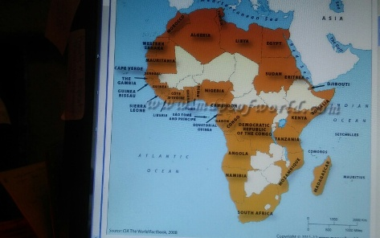

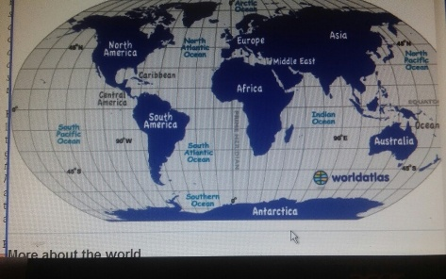

From Note taker: DAILY EARTHQUAKE FORECASTING PROVIDED AT THE FOLLOWING WEBSITE:
https://www.youtube.com/watch?v=53WRDJJrsSY
Look up Dutchsinse on the internet for more updates.
https://www.youtube.com/watch?v=JU_kGOCIuok

PUBLIC TEACHINGS FOR GARDENERS AND GROWERS
Dear Student, KF SSI Education is proudly presenting a new series of extra teachings that will be delivered by Lisa and Jimmy MacDonald from Australian continent.
- For Public Teachings for Gardeners and Growers in English join the meeting ID 921-749-720 or click https://zoom.us/j/921749720
- Public Teachings for Gardeners and Growers in English are scheduled each 2nd and 4th Sunday of the month, starting on the 27th of November 2016 at 8:00 AM UTC or 7:00 PM AEDT (Sydney, Australian time)
- Teachings will be recorded and published on education site as well as on our official YouTube channel https://www.youtube.com/c/KeshefoundationOrg

Calculate your local time with http://www.worldtimebuddy.com/ Good luck to Lisa and Jimmy! We wish that you raise global awareness and bring us lots of new students to the regular study program as well as those that dig deeper to the special Private Teachings for Agriculture headed by Dr. Gatua wa Mbugwa. Enjoy learning and do not forget to teach others what you learn.

Stanley Christmas KF SSI Education

