Transcript of 156th Knowledge Seekers Workshop January 26, 2017
https://www.youtube.com/watch?v=rmcKwio-fc4

Transcription v2 courtesy of Lynn of Montana, with introduction, hyperlinks etc. from Corn of NZ, and then final polish and edit by Michel of Quebec for publication on www.transformacomm.com where the whole transcription can be downloaded in word or pdf format.

Comments by Cornelius van Dorp

This landmark workshop completes 3 whole years of weekly Knowledge Seeker workshops with not one week missing. It starts with some details of the Austrian hacker who has been working against the Kf, and then there are some updates on the developments in Ghana. Jon Bliven of Arizona shows two more videos on his spaceship development and we can now see that the spaceship has left the floor of the factory. MK gives his interpretations of the spaceship structure and relates it to the structure of the souls of horizontal and vertical people. There is also a report from Justin and Heather about the protests at Standing Rock and MK gives his advice on how to deal with the situation without fighting, as well as some tips on how to use the Gans for protection against the cold weather. Jacky shows a video of a Frenchman who has created water by interaction of GANS and MK explains. Finally there are some questions from Wanqing of China about nano gans and plasma fields, and an update on the contamination issue at Fukushima.

Content Summary

Introduction and information on an Austrian hacker who has been caught red handed trying to damage the Keshe foundation

Kf Ghana has received it’s location on the property

Kf as of this month has entered into the industrial commercialization of the technology for farming.

Jon from Arizona has the spaceship off the floor

We are attempting to build the consciousness of the Spaceship

Kf has been given a gift of 50,000 sq meters of land to build the first flight platform in Africa

Testimonials are Important

The Kf Ghana building is owned 25% by the Ghanaian Nation

What are the pre-requisites of attending for a plasma degree or joining the research and development team and what language is spoken?

Jon Bliven plays his 2nd video and MK explains the void in the middle

It is important to understand the application of these teachings to the structure of the soul of the man, and how that relates to the structure of the soul of the vertical people

Heather and Justin give an update on the standing Rock protests

Some tips from MK on controlling the environmental temperature

MK: My ethos has been not to fight; fighting takes too much energy.

The Situation at Standing Rock

Alekz says he has used CuO gans to keep his feet warm

Jacky from France shows a video of a French knowledge seeker creating water

A question from Wanqing of China concerning nano gans and fields

W: so the question is if we want to use the gans in the reactor for the rotation is it necessary to use the plasmatic measure of the gans?

Worries from the Japanese group about contamination of the ocean at Fukushima

Rick: thank you very much Mr. Keshe and it’s been an honor to work with you for these 3 years

Transcript

Introduction and information on an Austrian hacker who has been caught red handed trying to damage the Keshe foundation

12:35 minutes. Rick (R): Well … that’s our new introductory video, thanks very much to Flint for that! welcome to the 1565h KSW and to hear Mr. Keshe (K).Today is a very special workshop as it’s the 3 year anniversary that we started the KSWs.

1341 K: Yes, good morning, good day to you wherever and whenever you listen to these teaching. You are exactly right; this is the 3rd anniversary. Up to now we have not missed a single week. It is interesting how we gather knowledge. I was thinking today what has been achieved after 3 years’ hard work. It is good to celebrate the gaining and processing of the knowledge. In this time we have learned a lot about human behavior. In last week’s teaching we explained the facts about Dirk (DL). This was done deliberately to bring out of the woodwork the criminalities that are going on around him and the way things are done. If you go on the website about Dirk you will see the information that has been released this morning.

1447 K: one thing is that the gentleman who has admitted directly hacking the website of ‘facts about dirk’ by putting a notice that this website has viruses. This is what he has done all the time and we were looking to make a connection between him and Dirk and that they are collaborating. In the bottom part of this new revelation we see that they clearly state they are calling the police and state governments wherever they can. In a roundabout way they use 10 different names. This gentleman is about 70 years old and he lost his brother in circumstances that they had asked Keshe Foundation (KF) for help which they could not do. At that time the knowledge was not complete and he went on rampage to take revenge on the KF with these people including DL.

1548 K: in all these attacks you will see children were threatened by this gentleman and another associate. We have managed to release this information, his name, his address, the attack he has done and all his computer and telephone communications. He is the guy who made a threat to the child of Alekz. He is the guy who made threats to the children of other people. This is the pattern of pedophiles. If you look at what the securities have released these men talk about each other and say they are going to call the government of Ghana and this and that. Then you see a strange name appear and you think we are wrong. These are the hidden communications we have been monitoring in the background. All these communications have been spoken about with the Austrian police regarding the arrest of this man.

1654 K: all his communications, including telephone, have been downloaded by the Italian securities and Interpol because he is a doctor in computers and he has been hacking all the computers that we have had damaged and lost. He has come onto different teachings and he calls himself doctor computer as he has a doctorate in computers. But he has stepped over the line by making threats on children’s’ lives. The police and European authorities are taking this very seriously and his computers are monitored. We turned this information over to the police 6 months ago.

1735 K: you have every right to know his name and address. Call and write the police and let them know this man has hacked your computers and made threats against your children. The address and telephone numbers of the police in Austria and Germany are on the site. Furthermore you can write and talk to this man directly. His telephone number and information are released and are on the internet. This has been done deliberately by the securities to let people know these people are involved in hacking. These are the supporters of DL and you see them communicating directly and what they have done—we have terabytes of screenshots. There are no allegations—we have them and now the securities have decided to release them because we are looking for the next steps of ‘leaks’ and other things we are looking for.

1838 K: from the KF point of view but now securities are finding this doctor has been threatening and we know he has made at least ten threats against children of KF supporters who withdrew because of the threats they received. Now you know who this man is and he appears across the internet with different names. He uses numerous names and when they checked on these, his name is “Robert” and Varily Kawinki (?), Martin Singer, Sherrie Holmes, Short Visit, Chris Anaya, and other names. We have and you will see his home address and telephone number that are published certain things across the internet that we have been made aware of. The only thing to do is go and look for his name. It is called ‘Doctor’ and the address. His name, you will know, his phone number and his address have all been released on the internet.

2018 K: Sir Robert we have been watching you and we have seen what you have done. The police are very interested to talk with you and go through your computers. On this communication that we see now is that you admit fixing a hoax on the ‘Facts about Dirk’ as you are a hacker. We have all the details of your schooling from 1951 to 1961 and previous addresses with 34 at the end of it and we see what has been released in Austria. The police near you already have the full details on you works in threatening children and hacking. If you cannot find it, there is an email at the end of ‘Facts about Dirk.’ Fill that out and the security people will respond to you and direct you in where to go to place your complaint.

2129 K: Interpol, the European Police Security, the Child Trafficking section and the Austrian Police can be seen at the nearest station. Their email has been attached. If you lost your computer, you got hacked and had to change your computer in the last 12 months, and if you receive new threats against your life and children as has been done against Alekz’ wife and child. The man can claim he is demented. All his communications since June 2016 have been clearly watched by security services and now we release his name.

2222 K: There is a series of private telephone numbers that Interpol has and they have monitored all his telephone calls in the past few months. We talked to securities and the information is clear: it’s the same pattern of work as Sterling. You see clear communications between DL and “Mr. Robert.” On the other hand you see other people who appear in the same places living in Germany and working with some in Italy to create mayhem at the KF. This is what we saw in the work with the Italian newspaper and this is following the structure that we found in activities around the world.

2325 K: it is all the pedophile activity. When you talk to a man you threaten the man, not his children. So, Dr. you have been busted. We have your name. Go on the internet. The securities have told us that tinyurl.com/pc-doctor. You will find his details. Or go to tinyurl.com/amad20110. Write to him; the police are available. If they made a threat against you the doctor has to answer to the police, especially the Austrian police who are informed about this. We have talked with the Austrian police and the Italian police and national securities as this crosses borders and they are informed about the situation. Now we see what we told you from the beginning: a gentleman called Sylvester was part of this and you will see what they say.

2445 K: We have called in the Ghanaian government and their securities are providing the details. It is very interesting. We are fully aware of what you are doing. The governments are looking at this because of the threats made to children and the computer hacking and downloads of the data and the mayhem he created at the age of around 70 years of age. But now doctor you need the medicine and I think that medicine sits in a jail for you for threatening children. You have confirmed that you have hacked and you did it after last week teaching and you put the hoax about virus on the ”Facts about Dirk.” You are very proud of this; we are watching all your communications.

2542 K: we have taken pictures of all. We are ‘sitting in your computer.’ You thought you were watching us all the time when we were watching you. That is something that is in the European Court of Justice. We stay out of this because it is the jurists’ role in criminal cases. If you go further on the website it explains a lot of things about the facts you will see a new revelation when DL infiltrated a guy who was one of the top politicians in the Belgian government who took steps against the pedophiles. This same ‘Dr. Robert’ has broken into a circle in the political party and put slander against the politician.

2635 K: our securities are watching a lot of things and the same wording is used. They have found these people that use this wording are very, very effective and people consider it. Mr. D. L. uses these words in all his accusations against anybody else. He accuses everybody of one thing. And, the strange thing is that in these writings he has clearly indicated that is not true is calling others a pathological liar. He calls Mr. Keshe and someone else we saw last week ‘pathological liars.’ He uses these words and puts this in every sentence. Everyone is a pathological liar except DL. So it shows the state of his mind. So Keshe is a ‘pathological liar’ as is the politician in Belgium. Everyone he infiltrates he says are pathological liars. In August of 2013 his writings about Russell were the same in “Facts about Keshe.” We see the pattern of the work.

2800 K: interestingly enough the two, the doctor and DL, are collaborating together to damage people. They can be connected to each other. When you read about this ‘doctor’ it says that his style of writing show Linux Master Board some years ago using the virus, the user name. at that time he advocated and fought against the Linux operating system which he says is endangering his work as a PC ‘doctor’ and a specialist in Windows. It is own writing that they are watching to see if he is involved in raping children. The Austrian Police, the Italian Police and the international securities are looking at his connection with the pedophiles and how he hacks into children’s telephones. Out of nowhere he is calling children.

2912 K: He is 73 years old and is an Austrian using the multiple names. What we see is that he is a cyber criminal. Give this information to the police. The police links are mentioned and the police in the stations near both homes need to be called and shown your information so they can connect these links. They will make the portfolio and the police are aware of the computer doctor. Maybe in the world of pedophiles it is legal to hurt children. You don’t threaten children and you did that to Alekz’s wife and child. You have threatened children in Austria.

3024 K: Now your information is downloaded. Try to destroy as much hardware as you can; everything has been kept on screen shots and on the internet; you cannot destroy them. We have phone numbers and they have been monitored. If you want I can read the numbers out. There are 5 or 6 telephone numbers that has been monitored. We told you several months ago we were going to release information to the security people; it has been done and we have done our job. You tried to destroy the KF by working under your brother; don’t think we didn’t see what you have done--if there was a brother. This is the pattern of the pedophiles.

3112 K: as we have said we are going to release more names and more and more names and details as the securities tell us. We read it; it has nothing to do with us. We advise to read and understand exactly how they communicate with each other. Most importantly, just click on it; there is more information in the background. And read it; it is interesting how he infiltrates organizations and then he writes about them to discredit them. Release the names of the people who were abusing and killing children. He was given a video of it and then his bosses told DL to infiltrate and make sure the political group does not come up. He did that. There is a lot what has been written about me that many of you translated is a copy of what he has written about me.

3214 K: he pastes and copies. We see a pathological liar, which is DL. What he writes and accuses people of, is what he is and writes in every sentence. Interestingly enough they have released a picture of me and the King of Belgium. The king is standing in the background and you see the Queen of Belgium standing on the other side. This is where I was writing the book. The fourth book, which has not been published yet. I was casually writing and the lady on the left is the ex-queen of Belgium. The man on the right is the ex-king of Belgium. Immediately after this meeting they started threatening and the attempts to kill me started.

3318 K: it became so intense that we left the country. This is a casual location because DL was on my left and only two people were writing my book. On a Sunday afternoon it is strange that the King of Belgium came to see a man who was an unknown writer. That is very unusual. A king does not do this. Now you see the position. The man in the gray hair and clothes, bless his soul, was one of the top herbalists in the world. It was a pleasure to know him; he passed away a year or so ago. He had the whole essence of knowledge of herbs from Africa into Asia. So now you see how this is all connected. Just click on it and you will see a lot of details in the background the way the security people have set it up.

3415 K: Please write to the German and Austrian police stations and let them know if your computer was hacked or you received threats against your children. They just need to tie up all the links together. Internal police investigations have already started against this man in Germany and in Austria. (34.34 minutes). He made a grave mistake. It was prearranged to do this last week and they feel so confident they started writing each other. This is how it happens. Sterling did the same thing in the US. When they feel safe and think nobody sees them they start communicating and you see the screen shots. They tell you how they are hacking the computers and the telephones. Now they are being investigated. Computer doctor is a hacker and he shows how he is hacking.

3515 K: A lot of you went to look at the “Facts about Dirk” and you got a popup that said there was a virus and that frightens people. Frightening people is his job and this is his pattern of working. We have all the details of “Mr. Robert,” the computer doctor and we have all your telephone numbers and address. We shared the information with the police in June, 2016. Now the security people have decided to bring in the police. We have monitored your telephone numbers and you are ‘gravely sick.’ A man who threatens children needs to be somewhere that he cannot use a telephone or a computer to threaten children. All your hardware, Mr. Robert, has been downloaded and copied by the intelligence services. You cannot claim “I didn’t know” or “it’s not mine.” We have been watching you for 6 months.

3625 K: now let’s go to another point regarding the KF in Ghana. We told you that you are busy writing about KFGhana and you are very busy writing everywhere and we are watching you in a manner of speaking. We needed evidence that you are working in that way. We have informed and are talking to the South Korean police and intelligence services what you are doing in South Korea. They are watching and you are not making threats and you cannot send communications in which you are lying. According to the Korean Securities our nation is clean. The police are monitoring in Korea. We needed evidence that you were writing threats in letters and sending false information to different governments, which is a criminal offense.

Kf Ghana has received it’s location on the property

3720 K: Going into the teaching and further extending KF Ghana has received it’s location on the property and in the next months we will bring it up to standards as one of the central research centers in Africa. I thank most of you who are supporting us in the background. We need to push with this as one of the positions through FDA and through the standard boards of different nations. We are bringing the technology to the front and we are supporting a lot of research. We thank especially the people in Tokyo University for their support.

3808 K: I have to thank a number of people who have worked relentlessly and unconditionally in the background with us for the last 3 years. The first thank you goes to my wife, Carolina, who has been there. She burned a lot, took a lot and she is still there with the technology and the science. The other people around us we mention are people like Rick, Vince, Stanley, Emma, Flint, Dr. Klaus, Dr. Rodrigo and other people working relentlessly in the background. They work to see the Foundation stays and we see people like Armen, who is relentlessly there and the Arizona people like Jon with their testing. It is enormous what they have achieved that you have seen in their videos. Some of you don’t understand the potential of what is happening in Arizona.

3926 K: There are hundreds of people who work in Holland, Belgium, Germany, America and people who are teaching in their own way, even Rome intheir own way. We see doctors and scientists working to improve different aspects. This is important and we work as a team. Without this teamwork it is impossible as this is not a one-man show but a whole world show. We are working as one team. It is important that we see another three years and more that the knowledge is coming so fast and so much that we can take it to new dimensions.

K: we are entering agriculture and if you have cancer and want to join the cancer trials please get in touch with the medical team through Dr. Klaus. The process of starting the clinical trials has started this week. We have a number of people who have understood that you don’t need an FDA even when I have explained to the FDA people in a couple of simple ways that we do not need to sacrifice the life and the soul of the animals for a man. They understood that we have to have respect and they understand it is people that have the (health) problems and we have to solve it through them and not through animals. Then we are raising the level of understanding of officials. Why should animals be harmed? When we get a sick bird or a bird with a broken leg that fell out of the tree, we nourish it. If we find a little animal that lost its mother we nourish it so it can grow. And then we inject animals with sickness so that man can be cured?

4128 K: this is wrong and animal testing has to stop. The science of the plasma technology is so high that we can now further the technologies and see the performance of the plasma and the interaction of the plasma with the medicine and the gans of the body. We don’t work in the matter state; we work in the plasma state. Then we see no side effects. If we see side effects through plasma then we can do something; we have to change the level of what I call the abuse of animals through understanding the technology.

K: In these teachings there must be a heavy amount of teaching to the top scientists so that they can filter this knowledge. It will take a long time to change what has been set up because it makes a lot of money for pharmaceuticals’ clinical trials. Hundreds of millions of borrowing and shareholding are used for this and people lose their livelihoods buying and shareholding these pharmaceutical fabrication medicines. The money disappears. With the new plasma technology we should be able to save the souls and the lives of the animals. Now we create the real life of the animal and we can interact. We don’t need to harm anyone.

4252 K: This is the beauty of the technology and what we are doing at the highest levels with the world scientists. Governmental and scientific researchers have to understand this is a new step and new technology. It is a new understanding and a new way of doing it. We used to use donkeys and now we fly with jets. We used to have obsolete animal test—that was like the donkey. Now we have achieved the ‘building of jets’ and we don’t need to sacrifice the lives of animals. I object even to what is going on in Tokyo with the research.

4344 K: But at the moment now that we can the plasma environment can change the cell and we can see a list of the conditions of returning to the original condition… now why do we need to sacrifice and animal—a pig, a cow, a mouse or a rat? These things will take time to go because there are a lot of people making a lot of money out of this that they have set up. They are not going to go easily. On the other hand we don’t fight. We introduce a new technology and the way it is done it just naturally takes over. You will see in the Ghana KF management team the top scientists of the nation. They want to be part of it and they have asked us to be part of it. They want to be in it. They are in it and they see the solution. The reason we are so successful in Ghana and now we are going into Nigeria with Alekz who is one of the people I have high respect for. He will be with us for several hours in Accra for further development and working with the new scientists and researchers to extend this understanding.

4520 K: we are making Ghana an African center for world research of technologies. This is the way it has to be and this is how we have to change the course. We do it by example and not by fighting. We showed the top scientists the work and we show people the results by people they have respect for and who have used the technology. Then the rest is okay and they want to know how they can accommodate it. We see the same thing with the energy and with everything else. As you know in Ghana we have a huge energy crisis. Here the shortage of electricity for industry, hospitals and government offices is great. We have the solution to change and we are working with the government to do it in a way that it does not bring the government more debts.

4618 K: the biggest problem is the compensation and buying of energy units in the hundreds of millions of dollars. This would put the nation in debt. With the new technology you don’t need to be in debt. The government guides people and in a way the nation together walks the country out of debt through energy. Energy costs millions of dollars for the country. A few billion a year is used to purchase fuel to burn for energy. You don’t need to do this. The new technology is available. In the next couple of weeks we release the technology which is partial and is not part of the Keshe technology, but it is given to us by the inventors and we can adapt it to the use by the plasma technology.

4707 K: the system has been running for a couple of months plus and producing 10-25 Kilowatts of power in a free standing unit. We are talking and working with them and the technology will be able to be released. We are adopting it as we are doing with the solid state generators. These are how the collaborations start with people who really mean to change the science. KF will not only stand as plasma technology in what we do. We add scientists who have been silenced where they can have a word and show their knowledge and technology amongst us.

4750 K: this is how the future has to be. It is not just that all the solutions sit with our people. It sits with humanity and where we see the change can be by silenced technologies, we give a platform. We have to; this is a new world condition and this is change that has come. We will announce in the next few weeks. I have seen the operation of the system and it’s a beautiful system. It is a generator on its own that is built by a group of scientists. And KF has given them a platform to bring this and this will help immensely in a country like Ghana. We don’t have to borrow from nations to build a dam. The nation builds its own system to support itself. There is no borrowing, just adding to the GDP with capital investments.

4850 K: it has become part of the investments for other countries. The third edition of the Magrav generators will be tested this week. Hopefully this is correct and everything is correctly done. I discussed this with Armen this morning and I said that we need to test our things internally. Then we don’t have problems created for us. So, there are a lot of people around the world who have become part of KF and we are progressing and thank them. In the 3 years we have reported progress this is the shining star of what we have achieved. There are many testimonials, there are many systems, there are many people reduce their pain and save their lives by using the gans materials to save their lives from cancer.

Kf as of this month has entered into the industrial commercialization of the technology for farming.

K: many people have seen an increase in return of their materials in harvesting. KF as of this month has entered into the industrial commercialization of the technology for farming. If you are a farmer and you are looking to increase harvest or if you are in animal care, we have developed technologies where you can eradicate many conditions. We have been talking with farmers in the last couple of days and it is interesting. There is a huge problem in Europe with the limitation of the amount of manure from animals that can be put on the land. The rest of it costs billions of dollars for the farmers and the governments to be shipped into Russia. You see a lot of boats anchored in port. You see a lot of tankers driving on the highways of Europe. They are carrying animal manure to the Russian border. The reason for it is because of the toxicity and nitrogen levels.

5106 K: we will start measuring what we develop for the farmers. By their not using antibiotics and reducing the food consumption because of continuously feeding dry food, and in their being able to give a different emotional feeling to the cows or the birds, we see the level of nitrogen drop into the standard European levels. So, if you can achieve what was started by the trials in Italy in the next 6 months, then we see that billions do not need to be shipped across Europe. The manure can be used directly in the farmland with fewer odors. With what we can add from the technology, the odors will die.

5200 K: If any of you have lived in the farming areas in Europe, you will see when they get permission and the farmer is allowed to spread the manure on the land, neighbors for kilometers cannot stand the smell they breathe for a few days. By reducing and adding materials which we have into the manure, you destroy the smell and you reduce the nitrogen levels. Everything goes back to the way it was in the olden days. The antibiotic levels reduce; the comfort of the animals will change the texture of the meat. We have seen this before.

5236 K: now we are doing this with collaboration with farmers who have from 1000 to 2000 or even 10,000 cows. We see the farmer reducing his bill. A farmer in Europe with a thousand cows has a standard expense of 40,000 euros per year for antibiotics for his animals. That is 800 Euros per week. Every animal that sees 10 cents of antibiotics and these antibiotics breed antigens as they stay in the bodies of the animals. We are the consumers of the milk and the meat.

5328 K: then we see how the change in the environment and in pressure the digestive system of the animals will change the behavior of the animals. The meat and milk will change and we are looking in the test trials to see the extension of the shelf life of the milk and the animal because of the bacterias created inside. The antibiotics use gives a limited life span and doing this change will extend the lifespan. (53.57 minutes). The trials with the farmers in Italy have given us a huge opening in how we change the animal care.

In Ghana we start the process in the next couple of weeks, looking after the trees, coca trees is one of the biggest sources of income for this nation and the national income from coco has reduced because of the infestation. All we need to do is to change the environment; we test it in the next few months and release the data… Mangoes are effected, and in Italy we see the same sort of disease, Olive trees are dying we see problems with the wine, and orange trees across Africa because if not having the money … Now we have offered the help of the Kf – we change the environment, we don’t come to change the animal. And we see the changes increasing the production, the income of the farmer and the income of the nation. This is how we are going to have an effect and how we are going to we are not spending multi billions on pharmaceuticals; we are simply using gans water. That is how cheap it is to change.

5539 K: in Europe you cannot do everything because of the Lobbyists. In Africa the farmers see their income and yields increase and FDA has no say in what the farmers use. A tube of the CO2 gans water can change his life. He can’t put his child in school when the harvest is at 60%. When the harvest is 100% his child can go to school. The child gets an education and he can put clothes on his back. This is where the change comes in Africa. In Europe the banks control everything; in Africa the change is a reality. We post these things and this is the beauty of KF if you understand the work of the foundation and you can replicate it in your countries.

5630 K: we brought in masters degrees and highly educated people to work on the floor in the factory. Now they have learned and they can see, they can feel the energy and understand what the system does. Now they are coming up with their expertise and testing things for pain, coconut and everything possible to see how they can bring change for their own country and their own animal care. This is why we came to Africa, to get to the root of man and not to fight, get bombed, shot at or poisoned by people who are like DL because they want to make money out of it. This way people make money, huge amounts of money out of it but as one race of humanity. The money made by the farmer gives him enough to feed his child because he has the harvest and money to feed. This kind of income happens around KF world wide.

5740 K: this is our profit. Somehow by the will of God we go from one point to another. We will survive. We will be there. They ask me why I share so much when I could make billions. We have already made billions as one Nation. This is what we have achieved in the past 3 years.

A lot of you are looking for the flight system. When humanity is ready, the flight system will be there. But we still work around it. Jon are you there? He will show you something very interesting. Let me explain. They started if you remember measuring fields about 12 to 14 feet. Last week they went outside for about 50 feet and the field has expanded to across the road to about 80 feet. It is expanding. The electronic system is the strength on the electron level but they also use the field interaction with the feet of the man that closes the circuit. This is something very interesting. Thanks for being there Jon, and thanks for all your efforts.

Jon from Arizona has the spaceship off the floor

5936 Jon from Arizona: I’ll show 2 short videos. What we are doing is a big deal and it’s what our hearts call for all of us to do. What we have done here is we have done some modifications to our spaceship and one that we have done is to add booster bars into the configuration.
K: please explain what the booster bars and the reason for them.
Jon: the booster bars are ½ inch copper pipe and we have nano coated the inside of the copper pipe. We have left the outside totally copper so it’s only nano coated on the inside. It’s similar to what you referred to as the hollow core when we take out the copper wire. We put gans oxide material on the inside and we wound on the outside the nano coated copper wire and we chose CH3 to try to pull out the fields and bring those fields that we pull out into the mixed field plasma that we are opening up. Let me show you on the video

(Video: 1.01.48 minutes).

David: we have the gans and capacitors set up and we did it this morning. We can change the speed on the motors. .. etc (difficult to hear what he is saying)
Jon: we have to listen.

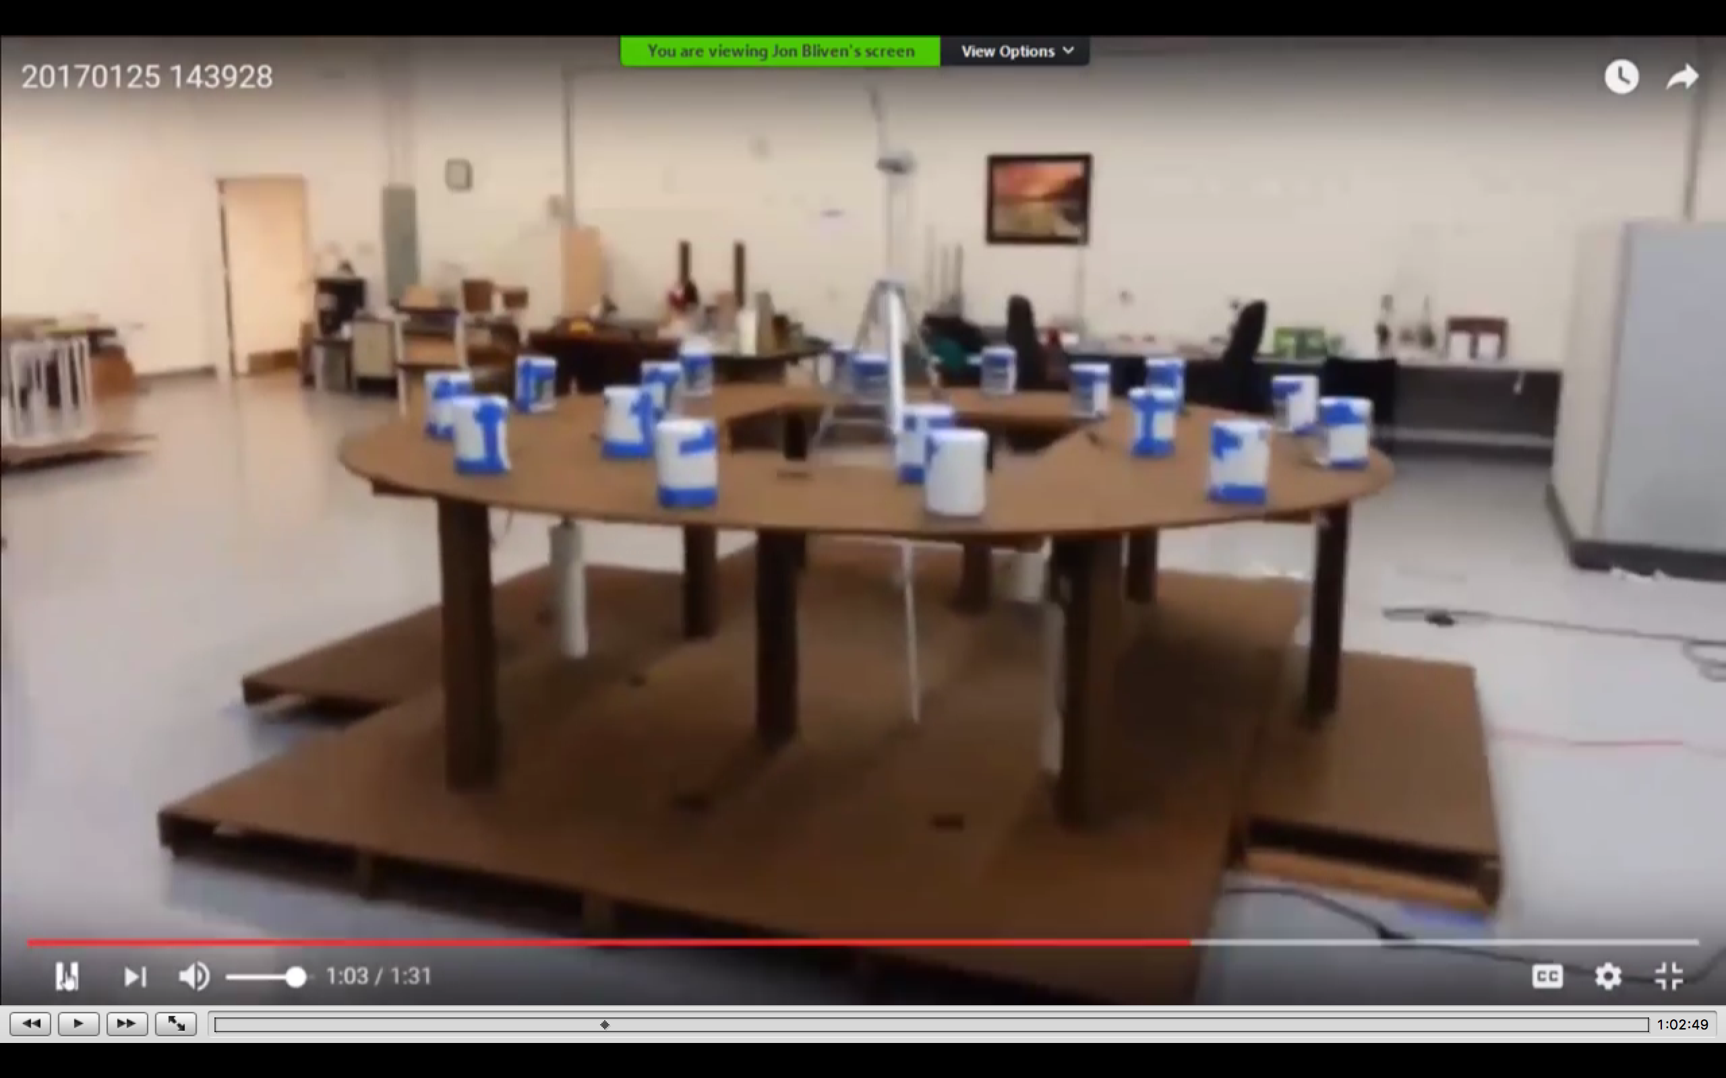

David: I will turn this on and this shows the difference of the fields.
Jon: the motors are picking up in speed. You can see the speed is changing quite a bit and they are going a lot faster. The field size is still about the same about 14 feet out.

10322 Jon: what was interesting with that was that the violet ray was about 20 feet away. We turned it on in the background about 20 feet away and when we did that the motors increased dramatically, not just a little bit, but dramatically. If you recall on the other side of the facility here we have the set up where we have all the magnetical coils connected together and the gravitational coils connected together. We have that also running. Here with the measurement around the fields they are about 14 feet out. In the next video you will see they are more than 14 feet out and much much stronger. I was shocked at how much stronger they were. Give me a second and let me pull up that video.

10456 K: what is interesting in what Jon said about the fields that were running when they put the plasma booster motor on? This very interesting. Why does it do that? Because the field strength adds and overcomes the matter state. It is the freedom of the core, which is creating the faster rotation. You hear the motors building up and there is something else that you have just seen and that was the new structure. If you can show the video you will see a difference; before the Magravs were on the floor. Jon has raised them. The video shows John checking the fields with the dowsing rods and they are at 75 feet out.

10610 K: what has happened is Jon has raised the platform of the controlling structure with the Magrav units. Now they set on the condition of the structure. The 3 star formation cores are placed underneath in a specific configuration to create the field contraction. The top reactor is hanging on a tripod. So what we see now is the structure set up that is as far as possible from the platform on the floor. There are hidden things in the background like the floor underneath the configuration has been painted with gans material, the gans water to create as much isolation as possible from the earth’s magnetic field so we can create the first boundary level. The wooden floor has been treated the same way.

10720 K: so we are trying to create the shield separation from the top and the Magrav units, the gravitational units and the cores. This brings us to the closest possible way to be able to create the space ships. These tests are just tests and you have to understand the reason why you sometimes you might see shadows and shapes. The reason for this lack of creation of the full structure is the drainage on the system. The drainage on the system is not so much environmental. It is through the wire connection to the grid. The lines that are connected to run the motors are draining plasma in the feedback that is more than what is put in.

10820 K: so we are not replenishing but feeding into the grid the Arizona energy. One of the reasons they cant dssee the solidification and can see a small increase in the fields with the plasma maker making the change is because whatever is created and is holding and building up, most of it is getting drained through the power supply lines. So the next step for us is to equip Arizona with a self-sufficient lasting system, which will be done in the next few weeks. This means all the generators will be internal and all the fields will build up inside. Even the generators’ back up battery will be energized by the field inside. This is the time when we expect to see the first generation of the spaceships. The energy feeding lines are the causes of the draining of the fields. The minute that is achieved then the structure is completed and you will start seeing a better configuration of the structure. The interesting thing is that we will see different performances from the system according to the fields it creates. This has been shown in the other videos by Jon. (1.09.50 minutes)

We are attempting to build the consciousness of the Spaceship

Jon: before we get into this video let me share something I shared with the Universal Council core group and Sandy. One of things we are doing and this is all the work force in Arizona is that we are attempting to build the ‘consciousness of the spaceship’ just as we are building the knowledge of a baby. We have named the spaceship “Hope” and I have told people when they go to bed at night and are having quiet time, to send loving energies to Hope and the belief that we she is going to materialize and help move humanity forward. I am asking that the rest of the collective join with us and send your positive loving energies to Hope. You can do that wherever you are and simply send those energies from your heart and consciousness in the direction of the spaceship and know that you can do that. So with that let me show you how big the fields REALLY are - our whole building is sitting in a plasma field now.

11137 Video: this is pretty amazing; David is checking with a dowsing rod and there is the front of our building. The spaceship is about 75 feet back and David is way out here and his still checking…” (1.12.00 minutes)

11200 Jon: so that was over 200 feet out and he went all the around the building. The outside walls of the building are concrete block and even through the 8 inch block the fields were just as strong. So this goes through block walls and this encompasses the whole complex. If the fields were a little bit stronger we would be impacting the coca cola plant across the street. So it is pretty amazing how large have grown. The booster bars have opened up another 75 feet so they seem to be helping quite a bit. You can only see the total field strength with the dowsing rods and we don’t seem to be able to pick it up with the field detector which is set at 14 feet out and 14 feet high. So it’s like a big bubble now.

11331 MrK: This is correct because you are draining through your cables. Your power supply would not allow it to happen. You are feeding a lot of plasma fieldsinto the grid which down the line converts into energy for someone somewhere. The interesting thing is that you say you can detect the fields with the dowsing rods. If you remember we go back to an earlier video where the dowsing rods were showing the field around 14 or 15 feet. With the increasing it was beyond the walls about 60 feet last week. Now we are about to 70 to 75 feet and this is the radius. So if you look at this your total spaceship has a total radius of around 150 feet.

11335 Jon: we were 200 feet out when we were standing by the Coca Cola plant.
K: is that the radius or the diameter?
Jon: We only went in that one direction because of a wall.
K: then that is 400 feet on the diameter. This is huge. This is 120-meter long spaceship in diameter and it is taking shape. Don’t forget that now the structure is inside a confinement. So how you see the fields at that level is because they are above matter level. By the time they reduce to become matter level they are at 200 feet. The building of the shape of the craft in that room will be in that room unless you create fields above the matter level, go through the ceiling and then manifest yourself which is very easy to do. A lot of people might think they built the spaceship inside so how are they going to get it out?

11548 K: that is very simple. I will show you the next step that has been done in Iran. You don’t see a craft anywhere. You can put all the satellites you want to look for it everywhere. You have a big industrial building and you build your craft. You change the boundary and the boundary and matter level of the roof that you chose at the point of the design of the craft. Out of nowhere the spaceship appears, but you actually confined it inside. I gave a hint a few years ago and now Jon can go back on that teaching.

11636 K: The test flights for countries like Iran is not near the desert and nobody monitors and we don’t need to. In so many ways we don’t need the oceans because we can always retreat onto the desert if anything goes wrong. We chose the position of Descanzano and Barletta, and we clearly explained to the authorities that we needed to be at sea level so we could do test flights. In Arizona it is the same; you can lift off and you go through the ceiling and create fields, which are now above matter level and you have confirmed that. Now through the same thing you go through the ceiling (as you did the walls). The matter condition of the ceiling barriers becomes irrelevant. This demonstration of what we have just seen with Jon and David is a clear indication of what is to come and you should have understood this.

11744 K: those of you who understood, now you understand that this is the aura of the system. Now you can change the aura to the solid condition. Or the aura can be at the strength of the matter state of the copper and what you chose as the ceiling, so the two have no interaction and you just go through the ceiling. What you are showing is beautiful but it is good to understand the knowledge behind it and what the science is. Anything else Jon?
Jon: that is it for me.

11824 K: I have seen a video where you have a hole in the field.
Jon: yes that is true and that was kind of strange.
K: can you show that to us? (1.18.42 minutes)
Jon: let me pull that up.

Kf has been given a gift of 50,000 sq meters of land to build the first flight platform in Africa
11848 K: the principal of the flight is the ultimate goal of the KF. As I said that with all the calls that Mr. Sylvester and Robert and others are making with threats we have been given, thanks to work from Benjamin, Ghana Atomic Commission and the rest of the team, the KF has been given a gift of 50,000 sq meters of land to build the first flight platform in Africa to be used as a launch platform. This was given to us by the authorities and we had asked for it a couple of months ago. As a surprise last Friday when they gave us the contract for the building we are moving into, they gave us the land to build the first flight platform in Africa in Ghana. We thank them for that and we will build our own space station. The land is in the secure zone and it is a pleasure to be trusted so much.

12022 K: we thank the Atomic Commission for giving us the space for the factory to increase production. This again was given to us this week. We have taken over 66,000 square meters of covered area that we can go into production and add to the production. So the KF Ghana, the more we are here and the more the governments and leadership see how we are adding and expanding, it is literally bringing the whole Ghana team to work together and support us in that way. These 50,000 sq meters of land for the first launch pad for the spaceship is a huge breakthrough. We are given the title to the property and they are transferring the deed of the land into the KF Ghana and the shareholders. They trust us so much and the building that we were given I think I shared it with Rick… Rick can you show that please…

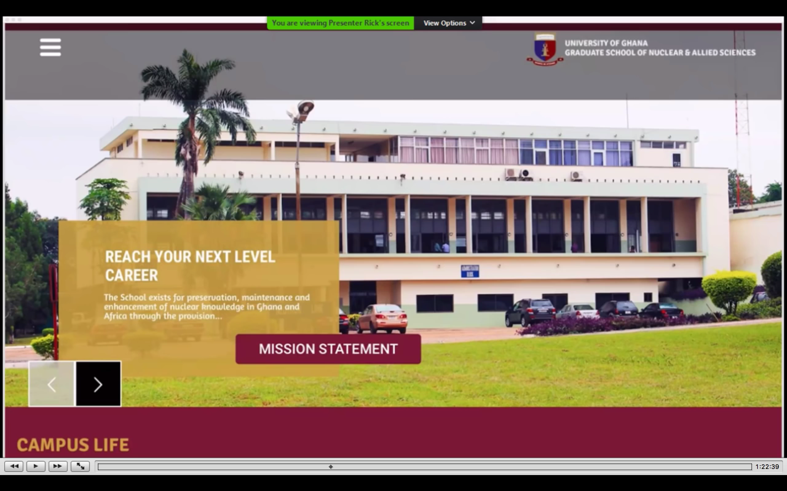

12224 K: This is the new headquarters of the KF Ghana. We have taken a contractual position as of last Friday on this building. The ground floor is for lectures and theaters. The first floor will become totally the research center for all the Ghanaian governmental institutes in research and development in every aspect. The beauty of this is that this is a huge span in what we call the structure that was built by the Russians. It allows us to build what we call one of the top research centers in Africa and we have invited all the organizations and anyone involved in research and development in institutions. We are meeting together and we have done 2 or 3 meetings up till now.

12319 K: Whatever expertise and systems they need are going into this building. If you want to know about physics, chemistry, space, or cosmology we have access and will put it in this building. We have access to more buildings. The top floor is the administration center of KF Africa. For all the coordination for teachings we have a section as part of the University. This will expand into the whole part and what you see now is the headquarters for the KF Africa and is a gift from the Ghanaian officials for what we are doing, and they understood the change. This is where you reach the next level in your career and strangely enough we are inside the University. So, whatever we do works closely with the nuclear research center, with the biological side and with everything else. This is the new home of the KF for years to come in Africa.

12430 K: this is how much the writings of Mr. Sylvester have helped us. Thank you very much for your lies; they see through them too. I hope your careers ends very soon. It is strange how governments have become wise to what I call these new developments and technologies. It is not easy to reach this building as it is part of the secure military zone. If you are not cleared for the military zone you cannot walk into this building. So we are part of the advanced research for the nation and we are protected by the government. This is very interesting for us. This building is on one of the main roads in Accra and is one of the crown jewels of the Atomic Commission and they see us at such a level of development that they think it is best for the technology to be so in front of the public so that they understand Ghana has a space program.

12537 K: we are not taking any scientists from outside but are encouraging the scientists to move inside and bring the knowledge back in. So what you see, and I thank the new Ghanaian government and the Atomic Energy Commission for such a gift to the foundation. The land that was given to the foundation is right across from this building so all the development of the KF—the factory, the research center, the University, the space platform—are all within walking distance from each other. We have called this part of Ghana research center where we produce gans material and where we achieve the medical (research). What we call the gans lab (?) has taken place in this part of Ghana in Accra. (1.26.40 minutes).The next step for us is the building of the flight platform and we build it much different than the 21st century platforms; we don’t have to build a launch pad. We don’t need one. You will see the structure as you have seen with Jon with the entry platform.

12705 K: when I explained this to the management of the Atomic Energy Commission they said that this was in the center of the city. I said that it doesn’t matter. It doesn’t make noise when it lands and it takes off. We have a huge area for expanding the space center. If you look at it, the land that you will see soon when we show pictures of it, will become the launching pad into the space program. As we said in our conference; we are leaving for Africa into the space ship program where we have full support of the government and there are millions of opportunities to bring the technology into every aspect of the health, the water and this is what will bring the change.

12755 K: in the West they have everything monetized and don’t allow for the change this way. In Africa they have nothing to lose and everything to gain. You cannot help their people with chemotherapy; it costs a fortune. Now with the gans it costs a few cents. For diabetes they have found a solution. I showed you the picture of the foot last week and I will show you more pictures of the feet of diabetics. After a few months they are marching in the military. We know the condition of diabetes and when the officers are with us they interview these people and they know most of these people. Most of the scientists have been to school together. They are from the same university so when their friend says, this is what has happened to me and I have improved. They trust and they know the change has come. This thing is not coincidental.

12854 K: I chose Benjamin a year and a half ago when he came to Barletta. I said Benjamin go to Africa and open it. When you see this building we call it Benjamin’s building because he created the center and relentlessly lives in the hotel of the atomic accommodations. He has helped everyone who has come one by one. Everyone has walked in, leaving containers and bottles of water at his door at night. He has built it so we can see the change. We are not talking we are just promising. Hundreds of workers at Atomic have been helped in security, management, health, agriculture and they have seen the effects. We have become part of the family and we are not outsiders. When these people like Sylvester said we were terrorists they laughed.

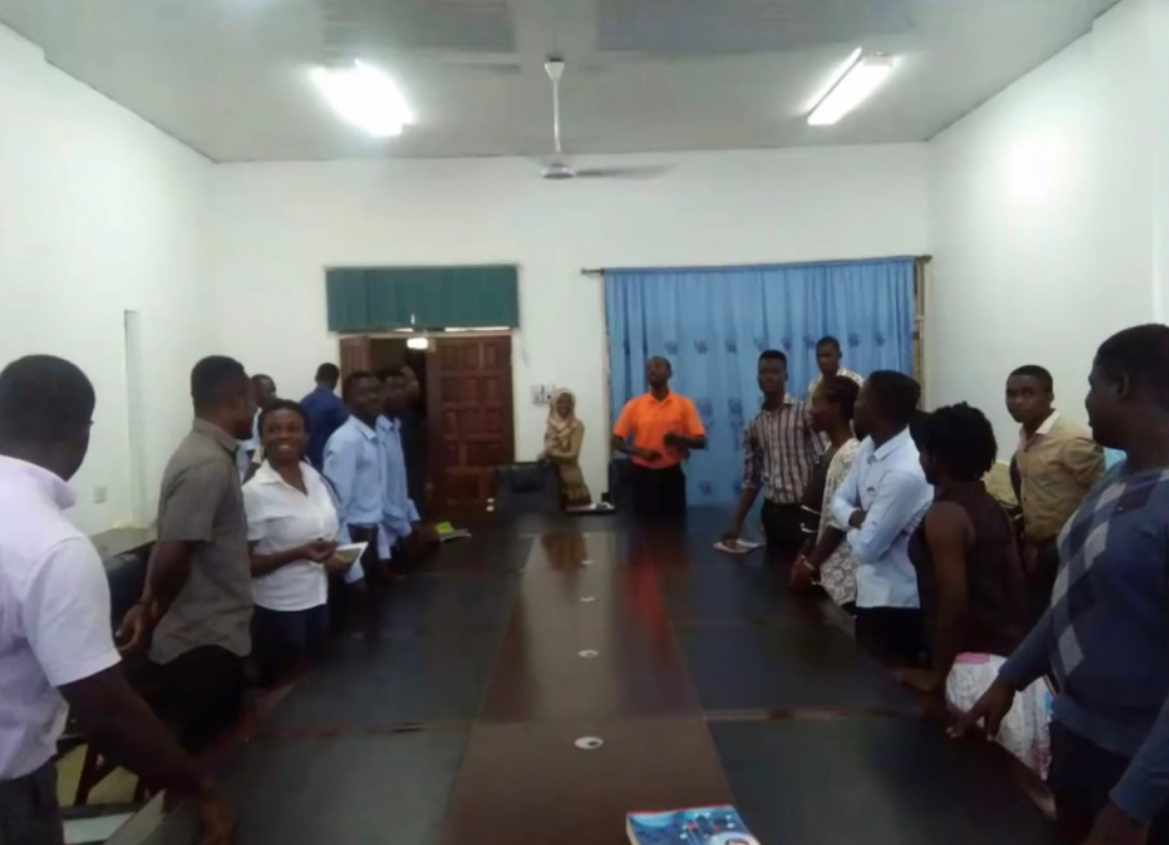

13000 K: they said to let the security handle these people (like Sylvester). Making false threats is a criminal offense. Now the groups of scientists you see here, some of them now are part of the KF and working with us. This is what we envisioned in the last 3 years. We have seen this, we have seen Arizona and the Philippines and we have seen research centers across China. You have seen the presentation of the work the Chinese do. This is and has to change so in the next 3 years we achieve most of our goals. We are part of it and we become part of space. You see the water treatment results that were presented as a paper in the conference. As you see it KF Ghana delivery of the technology. We are doing the same thing in Tokyo. We are doing the same thing across the world. This is an achievement for us as a family as every one of us has contributed something into it.

13128 K: the whole structure now is that Ghana has officially become not only a nuclear country, but with this land that we start building on Ghana becomes part of the space technology (1.31.45 minutes—map). We learn from NASA and the Russian and Iranian space agencies. We learn from the Chinese space technology. But instead of propulsion we use gans technology, which is much cheaper and more effective. This is what we have achieved and this is the first of many spaceship launch pads across the world. This is where we are going and how we sit now. This is thanks to all of you. You have to understand how you have helped. Today is what we call the delivery of the annual report of what we have achieved.

Testimonials are Important

13240 K: you did the test of a skin infection and you posted a testimonial. You did a test with cancer and you posted it. You have done something with food and you have posted it. These are important and the support you have given to Golden Age of Gans testimonials have to be connected to the KF. All the testimonials you are collecting, please give them to the webmaster connected to the testimonials of KF. These all help because the scientists talk and then see one, then two, then ten and a hundred testimonials. They see potential when they see what is happening in Ghana, China and other countries. The scientists are looking at the testimonials to find a structure to make them data presentable so they can be used.

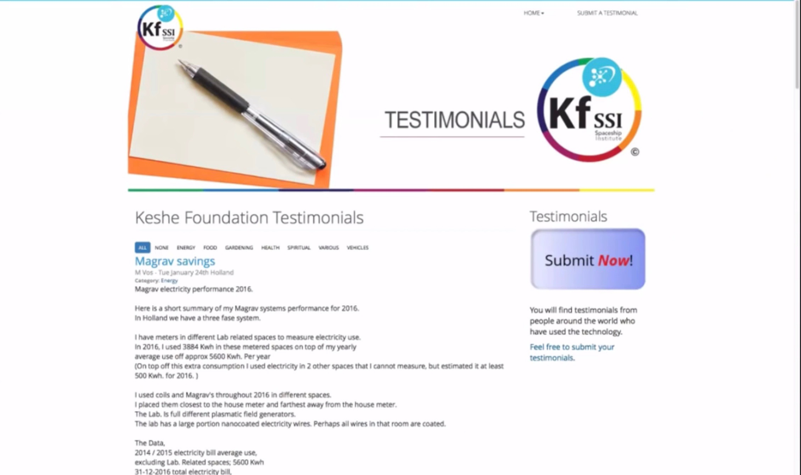

The Kf Ghana building is owned 25% by the Ghanaian Nation

13344 K: this building is the first step into setting up the joint collaboration of governments but being part of the government. The reason we are in this building is because KF Ghana is owned 25% by the Ghanaian nation. As I made the same declaration to Italy when the disaster happened I opened the assets of KF to the nation. We have done the same thing with the Ghanaian government. We have 75% shareholding but the assets and the income go to the nation. We take what we need to live but the income from the factory will be available for the nation for what it needs to pay the huge debts incurred over the last 8 years. We pay for the scientists, for the technology and development and for a lot of research.

13448 K: I said to the leaders of this country that our share belongs to this nation. We are not siphoning it off or taking it off to hide it somewhere. Very soon the KF bank account will move into the central bank national reserve because they see the income and we have become part of the national assets. Now you understand why we have been given so much here; this is the way it has to work. We control the management because we see the direction we have to go so the nation understands. But the assets belong to the nation. The KF bank account in the coming days will move into the central bank as we asked. They have always responded. Then it can be used for everything else the nation needs. But we do have a control—it cannot be used for bribery or ‘over invoice.’ We encourage research and for scientists from Ghana to come back from different parts of the world to add to our knowledge.

13610 K: this building, the factory and the space center will add to the knowledge. In Ghana we have a couple of NASA top scientists who are Ghanaians. One has been appointed to a senior position in research and development. We will bring that collaboration and they will join us and take this to the next step. This is how it should work. We have Barletta as a center in Europe but under–used. They are just waiting for someone to do something. A few people are running the center and 2 or 3 people actually use it. It is left there for people or whatever. Here we have changed it and most of the people you see in the picture (1.36.57 minutes) work partially for Ghana Atomic and partially for supporting KF Ghana. It is the same company. They are most of the top scientists of the nuclear industry.

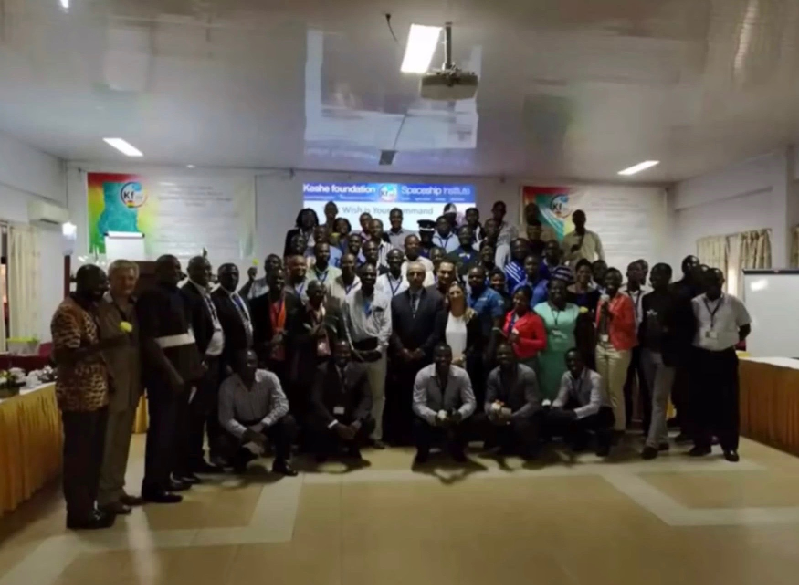

13710 K: you have to explain to a lot or people who have a fear of plasma. Explain to them that we had matter and then we came to understand atomic, then we understood nuclear. Now we are at the essence and we see the center that is more friendly and easy to use. KF belongs to the nations and we are One Nation where the knowledge is spread; this is our annual report and cancer research is going forward. For those with cancer we have to ask for a donation to support the research. It is not cheap; when we go to this level we have to pay the scientists and we have to pay for a lot of things. We have material at the moment for 50 (in the cancer trials). This process done by KF around the world is monitored by FDA. All the data is passed on to FDA. We have asked FDA officers why they have to harm animals (for research) while people are dying. They say we don’t know if it is going to work on people so if it doesn’t work on the animal we say it doesn’t work.

13832 K: they are doing it themselves and compared to chemotherapy it is less than 1/10th the cost of chemotherapy. We have to learn and understand new ways and as One Nation that is our job. The top management team of KF is taking a lot of pressure because of innovation. We need to bring the technology to a level and you see the investment is paying off. We are building the trust of governments and when we open the first groundwork for opening the first space research in Ghana the President and the ministers will be there. This will be in the next few weeks; the nation is proud of moving forward using their own scientists in space technology.
What are the pre-requisites of attending for a plasma degree or joining the research and development team and what language is spoken?

13930 Rick (R): people are asking if people from other countries can attend and what are the pre-requisites of attending for a plasma degree or joining the research and development team and what language is spoken?
13949 K: Ghana is an English colony and English is a common language and the official language is English and there is no problem here. It is not like Italy where we had to learn another language. There is a pre-requisite at the moment for what we are doing in Ghana. It is to give the trust back to the Ghanaians. This is one of my priorities and it is taking time. Gradually they are understanding in the past 2 or 3 months. If we bring people from the outside they become the ones who bring it to us. I need to build the trust in Africa for the Africans. I have been here for 25 to 30 years in this part of the world. I worked in this area long enough and I understand the culture.

14052 Rick: maybe they will become the teachers for the rest of the world and have the rest of the world inviting them to come to teach the others at some point.
14103 K: we are doing that and we have been give two ½ hour slots twice weekly on one of the main television/radio channels. Benjamin, other guests from around the world and I are doing this. Most of the material will be presented by the scientists who are teaching. They know they have to come and explain in their language to the people so that the people will understand. This is reason we brought scientists in and they teach for those ½ time slots. We bring Ghana nation to the highest level of understanding of the plasma technology in the next three months.

14147 K: Everything has been done because we interact with government. We are part of one of the most prestigious institutes in this country, which is the Atomic Nuclear Center. It carries a lot of power in interacting with different ministries. We are not KF form ‘somewhere…somebody is here’; we are KF Ghana Atomic and we our factory is less than 10 meters from the nuclear reactor. We are highly prestigious and this position gives us access and opportunity to explain this technology at the highest levels. The people at the highest levels are highly educated and they understand. When we go to high levels Benjamin is good at explaining at what they have done and who has used what. Their first reaction is I have some water. Or my son or I have this problem… We walk out with bottles left behind and we already have the people converted because they do it themselves. They bring their secretaries in.

14310 K: we were with Benjamin last week with the board of one of the top organizations. A couple of days later we returned because we had more work to do with them. The head of the organization which is one of the top national organizations in this country said, “Can you help my secretary.” She said she had given birth and had this problem and it took me 5 seconds and I told her what had to be done. In these ministries and offices they have already started using these materials and they see how well it works. They can sleep; something feels better or has changed. We are educating and this is what has to be done.

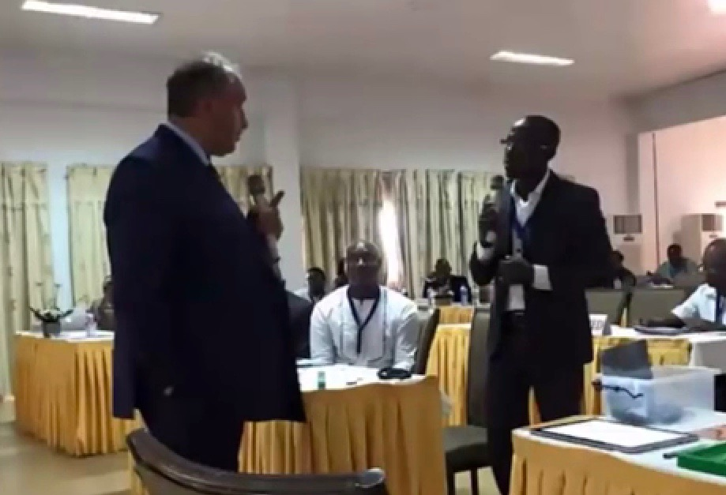

14356 K: You see in the photo the man talking to me who is one of the top scientists in radiation control in Africa. He has a twin brother and we were setting up new standards with the help of these people in the coming weeks for radiation detection and cleaning up doctors who are getting contaminated in X-ray rooms and in the contamination rooms. This is the beauty of when we came here exactly 3 months ago. We have achieved in 3 months what would take 10 to 20 years in Europe. In Europe because of DL we got shot at, poisoned and blown up and everything else. Here they open their arms. We offered the same technology to Belgium and to Italy. But, shutting down and listening to the lies of these people (Sylvester and DL), a 70 y o man, a computer hacker and most probably a pedophile who has spent so much time damaging people’s lives. He will spend the rest of his time in a 2 x 4 cell.

Jon Bliven plays his 2nd video and MK explains the void in the middle

14509 Jon: Mr. Keshe, I have the video.
K: please share that with us.
Jon: (1.45.33 minutes) this is a very short video that was earlier in the testing and one of our transformers was down but we still generated significant fields. Let me show you what we found, it was kind of unusual…

14557 Jon: we are here in Arizona and David is measuring an anomaly in the field from all the reactors that have been going a couple of days now. They are all spinning and you see the booster unit on there. What David is finding is that there is a void; he is on the top of an 8 foot ladder and it is probably 15 feet high or maybe 12 feet high. Right there is a void. Show them how the void in the middle is on and off. In the middle it goes all the way up to the top. It is still beeping up high in the middle and then it has this point here where it is shut off. When he pulls it backwards there is a void right above the magnetic ring at 12 feet high and it goes back out again. That is very interesting.

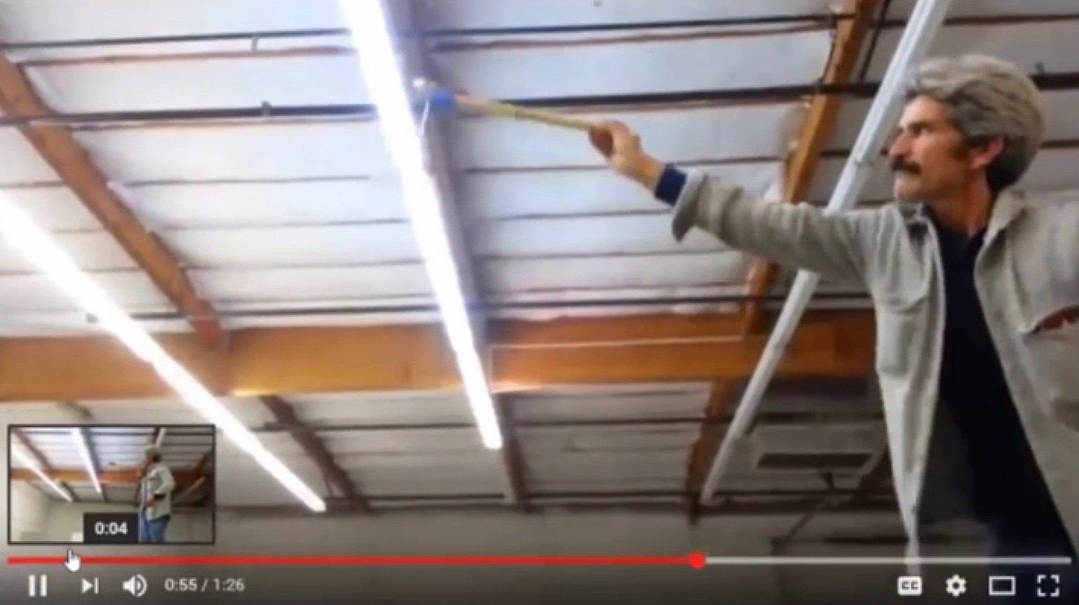

14730 Jon: I don’t know how to explain it but the void has gone away since we have gone back to the other configuration.
14738 K: Yes this could be because of the fields and condition that you create and they are fields that you do not see. There are a lot of things that are important to understand. What I have seen that is not understood in part of the teachings. Let me share the screen and I will explain. In most of the teaching up until now we always looked at aspects of the flow of the flux but in fact we have not understood some of it. When we have two magnets or two plasmas in our teachings we always refer to the flow of the magnetic fields from north to south. And the same is vice versa here. (1.49.12 minutes).

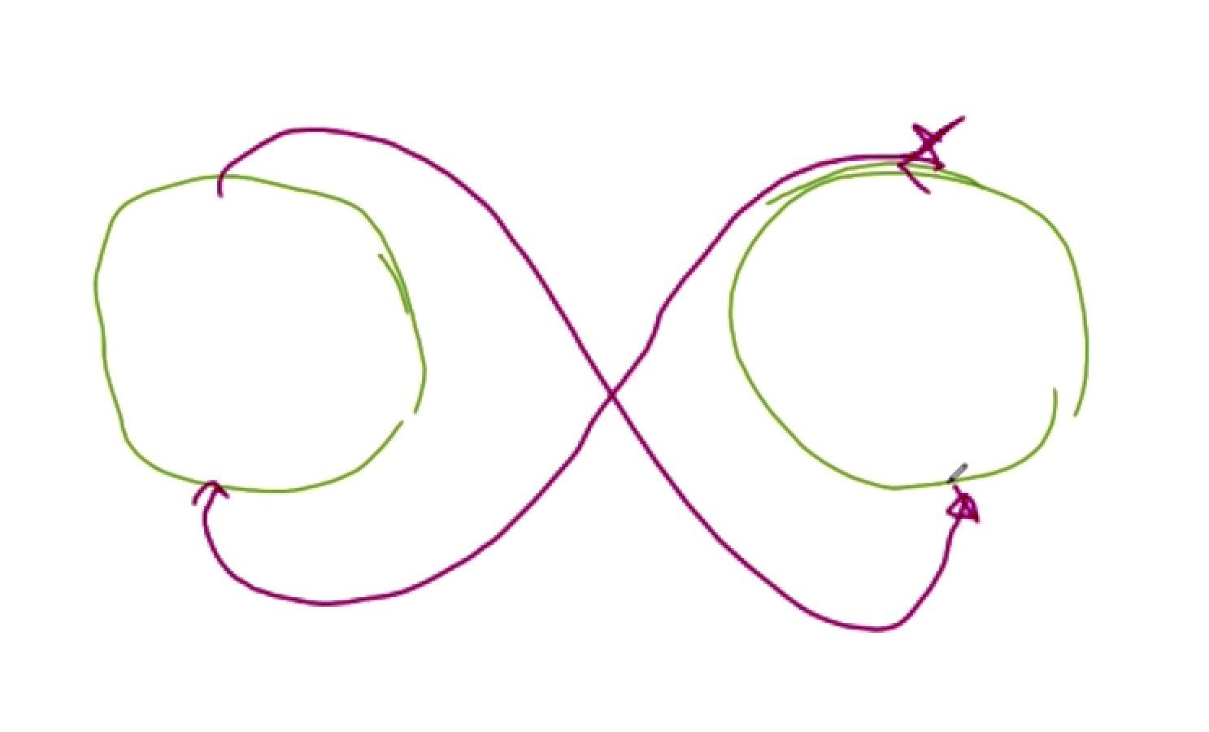

14910 K: In reality what we have shown is the operation is the gravitational magnetical conversion, which is the separation. But, in fact if you go back to the teaching and understanding from the beginning there is the field repulsion between the north and the north and the south and the south also. This is the field force that keeps the separation. Go back to the teaching and the understanding of the field of the plasma where we speak about putting north and north together they separate and when you put south and south together they separate. There is no difference in the plasma when it is in this shape and this contact. These fields do not all go together; some are spread. The interaction of what comes here creates the separation from the North Pole. What comes here (1.50.32 minutes) and what comes here creates the separation on the South Pole. Not all the fields are in a field conformation or a pattern like this (1.50.44 minutes) that create the separation of the positioning and these fields create the attraction. When these forces come to balance with each other this is the position where the two entities take their place.

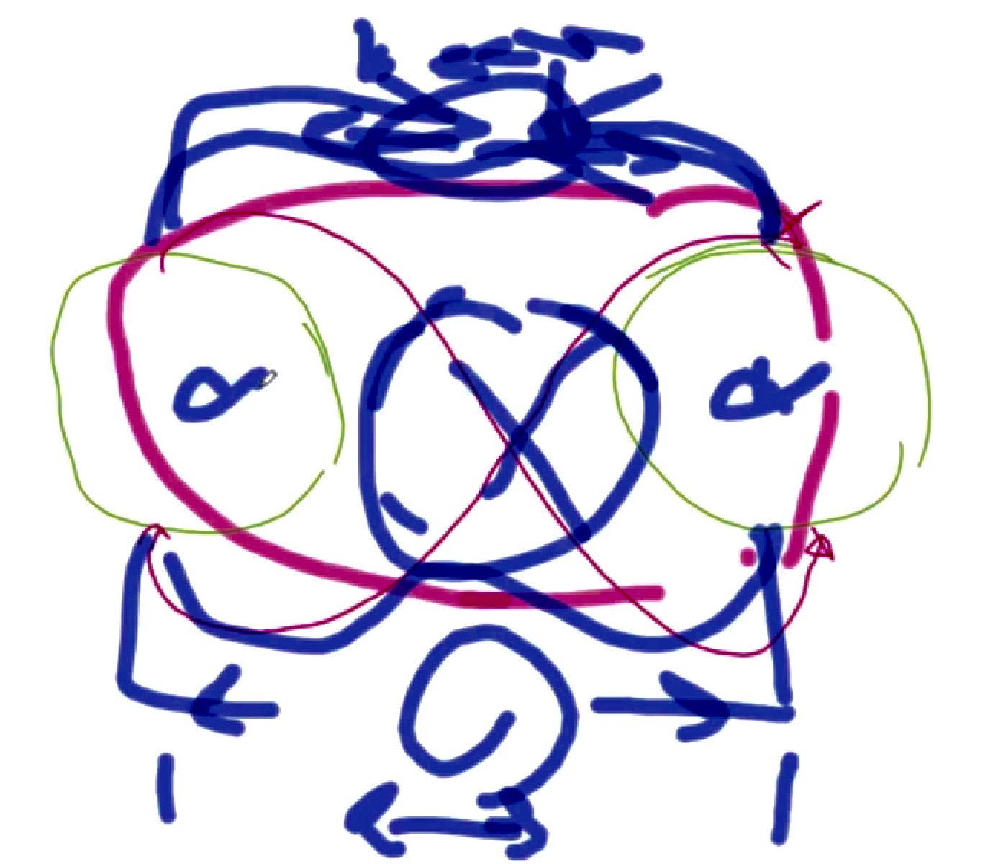

K: This is what I explained in the some of the teaching and I carry on explaining so we make more understanding of it. The 4 field forces we talk about, the 2 gravitational, which are here and these two here are the magnetical separation (1.51.24 minutes). We have to understand this and this is the backbone of the science. If one of these positions is slightly wrong the distance will change and one plasma will tilt towards the other. This is the position of the earth. We are in a way giving more and taking more on the gravitational and this gravitational in respect to our environment has tilted the earth into an angle. (1.51.58 minutes). The 4 field forces are the gravitational, the two of each which they pull in and the two magnetical.

15210 K: so, if we back on the whole understand, it becomes very easy. You have two plasmas and you have the four field forces, which you have created—the repulsion and the 2 of the attraction. (1.52.43 minutes)

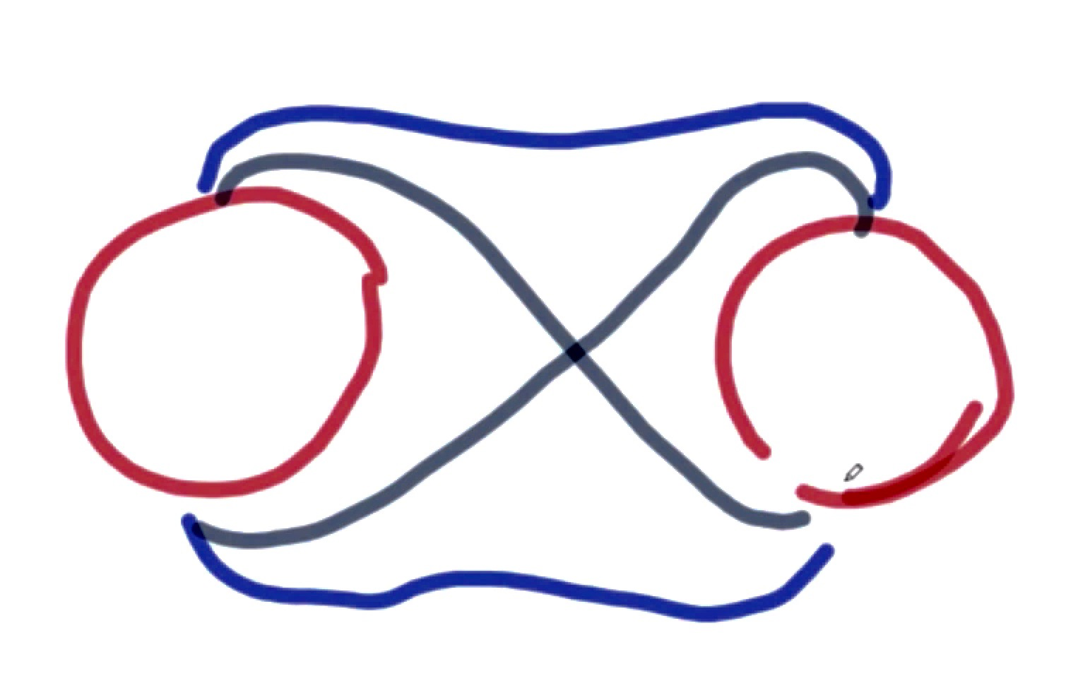

These two create the separation and these two create the attraction. Now you see this is what we need to understand. That is how plasmas stay separated from each other. That is how the positioning is created. And, if we change something in here (1.53.18 minutes) deliberately we tilt one in respect to the other. You are a spaceship and we have lift. How much we let gravitational become the stronger that the magnetical, decides the angle of take off or the angle of landing.

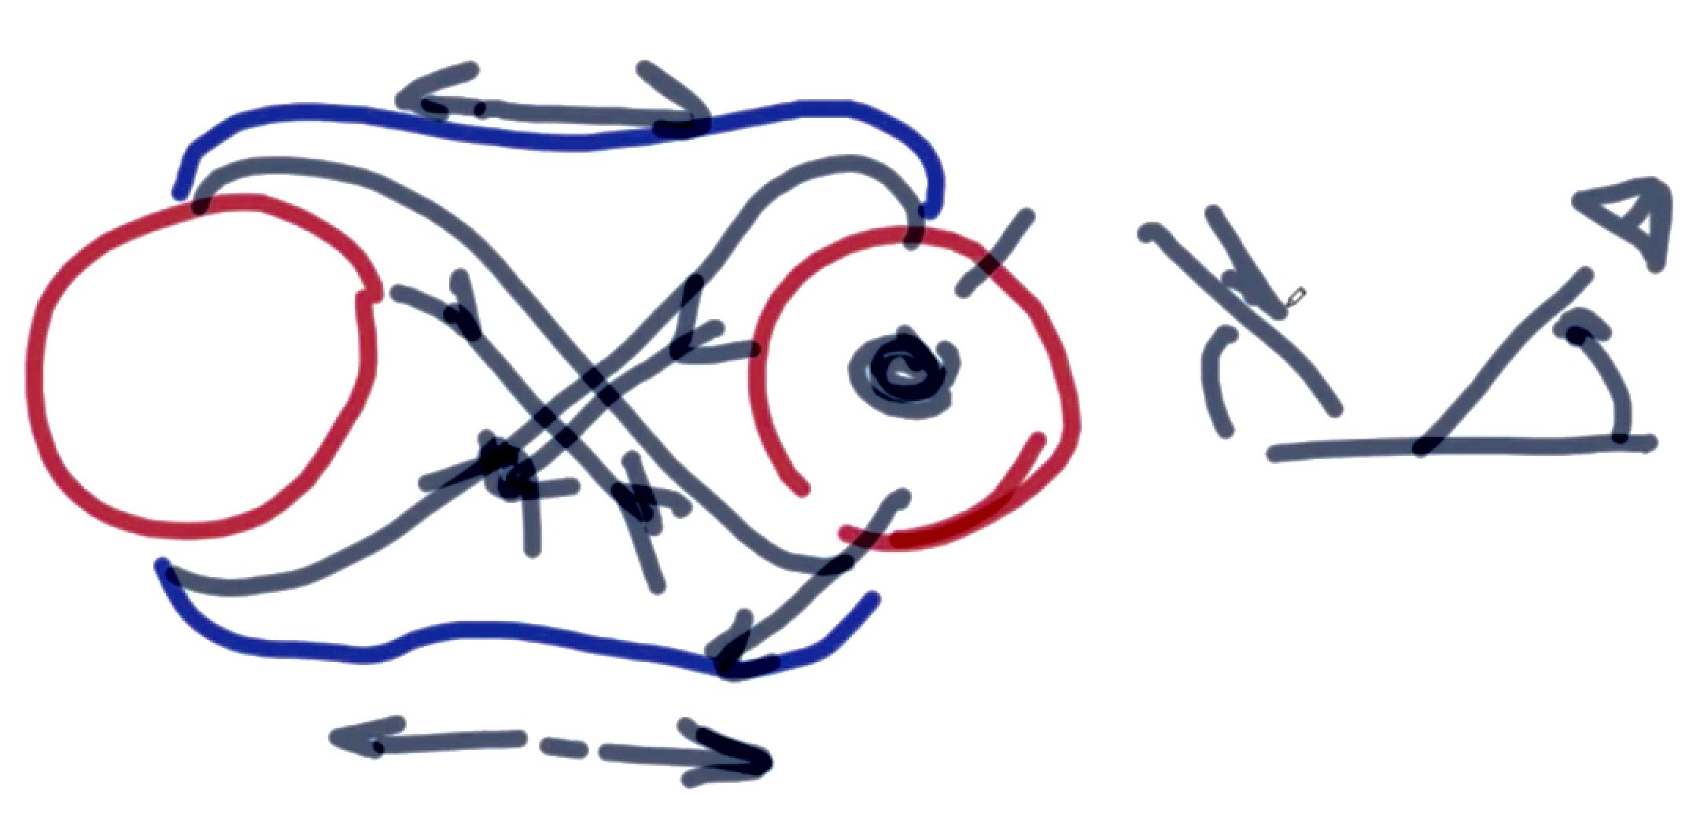

15349 These are pieces of the knowledge that have to be understood to be complete. That is why you see gaps in positions. You have vortices of interaction of different coils and in some places you see gaps. These gaps are what you call black holes and you can fly through them and use them. You look for them in certain specific conditions. They have strength beyond your detection strength.

15418 K: it means they are tuned to somewhere else and they exist and in existence they are connected to something somewhere else where you want to be if you need to be. So when you look at this maybe you understand more of where the repulsion comes from and where the attraction comes from. This goes back then into a lot of interactions and attractions. A lot of things have to be explained and one of the things I have tried to bring up in the teachings, and keep this picture as it is a very important part of the teaching, which you have not understood, and what I keep referring to as the 4-field forces. Number one is the circle on the right; number 2 is the field on top, number 3 is the field in the center of the 4 fields, and number 4 is the field on the bottom (1.55.02 minutes)

It is important to understand the application of these teachings to the structure of the soul of the man, and how that relates to the structure of the soul of the vertical people

15506 K: something that is important is that now that we are entering into the different dimensions of understanding of the technology, it is important to take this to the next step to understand the science of the creation more deeply. I have spoken about this in a couple of teachings and it is important for us to understand more after 3 years about where we come from. We speak about the soul of the man and we think we have access to it because now we can place roughly the position of it. The inertia of the soul of the physicality is somewhere near the heart. And we have the emotional soul which is somewhere in the center of the brain of the man.

15605 K: When the two interact it is the interaction of the physicality very much like what we see. Just turn this about 90 degrees (1.56.14 minutes—Notetaker, think the man with the circle on the right that became the head of the man). What you will see is very, very interesting. Let’s see how we can see and understand something that we never understood. The body of the man has chosen the position of his soul because of his construction. He is very much a two level entity. It is like earth and it has gravitational and then it has inertia. The physical part, which is the inertia part of the man, which is the interaction of the physical part, which is to the ground, to the earth, is where he came from with matter side of it.

15700 K: I explained this in some teachings and this something which you have to understand. When you look at the body of the man you have the emotional side which is the brain and the soul (1.57.07 minutes) and you have the physical part which is from the neck down. Each one has its own soul and each one has its own sensor operation of the man. The bottom circle with its soul is like the inertia part. And this top part with its soul is like the gravitational the Magrav part. The two work in conjunction and in interaction with each other and that is why your heart falls with your emotion and you fill it up when you have a fear and when you understand something. So in fact the two parts have chosen and they have the inertia part of the soul (1.57.52 minutes) and what we call the emotional part of the soul.

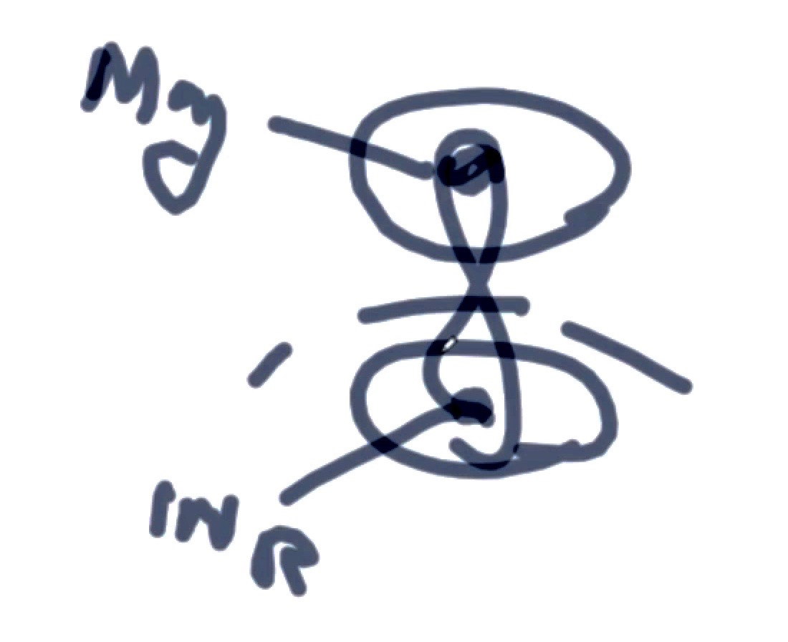

15757 K: the question that has been a mystery in the world of science comes to the mystery of the horizontal people. The question to ask is where is the position of the soul of the verticals (trees, plants) We know they have emotion. We know they feel pain and we know their response to lover talks. But the question for humanity is to understand because the first enigma is the plant which man has been with all the time with and he never understood. Finding the structure and the position and the working of the soul of the plant then becomes the riddle for man to find the soul of the entities in the universe which we to understand. When you see a structure walking on the ground, is the soul at the bottom of his feet or is it on top of the position of what you think is the head?

15918 K: where can you target your emotion toward the soul? Where can you target your soul towards the soul of the entity so that he can get a response? It is no use looking up to the sky for what is on the floor just because you see a physical manifestation going up. This becomes important because now that we go into the agriculture we understand that we touch the environment of the plant so that it creates a condition that the pests and parasites and whatever, being it a tree or vertical moving or horizontal moving the parasites don’t want to be there. But, have you changed the environment of the tree or with what you have done have you touched the soul of the tree so that it has changed its manifestation? Have you given the guarantee of success so that it will survive and you made survival much easier so that it has been given a chance to change?

20029 K: We see this in the man. We give people with psychological problems ZnO with CO2 and maybe a little bit of CH3. They change; their posture changes. The stand up; they don’t stand abused and the pains go. So it is with the tree and the plant. Do we understand this so that we can implement it across the universe wherever we travel? The question I put to the agriculturalists and to all of you is where is the soul of the plant? Where is the soul of the tree?

20116 K: We have videos and we have cases, of which I showed one in the private teachings, where the physical brain where a person has gone through an operation in which most of the physical part of the brain that operates the arms and the legs is removed because of a tumor. When you look at the person in the video he is physically flat just like they took a slice through the brain. But, the person is still alive and still talks but he cannot move. He has been in bed for 5 years. The soul is still there and that is why when the doctors cut at that time they didn’t understand the position of the soul and somehow they missed it. They have taken the physicality part of the brain out.

20210 K: in understanding that you can literally bring all the working of all the physical part of the brain to one point given in the spinal cord, we encourage and we brought the position of the wish of the will and the emotion of the soul into one part of the body of the person and the person after 5 years literally walks off the bed. He is able to walk, to move his leg, to hold things and to write again. This has all been videoed. It is not a dream. So, we can bring the emotional part to the soul.

But where is the soul of the plant? Why, when we cut the branches of the tree nothing happens? But, if you cut the tree at a certain point in a certain place the tree never grows. Does the soul of the plant sit along the strength of the length of its body? Does the soul of the plant connect to the root of the plant? Does the plant go through the same emotional condition as we do and get cancer?

20333 K: the plant allows fungus on the skin and we get the pesticides to overcome it. What about now that we use the gans material and we rub it on the skin and we see the changes on the skin? Why can’t we do the same with the plants and the trees so that we give them the point of comfort? We move the cancer in the body in the position that that the body finds new position. This is what we need to understand. This is the endeavor we have to take part in to understand more about our own planet. This is the part of the technology we have to understand. The agricultural team in the private teachings has understood roughly where the emotion and the soul are. They understand what the strength is, but now you have to position it.

20438 K: why is it when we cut certain plants and trees in certain ways we get certain responses? Why is it when we cut a tree at a point we take its life by separating the physical soul from the emotional part? If the tree feels when you talk to it, when the plant understands and responds to your emotion, then it must have a soul too. Where is the position of the soul of the plant? We have to learn this if we become the passengers of the universe because we always thought we were the only souls. Now we understand the hypocrisy of the earth being the center of the universe is gone.

20528 K: The hypocrisy that the earth is flat is gone. The hypocrisy of a lot of things is gone. Now we have to get rid of this hypocrisy and understand the reality. Where is the soul of the plant? Where is the soul of the tree? Can we avoid it? Can we strengthen or change it so that it changes its position and environment so that it does not have parasites and it gives the fruit as love. When you eat the fruit of the tree it is the love of that tree to mankind to bring humanity to its world because it is giving from itself. It doesn’t have to talk to say I love you but it gives its fruit—this is me; have some. Take from me.

20624 K: if the plant has such a feeling and the tree has such a feeling then where is its soul? Are we looking for the top of the tree or do we separate its physical soul from its emotional soul and that is the time when the tree will not grow any more? Can we find this point and then the question is, where does it sit? Is it upside down? Is the soul of the tree in the ball of the roots because it is protected like the man with his skull? And is the physical part of the tree that is sticking up the body of the tree?

20714 K: these are the questions that humanity has to find the answers for to be ready to understand that whatever you see in space does not mean that the soul sits on the top. If you target the wrong end, you pay heavily for it. We have to understand about ourselves first before we go further. We have to understand about the entities around ourselves before we enter into space. And, this is why man is not ready yet. Man is not ready to be on his part of the universal community because man is not educated enough yet. We are getting there.

20808 K: the problem is the total understanding. If you look now it’s very simple. Is the soul of the plant somewhere here (roots—2.08.21 minutes) and this is the emotional part? And the soul of its physical part sits here (towards the top). The interaction of the two very simply creates the aura of the tree. (2.08.49 minutes).

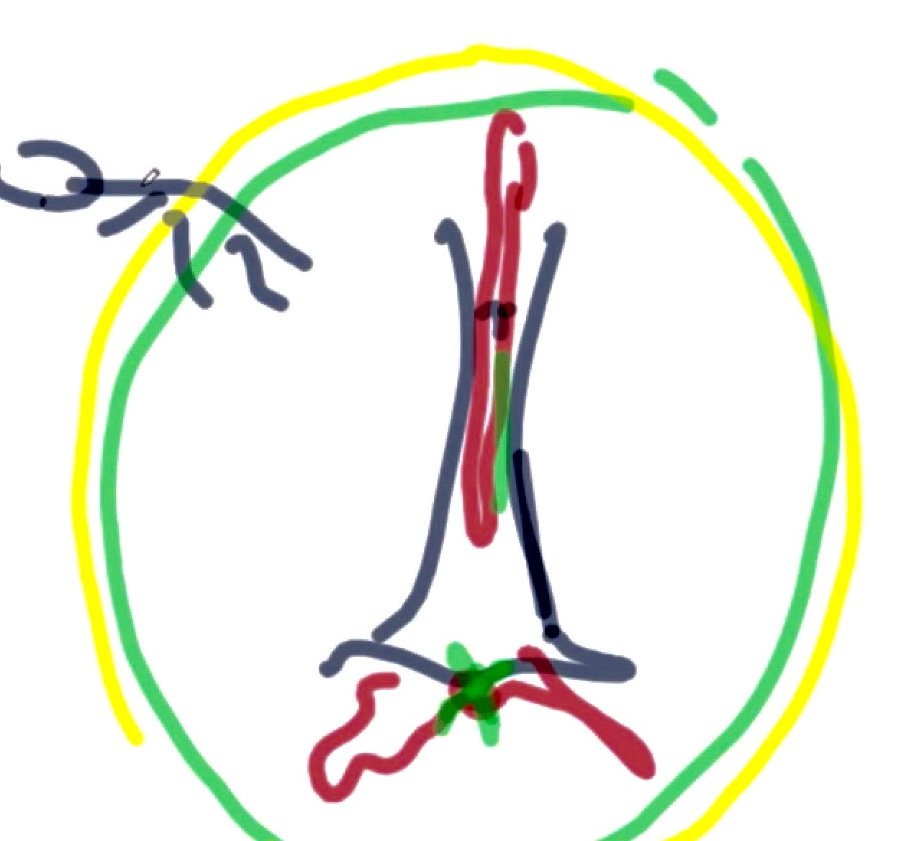

The aura is where we interact and change and when we give to the emotional side it changes the physical side. The aura changes and in this new dimension of aura the parasites cannot exist. We do that with the humans so why not with the plants? As I always say we are here to enlighten and it is for you to educate yourself. You have to understand the totality and the interaction of the plasma within the structure of the plasma of the entity.

20940 K: the biggest problem for man in space will be and is like any other travelers of the universe, and that is control of the emotion in respect to the soul and the manifestation of the physicality. When you understand this and you fall in love with another entity from another planet in the emotion of the love and wanting to be with that entity you affect your soul that it creates and manifests you in the shape of the lover at the point of manifestation. In Farsi there is a saying that means if you don’t want to stand out you better become part of it.

21037 K: Do we use our emotions to get the energy we need from our soul to change our manifestation not to be in the ship or our human form but to have 20 arms and 20 legs because in that area where we are assumes the existence and brings us to the level we want to be in. The emotion is always the same. It is the position of the physicality that we decide to change with our emotion.

21112 K: it is important for us to have more understanding of these points. It is vital. We have no choice. Otherwise in space we will talk to the foot when the head is on the floor. As I said we are too physical and we always looked up for the head. It could be on the left side, in the middle or on the right side. You have to see the behavior of the performance of the physicality. These are important things and part of the education we need to have. Until we are ready the space ship shall not be there. It cannot be there tomorrow because you have not understood the progress. The parts of what we see with Jon, the health, the agriculture, the people who make materials like gold and everything else is the same process.

21222 K: I want to explain something important to you. It is out of line (of this discussion) but it came to me. Peter from Austria received a threat and it came from Robert. He is registered and you can sue him for the attacks he has made on you. Contact the Austrian police. I just received a note from the security section. Please advise Peter from Austria; we know you received threats against you and we are monitoring what is in the background and we are getting informed. Please contact the Austrian police and make sure you register your claim against the threat of Robert has made against you in Austria. We will send this immediately; they are just after procedure now. You have to understand that the whole process, the whole structure I am getting information, Peter, that he hacked into your computer and that is how he got the information. The police are watching him; he is with the German guy. He hacked into your system and that is how they made the threats against you. He was laughing at that time and now he is crying.

21344 K: Now you understand the process and understand how the interaction of duality is confirmation of existence of one with another. We have the strength of the proton and the energy that is given by the proton dictates the position of the electron. The electron is the physicality so if you use the emotion of the soul and strength of the emotion you can change the position of the heart and the strength of the manifestation. This is how it will work and this is how you understand it. If you understood this you can change an apple tree instantly to create oranges. The process of the physical manifestation is the same and you just need to partially change the emotion. You will understand the effect on the physicality.

21457 K: these are what are important to us. This is what part of the structure is; it is now important to us. This is what will come to be understood and to be acted upon. It is important to understand that the life in any dimension in the universe is the same. It depends how much of the emotion side you want to give for the presentation and the position of the physical side. Let me give an example: we are not aware of the existence of the atom except that coulombs barrier or the atmosphere that is created by the proton and it has by the motion of the electron. This is how any plasma is created; the center gives. In what is converted to the strength of the matter in a given environment dictates the physical particles, which gives the boundary of the plasma.

21647 K: if you understand this and you understand the picture on the screen (2.16.50 minutes) then you understand how you change your manifestation according to the strength and according to the environment which you give because the soul part here (2.17.01 minutes) very much in strength dictates the position of the physicality. Now you have become a tree in a new dimension of space.

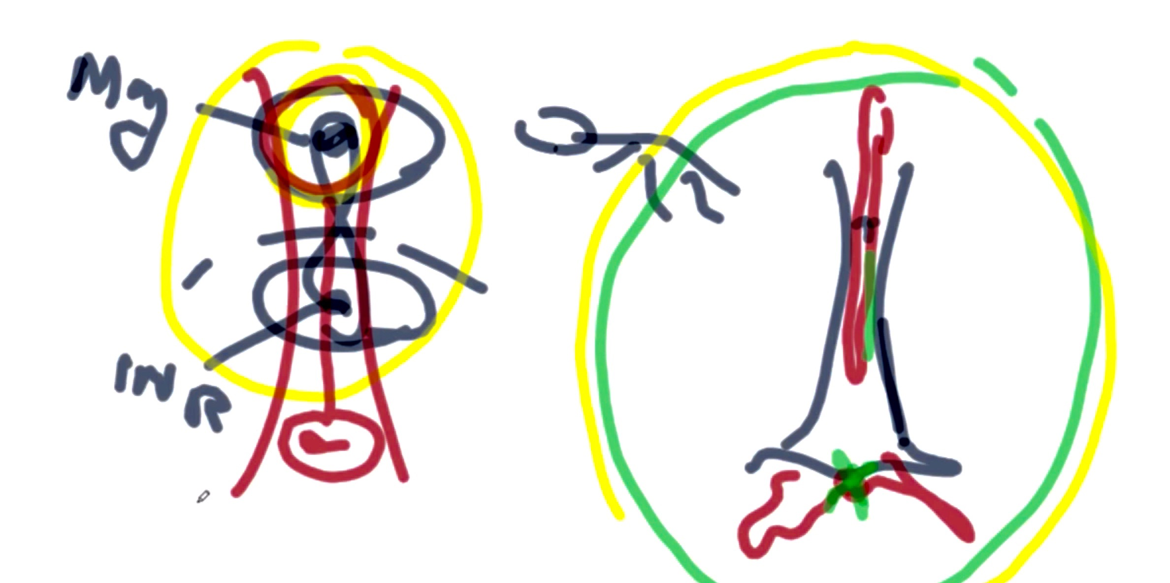

21735 K: I was explaining to the senior teams of scientists that we are training here in Ghana. I explained to them how we now understand the creation of amino acids from the gaseous part. We understand the creation of matter when the gaseous part attracts the physical part. The scientists were bending back and forth and asking how come we missed this? How come we never understood this? I walked to the tanks the scientists are making and showed them how the amino acids are made and how the interaction creates blood and he said, life and the knowledge of science has changed. Now we understand what we could not understand.

21827 K: for them it is a physical interaction. Now you try to explain that the CO2 container that they have started has a soul too. The ganses that you make at the bottom are more powerful than the gans of the amino acid. The amino acid on the top becomes the physical manifestation of the existence of the CO2 on the bottom. Your ‘animal’ is upside down.

21905 K: yesterday in the teachings I asked for a leaf from the mango tree in the garden. I said look at the leaf sideways. One side is nano-coated material and you can see the difference of the color of the leaf on one side compared to the other side. In between the two layers there is a layer of CO2 that is created, the same as the copper here. And now you see that on the top you create the fat now the leaf of the plant has fat on it. We always assumed that the water and the nitrogen given to the plant give life. No, the water and the nitrogen create a new environment. How much amino acid is absorbed from the environment? That is why you have that ‘greasy’ leaf. That is where the energy comes from. That is why greenhouses are useless with this technology because they create a barrier for the fields that would reach the plant.

22005 K: now we understand more, but we have to understand operation of the physicality and the soul in respect to space so that in space we don’t talk to the toes but actually to the brain and what makes the physicality see that is actually standing upside down. Do we stand on our head and speak to it or do we respect the way it is and appreciate the beauty of its physicality? Any questions?

K: if we don’t have any questions we can share what we see from the United States. I am receiving more information; the security people want anything that you received from these guys as threats, please register with the police in Austria. This is urgent. They will process for his arrest in the next few weeks as they will tie it up as we did with Alan Sterling (in the US last year). Now we know the threat made on Peter came from Robert under different names he calls himself on the website done by the securities. Fill in the form against him for the threat you received from him. The security services have already downloaded his computer and he will be committed.

22208 K: You (Robert) made yourself a cyber-terrorist since last summer. You did us a great deal by inviting yourself into the securities in Ghana because the securities in Ghana watched all the channels where you introduced yourself. You opened up yourself very well and in the English language you are Mr. Sylvester. A very strange situation that has come up with this man in Ghana is that he was present and a black man was there to shoot me because he was actually carrying a gun. When his colleague was arrested he had to be there pretending he was the cameraman. So, your hand is very much opened and the security forces are watching you sir. (Robert Sylvester). As far as we know the Korean government is not happy to have the terrorists either on the internet or in the physicality.

Heather and Justin give an update on the standing Rock protests

22320 Rick: shall we show what Heather Bryant has regarding Standing Rock protests?
K: go ahead please.
R: let me bring in Justin Smith and Heather.
22340 Heather (H): I have brought up some photos and videos on my desk top and we can check with Justin and see if he has enough connection to talk. They are small clips that he sent in earlier that we recorded.
R: he may have dropped out; I don’t see his name. Are you able to show the clips?
H: yes, once I can share the screen.
K: please cover up your screen and don’t show too much; these Mr. Robert and others are very good hackers.
R: don’t show you desktop Heather, just the video clip.

Heather shares screen with message from Carolina

Text: Carolina: I am still calling for huge support for North Dakota for the Indians. There are people on the road and please send them support by any means you have if possible. They are sitting in the freezing cold, icy weather to stand their ground so they don’t lose their heritage. There are so many beautiful stories, make your story beautiful as so many before you. You have received all the tools. Go to the joy and not the complication of it. Share and especially share with children.

22514 H: I just wanted to put Carolina’s statement up there first. Our efforts in getting Justin up there and getting him plasma energy supplies has finally come together in the last couple of days.
R: what is going on, and where this is with Justin, is he has had quite a journey to get there.
H: exactly. (Map: 2.25.49 minutes).
R: we are talking about North Dakota and the protest over the pipeline that is going through.

22618 H: Heather shows Native News Online.Net on the screen. There is a pipeline that is being built in the United States from Canada all the way down and they have plans on taking it underneath the Missouri River. That is also going through quite a few different Indian Reservation lands. Of course the Indian people are very conscious of their connection to the land and the water and the value of that. Usually when they put big pipes of oil under the water things don’t go well. There are often spillages and more. That is my understanding of the situation. There are many tribes that have come together to go up and be part of this. They have been doing this on and off for months now. It happens to come into winter that has made it more challenging for people that are visiting there. People have actually camped out to come together as tribes and do the different ceremonies they do and keep an on the process as it goes through the different legislative processes.

22750 H: there was a big one yesterday where Trump brought up different executive orders. (2.27.59 minutes screen shot). This summarizes that he gave the executive orders to continue that pipeline and he signed those. One thing I heard when he was signing it was that he held it up and said that it was signed. It is subject to renegotiation and terms by us. He kept saying that as he was signing them. My glass is always ‘half full’ so I saw that statement of renegotiation as a possible opening.

22850 H: so, Justin had been traveling and he finally figured out he was on the wrong side of the river and he had to re-route and go back up and around. There are photos he took on his way (2.29.17 minutes). It can be rather chilly up there and I don’t remember what temperature he said that it was. It was pretty low and all along we have been doing a chat on Facebook and he is keeping us posted with what he is doing. He took his dog up there. There is a lot of cleanup to do as ex-military people have been there and there was a lot of food donated. There are a lot of resources up there just ‘left around.’ Before he left we were trying to get some things together to send him. There is a photo of his hand on the ground to show that it isn’t totally frozen (2.30.34 minutes).
23044 H: Justin went there on ‘faith’ as he had $75 from the go-fund-me that was set up for him. He found the medical area and he tried several times to try to get things to the medic tent. A week ago Justin got us the mailing address to the medical group address. There is a beautiful person in France who put together a large box of plasma energy materials and sent them. A lot of things were put together ‘with love from France.” We both put in laminated instruction sheets on how to use the different plasma waters. I put together something for the medic tent for the different wraps that we use. The point is they got there which was fortunate and Justin was able to get into one of the meetings where the elders were meeting daily to touch base with what was going on in the camp and to give testimonials that people gave stating they were there for peace. They were also bringing up what they were being confronted with from the other side.

22330 H: here’s some short video clips (2.33.37 minutes.) Justin: I learned how to build everything I could out of garbage. There are piles and piles of garbage everywhere. (2.34.25 minutes). Thank you for the posts and I’ll keep you updated.

H: Mr. Keshe has taught us to scavenge for parts for making gans. We have been keeping track of the chat for and with Justin. He is very knowledgeable in these things as well.

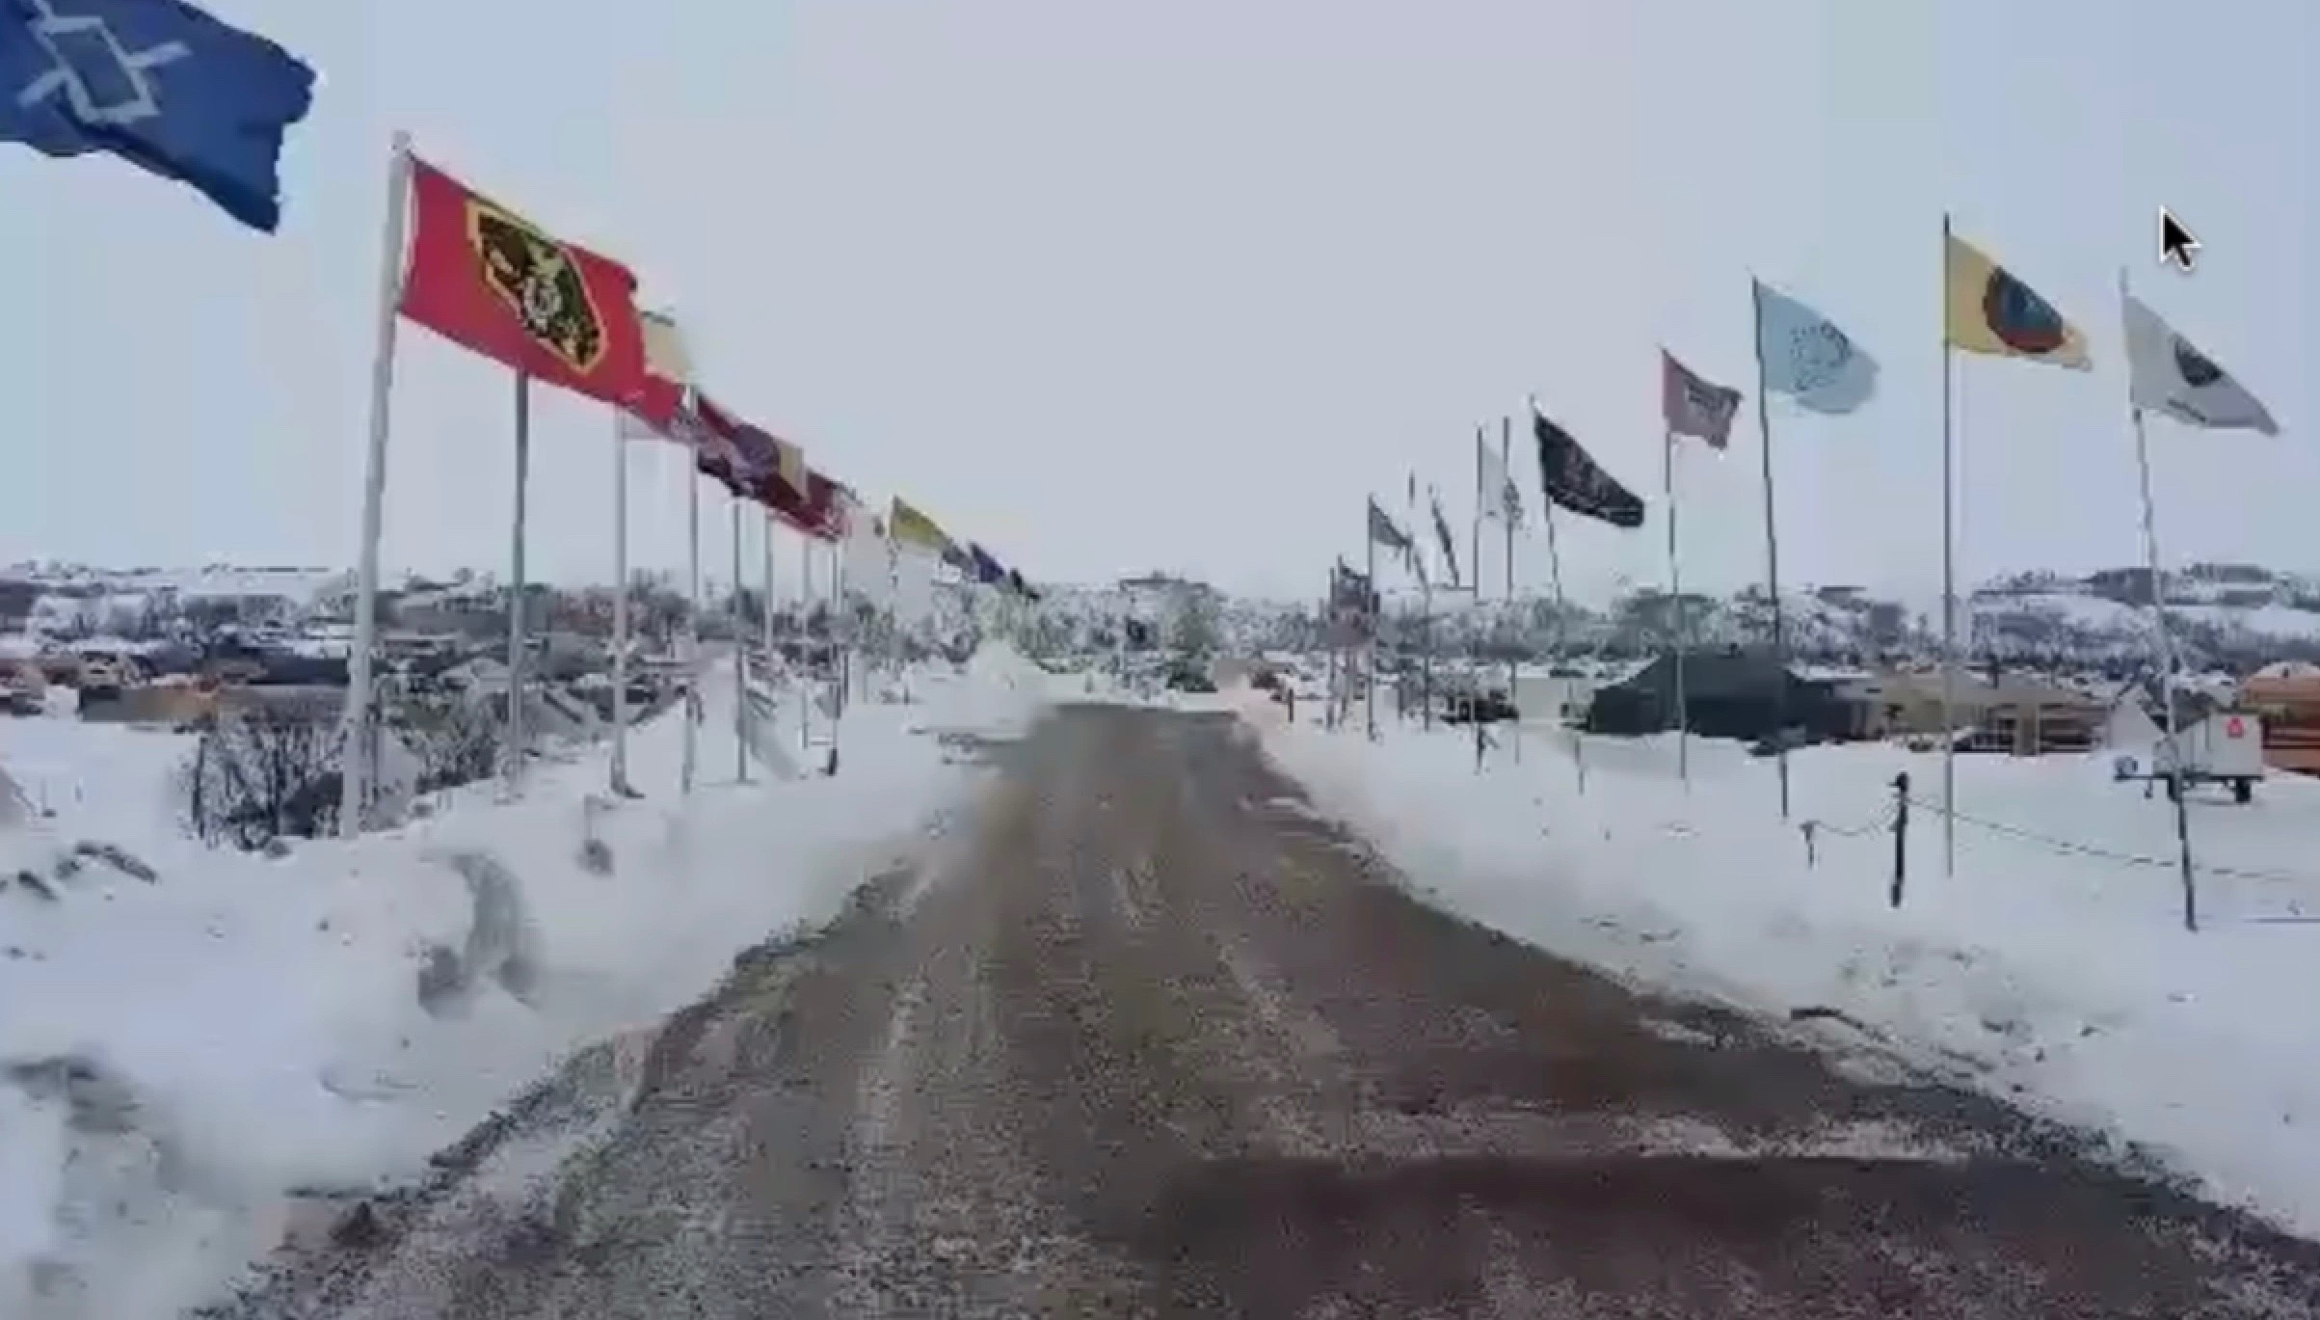

23509 K: are these flags the flag of each tribe?
H: I believe so. This is the area where they drive into the camp. Several young ladies who have been there have helped us get the videos up.

23544 K: how is the use of technology affecting the tribes or these people?
H: the anticipation is that there are a lot of opportunities to use it. He just got there yesterday and he is getting the boxes of what we have sent and he hasn’t been able to get them started on it yet. We wanted to ask you as well as to what kinds of things would as well as to what kinds of things would be useful in this environment where they are running off generators.

23634 Carolina: are you aware that Marilee has arrived in the camp a few days ago? I am posting the information out and he she has brought a lot of stuff with her. She is asking to connect with other people in the camp so maybe you can find her on Facebook.
H: I think they are talking on the chats. (2.37.12 minutes) There is a chief speaking and Justin posted that there are quite a few elders. There’s a lot going on and some of them have coughs. Some are back in hotel rooms because they are not healthy enough for the conditions out there. The technology could be of a big help to some of these folks.
R: Justin is back in as a viewer. I’ll promote him as a panelist. Go ahead and play his video.

23807 Justin’s video: Hello to everyone who does not know me. I am Justin Smith from Michigan and I am a student of the Keshe Foundation Spaceship Institute. I am here right now in Standing Rock with the indigenous people who have gathered together after 150 years of separation as a common collective to protect the water from death from the oil pipeline that is infringing on their property. What they are doing here is beyond parallel for uniting seismic differences and coming together for common purpose life they are leaving behind. They know how important it is…the water and especially the unity they are rekindling. Not all of us can help in every way and I am reminded by Mother Theresa who said not all of us can do great things, but we can all do small things with love. I have donated my time and I just got here. There is a lot to do. There is a lot of cleanup to do, a lot of people are sick and a lot of people are cold. A lot people are going a little delirious from all the toxicity, sprayings and toxic gases being shot at them as well as the mace in their faces. The violence has stopped here at the moment. The calm before the storm? We know more is coming. We have set up a team that has put together as many resources as possible in the background for the last month and a half. It’s taking quite a bit of work to get to where we are now. At this point we are here and we are ready to help. We are already under way and not looking for a pat on the back or anything. Mr. Keshe you taught us all to loves ourselves and if we really want to change the world we have to start with somebody else. I traveled in the United States to try to reach the people before I got here. Now I’d like to my message out there in a little prayer: If you have the ability to help in any way even your conscience put it out there—peace, wishful thinking, love and unity. Together we are one. Thank you.

Some tips from MK on controlling the environmental temperature

24123 K: it is very nice to hear what has been said. Maybe we can give you a few tips that will work. We are testing the temperature control in Ghana. This is important for us because here we have the condition of 35 to 40 degrees (centigrade) day and night and mostly during the summer. Even now it is 35 to 37 degrees. What the people are testing yesterday and we know this from research from other places is that the ganses have the ability to control temperatures. We have to find the right mixture. It will be interesting to know if you can wash the body with the CO2 or the extremities like the feet. Would that hold the body temperature between 24 and 27 degrees? Or would it hold the temperature so that you do not feel the cold?

24231 K: Maybe in your time there you can ask people to test mixtures like the CO2 and CuO and see if that brings the change. In a way you create a new environment around the body so that it does not feel the cold. It doesn’t matter where you are and you can walk in the snow or sit next to the fire. We have seen this effect in other places. When you are in position maybe you can test it yourself or others around you will wash the socks with CO2 and CuO. Just wear them. Don’t forget that we teach that we are creating a new environment. This is what we are testing here. Maybe all the ganses you carried in the mixture of the ZnO and CuO gives you the feeling of warmth when the temperatures are cold. You don’t need to wear so much clothing. We have to test and this is the opportunity for people who are in need or in that position.

24341 K: it might be better to hang the patches in the tent that you are giving them to hang on the body. We can change the environment. I do that in the lab. We put different bottles of ganses around the lab for interaction and they create the motion of the fields and that motion creates warmth. On one side of the room put ½ liter bottle of gans of CO2 and on the other side of the room put ¼ bottle of gans of CO2. This works by mass and in transferring energy from one to another you create the flow of the fields and with the interaction of the body of the man it creates more heat. Tents cannot be cold. (2.48.32 minutes water supply at Standing Rock)

24430 R: I think some of the clothes shown in this picture were sprayed with gans water. Is that correct Heather?
H: yes, that is when we did our community service project and had everybody bring in hats and gloves. We made the peace gans, which was a mixture of the hemoglobin gans, CuO and CO2. We sprayed that all over these things and then dried them thoroughly and then we attached a patch to each of them so they would have both of those.

24509 K: Carolina has a very good guideline. She says if you want to know if your CO2 gans patch works, touch it. It is always cool. CO2 creates coolness so you need to use CuO and ZnO. Or would you need to use CH3? She has a very good rule with these things and she says even when you touch CO2 you still have energy. It will always feel cooler so you don’t use the CO2; you use the CuO with ZnO and add CH3 to create the radiation in it. We don’t have the frost to test this in Africa on the snow. Don’t forget when the gans from the plasma pads touches the skin that stays with the body for a long time.

24618 R: what about the gans of cayenne pepper?
K: that would be hot.
R: if you are in Standing Rock in 30 below weather……
K: try it; this is the beauty of this technology; try it. Why not? There is always a reaction.
R: on the other hand the cayenne pepper is used in the Mexican culture for cooling, so that’s interesting! Maybe the CO2 gans in spite of cooling properties may start warming in extreme cold.
K: we see many effects and the people in position of testing have to tell us.
R: we are told the ganses don’t freeze easily compared to regular water. So it’s like an antifreeze for feet.
K: we see in Italy and from other researchers that there is a threshold of the amount. If you add 25% you might think that it doesn’t work, but if you make it 50/50 it might work.
24730 R: well that is the way with antifreeze in a vehicle. The anti-freeze prevents the over boiling of the water so it works in both directions.

Notetaker notes and photos.
Paul made these vials and coils a couple of months ago and the vials are on our unheated front porch. They have never frozen. The temperature was below zero several nights this week and a high a 3F and 8F a couple of days. Vial one has CO2 liquid plasma, Vial two has CO2--CuO---ZnO and the other photo is looking out the porch window across the street last night when I took the photos. Paul is attempting to create the oasis effect. Still working on it. We have treated all our gloves, hats and socks with the gans water as this was mentioned a couple of months ago. And I did Paul's tee shirts as he has never gotten back up over 96 degrees F body temperature after his first time on dialysis in 1996.

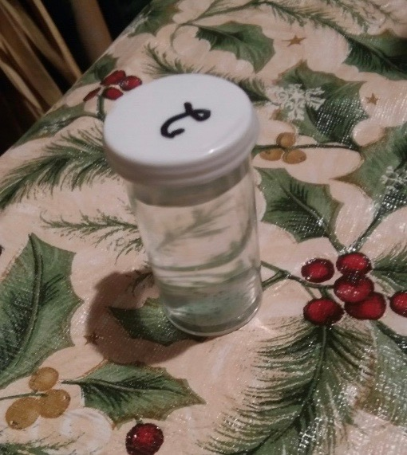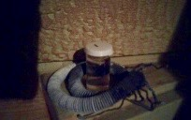

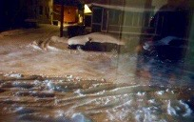

MK: My ethos has been not to fight; fighting takes too much energy.

24750 K: part of the work Heather was explaining and part of what the gentleman was explaining in his talk, include the contamination that the power company is bringing to the ground. My ethos has been not to fight; fighting takes too much energy. Let them do what they will do. It’s like a boxer; let them use up all their punches and when they run out of the punch you open it up and they fall. This comes to here in Ghana where we are looking into the structure of the oil and oil products. The past couple of weeks or two in the level we are working now, we have been asked with the Ghanaian National Oil company where our researchers in the foundation and the factory include an oil specialist. We have two of them. We will start looking at co-existence.

24900 K: The oil industry wants this oil to make man rich but the oil is damaging the ground where the Native Americans don’t want to have it. Maybe in the next few days we will see things as we are doing tests in the research center. We have added certain ganses to the oil and it’s becoming like a milkshake. So, with this technology can we create the environment where the Natives have the clean environment and the ones who are after the oil receive the oil that they want? I think that is a good compromise. If the Americans want to get access to all the oil to become richer because they paid someone off… let them do it. But we will try to find a solution so we can change the oil and the fear of it damaging the water. We see oil in a different way in our research here in the KF.

25016 K: let me explain so that you understand better. Oil is not a fossil fuel. Oil is a protein based product that is connected and linked up with more hydrogen and carbon to keep its condition in interaction with the minerals of the water. So, what it is, if we can use the approach that we think is 99% right that we can explain in the near future, we can change what the menace of the oil is into a food for the land? The protein chain will become protein as we use it for whatever and CH bond to become a sugar bond like a fertilizer. This can be done and we see this.

25115 K: So there is no use fighting each other and expending so much energy. In the new science we look for new openings and new structures for new ways to connect. As I said many times we don’t destroy anything. In the universe we don’t destroy, we accommodate. Where there is a fear of contaminating the water, at the point where there would be possible contamination you add this new material or you put a machine near it so that it creates a different condition in the environment. The oilman has his oil and the Native has his land with the sweet water and the food.

25158 K: those of you who have tasted CO2 tastes sweet if it has ZnO in it. The water gives you the pleasure of the emotional satisfaction. We can do the same with the oil. I used to be in the oil business for a long time. When I was explaining this to the oil researchers they understood; it has an extra acid in it. The only thing we are concerned with in this oil if you are with the Red Indians, ask them if it has analyzed and send it to me. Then I can tell you how we can set up an experiment how to maybe change it.

25240 K: I was explaining one of the reasons to the oil people here. I explained this in the teachings a couple of years ago. In Europe if you buy land which used to be a petrol station, oil station or somewhere that they used to use fuel you have to dig up the land and remove 6 meters of the soil for whatever reason. They said they reason they are doing this in Europe and America is that the oil you use in your car carries uranium and plutonium. It is a natural process and if the oil washes the sand. The uranium and plutonium are their and go with the oil. In the refining business we are not looking for nuclear contamination. But every oil inevitably has some nuclear material.

25324 K: you have to understand the totality of it. Oil is created on the sea level and the amino acid washes it as goes through the sea. The water from the land goes to the sea. It has already become a living structure but with the pressure on it, it pushes through the filter of the earth. It is like any filter with charcoal or calcium or whatever, earth is the mixture of the whole entity of the existence on this planet. Plutonium, uranium and radioactive material are part of this.

25400 K: when we get to the bottom where the oil stops it has washed everything of itself to the bottom. The pressure of water on the top has pushed it through. When we take oil out the first thing we do is we send it to a company called SGS. You cannot deal with anyone, even at the time when you put it in the tanker. When it arrives, you take the SGS report. At the point of entry of the refinery they have to give you the SGS report. And in this SGS report we see all the minerals and what is contained in it and if it fits a refinery because one can be changed on the high seas.

25440 K: so the certificate at the port will be important. So we look at it and always we look for uranium and radioactive materials inside of it. And we discard it; we don’t clean it, we let it go through because then you have to fill in the radioactive certification and the nuclear material. After decades of work I have seen the refineries literally put a blind eye to it. But in marine oil and in some of the fuels that are not filtered properly, for example 4 star in Africa, we find they are a different color when they are not cleaned up properly. That is true in Africa. But the radioactive material which we discarded and ignored lands up on the plot of land.

25534 K: when you buy land and try to change it from a petrol station in Italy or Belgium you have to take a soil sample that they certify to tell you that you can use the land to build on. And in that certification we look for uranium and plutonium in some cases that is always there in high levels. So we have to understand that when you deal with these oil issues, get an analysis of the oil. There is a way to make it safe so they can both co-exist. I don’t support the position of President Trump in respect to just going ahead, but I offer an alternative to the President. Let’s look; there is an alternative. Support the research, because we are doing this in Africa, and then offer an alternative to the red Indians, to the natives or anywhere. In Nigeria we have bigger problems with these things. We can change the oil to food. That is what it is going to become anyway. It is the CH bond plus the amino acid.

25645 K: in the oil industry we allow 43 to 47% of the fuel of the petrol that comes in to be used in your cars. The rest is the minerals which gives value to the product. So, people in the oil business we understand your position. For the Natives we understand the position. So, let’s handle this scientifically. Let’s bring the wishes of the President and the wishes of the Nation together. Find a scientific solution for it and don’t fight. There is an opportunity that we can do and we have the rights to do it. Here in Ghana we have the facilities. Send us the oil. When you dispatch it, we have a fixed address that you can send it to. Get in touch with the webmaster and they will forward it to where it has to come.

25742 K: Ghana is a very advanced nation scientifically and we have the facilities to analyze it. We have the scientists, so let’s analyze it so that maybe both sides can find peace. It is a pipeline and the fear is the contamination from a burst in the line somewhere. We can get there. We can mix it and I can show you how we make it into paste on a video. It is easy to do and it costs nothing. When it goes into a paste it is a food and it is actually minerals that we can use. There is a way to compromise with the new technology and it is our job as KF supporters not to push with one but to see the balance between the two. I know this can be done as I was in the oil business for years.

25844 K: let’s look and let’s find a compromise that fits. Let the compromise be a practical scientific solution and we are researching here in Ghana now. We are using different combinations of gans and we are seeing the effects on different things. And, we see there is a solution. Just give us time but let us bring the government and the red Indians together. Send us the oil; we have to see the content of it. Maybe for the red Indians the pipeline is the same as it is in South America where they bring all the casinos and the native Indians benefit from them. When the casinos are built and they are paid for them then maybe they don’t fight and the native Indians benefit and get paid from it.

25938 R: Well it was in the news a few days ago that the native band voted last Saturday to disband the protestors, they’re asking everyone to leave, so they can open the roads for their casino, because they’re going to loose business, and that is their main source of business. The road is closed now and they need to get the road opened, but to do that the protestors have to leave.

30015 K: there is something that a lot of people don’t know. Pipelines pay for their transmission. The countries that allow pipelines to go through them get paid very heavily. When the gases in Germany went across what used to be the eastern Bloc in Europe, these countries were paid heavily for the use of the passage through the pipeline. It is a huge income. If you can pass one million barrels a day sold at $30 a barrel that is $30 million.

30050 K: Even if they pay $200,000 to $300,000 a day to the owners of the land where the pipeline crosses that is a lot of money for them. It feeds back into the local industry. The pipeline is not just pulled through; it pays for the rent on the national passage. So you have one man who is trying to get his pipeline through let him do this. He pays. We will develop the technology that I started looking into a few weeks ago. And now we have petroleum people and we have the collaboration of Ghana National Petroleum and the KF team. We can bring a practical solution that we can export from KF Ghana Atomic Science and send the technology to the rest of the world. And we will see the benefit of it.

30150 K: the guys have brilliant ideas and this is possible; I have seen it and it costs nothing; it is very easy. Even if you use it in the high seas and it sinks to the bottom, then it becomes food for the sea because the composition changed. We have to see what happens when the animals eat it and that is the next step. It is like an ice cream. It interacts and within seconds it becomes ‘ice cream.’ It is a molecular structure that we can see and if you change it that way in addition with what we have done then it has to become food.

301254 K: so, let’s find a solution and I thank you for what you are doing. Let’s look at it from the position that the Natives get what they want, the President gets what he wants and the local casinos can make money and there is money from the pipeline. Anything else?

The Situation at Standing Rock

30302 R: Is Heather done and would Justin like to talk about that and then we can try to wrap up.
K: please let him speak.

30347 Justin: good morning; I love you all and thank you for your help. Right now we are having issues even trying to get the materials that have been sent from France and everyone else. It‘s an organization issue. At this point I don’t know where they are going and what the plan is. They are removing people from the camps and moving those that do belong here to higher ground. During the spring season there is flooding that comes through this area.

30427 Justin: As far as what the elders and headsmen allow to go on, we have to ask permission to just go around and throw the technology out there. I have already tried to do that and have met some resistance on it. I’m not necessarily going and pushing it on anybody but basically at this point I can’t even give it away. I don’t have a warm place to make gans. The warmest place I can find right now is a bathroom next to a heater that is a woodstove burner near the portajohn area. To make a gans collection kit won’t be very easy. At this point I have talked to the medic tents and the IT department, construction department and they are all trying to keep on going with what is going on.

30523 Justin. People are throwing things away so fast while they move out of here that they are leaving huge piles of garbage behind. They are throwing food out like crazy because they just don’t know what to do with it. There are other camps in other areas. There is more than one camp. So to find out where the other Keshe student is we are going to need to talk in the background. It’s a lot of turmoil right now. There are those who came to make a difference here and then there are those who are here to actually protect their land and water.

30602 Justin: the two groups at one point were on a common line but now there is a vast difference in what their initial intentions were. The spectators or possibly trolls if I may use the term have tried to turn public media into something that makes it look that what is going on here is of the wrong intention. So the elders and the headsmen of the tribes are doing their best to remove what I am going to call ‘riff raff.’ These have caused violence on themselves by provoking the guards on the hills by the pipeline. It’s not everything that we see. there were a couple of news crews here yesterday and I did my best to stay away from them. I did take pictures of their vehicles and I wasn’t trying to get any publicity. I just wanted to come and heal people and then go home. If we can it would be nice to give them some heat because they are going through a lot of resources just to warm their feet.

Alekz says he has used CuO gans to keep his feet warm

301726 R: there was someone in the chat: Alekz says he has used CuO gans to keep his feet warm. “I just dab my feet with a towel that is dipped in the center of the plasma jar and I had to repeat this every day to build it up.” So that is a big clue. Alekz is very sharp; he’s quite bright and I suspect that statement is very significant. He had to repeat it everyday to build it up. So it is something to consider and Mr. Keshe had just mentioned the CuO gans rather than the CO2 gans.

30813 Justin: I did hear about the coldness of the CO2 according to Carolina and she’s very intuitive and in touch with the healing. That’s good to know—great! Thank you. At this point I just want to reiterate that it is going to be hard to set up a collections kit that isn’t going to be disturbed, taken down, bumped and run over by someone.
30813 Rick: the first thing is to get in touch with the other Keshe person there.
Heather: Marlene Rosen; I am sending her messages on Facebook – didn’t relaise they were both there.
Rick: she already has gans materials.
30913 Justin: I believe they have been sent here and they have been sent to the headsmen and I haven’t been able to be in contact with them physically. We have had communication over the phone and Facebook. I haven’t seen or physically been in the presence of the boxes. It’s been 3 days. I’m sure it will happen soon.
Rick: is there anything else.

31000 K: we will try to make headway somewhere so that we can help both sides as we said. Most likely we can offer more. The problem is that the world leaders as presidents and prime ministers look at the long-term plan for the nation and keeping the industry going. They are partially paying the debts of the nation and they are partially in commercial point of view from the people in commerce. The tribe is trying to protect the environment and maybe with this technology we will find a point of compromise. Maybe it is time to find the point of compromise. It is not that anyone is wrong but without the commerce the nation cannot run and without the clean land the nation cannot feed itself. Maybe we can offer that alternative.

K: we will explain more about energy production that is coming and we are showing them how governments can change their position in respect to the technology. There is a lot that cannot be disclosed because even these people don’t understand it. It is our job to deliver the technology that works and they can see it, feel it, touch it and then they can make a difference. There are many of us and this is what we have to do. So thank you very much. We will try to do something and that is why we keep the line open with the knowledge seekers’ workshops and the presentations from this part of the world online. Long term we will find the solution for both sides.

Jacky from France shows a video of a French knowledge seeker creating water

31200 Jacky (from France) I just received a wonderful video from a French guy if I can share it with the people.
K: what is it about?
Jacky: it’s a French guy who is really concerned about the water and he makes beautiful experiments with cleaning the swimming pool without any chemicals. He uses only CO2 and CuO. This is the beauty of this technology. When we were doing the transcription and the translation of the kids’ workshops I spoke to this guy. I said to look at the kids’ workshops because Mr. Keshe explained how to create water. I know you like water and you have experimented for a long time. So he watched the video, he makes different combinations exactly as you described in the18th Kids Workshop and he failed once, twice, three times, four times but after one week and a half he showed us in this video how he can produce water only with the field interaction. I will play 20 seconds when he shows the water and it’s in French but its not complicated.

31352 – plays video…

31441 Jacky: This is the beauty of this technology and this is only done with recycling materials. He explains how to collect this matter yourself, and it costs nothing as it’s all recycling materials. It is a beautiful soul of the man in France who is not doing this for business but is doing it because he has the understanding that with this simple technology no man, woman or child can suffer from hunger. When you start producing water then you know that people will not die because there was nothing to eat or drink. It’s a great pleasure to show this to everybody. Thanks, Mr. Keshe for the technology you have brought to us. It is so simple. The people need to understand that this is why we are translated. Before the translations this would not be open to the people who don’t speak French. This cannot happen if the people cannot understand the language being spoken when showing the technology.

31623 K: is it possible to translate this into English or transcribe so people can translate to other languages.
Jacky: sure.
R: someone asked if there is a link to the video available on Youtube.
Jacky: for the moment it is only available on KF French on Facebook. He posted it this morning.
K: if you can, bring it into one part where it can be shown in the blue prints and testimonials. That would be fantastic. (3.17.05 minutes)

31702 K: the creation of water is very simple and what we are doing now in Ghana is we are taking water from the sea and they have started processing it so that after interaction with different ganses we have clean water to drink. We know certain ganses kill the bacteria, parasites and all the rest. That is not a problem. We know the biggest problem for us is desalination, removing the salt. That process doesn’t take long to do. This is important for countries like Ghana, Saudi Arabia and the Emirates. They spend a fortune on desalination and cleaning the water. With this technology we can add a few drop of (liquid plasma) water into the water and we change the water. This is important and we see that if you create the condition of interaction of the waters to clean the water there is no waste and there is a lot of gain in every aspect including the collection of minerals.

31813 K: this process teaches us a lot. We can use water in respect to another water to create the plasma condition of water to create water. This is the secret of this. It is no different than when you put a nano coated copper plate with a zinc plate and you create CO2. If you find the right combination and mixture of water with what you have created in the nano gans of the water, because a lot of you have done this, put them in front of each other in a given condition, even with the salt water, and even the natural water you should see the tank floating up.

31858 K: the principle never changes. It is us who lose sight of the ball. This is the secret. You want to create high quality water. Look what you have done with the copper plate and the zinc plate. You create the environment of carbon, which in interaction brought you CO2. Look at the gravitational field strength of the water and the gans water. What you should see is the rise of the sea level, the rise of the water in your container. Last time you locked into the carbon fields in the water. Now if you have done it cleverly you lock into H20. And, look at the structure of the amino acid, the COHN (or NOCH..It has different combinations as written). Now you see the magnetic field of the water because there are two waters.

32010 K: Look what you do with the zinc. You put the nano coated zinc and the normal zinc and what do you get? You get the gans of Zinc in combination with oxygen in the water you get ZnO or ZnO2. Why don’t you repeat the same with the gans of water? Go get the sea water and make the gans of water, any water, and put it in the water. You should see the level of the water rising. That is how you produce it and this is how the sea produces extracts. This is what we see here and somewhere in this box he has managed between the containers to create the gravitational magnetic field. He shows us that the box is empty in the water. And one day if he touches the side of the box, what else will he collect that he hasn’t noticed? Now you have taken the hydrogen on top of the box because the oxygen was in the water. You have taken the iron oxygen out. Now you have one C and N floating somewhere. If you rub the box and test it, does it contain nitrogen (N)? Or do you find an atomic Carbon on the wall. What do you find if you clean it a tissue? You will have a black material on it. It is not dirty, it is carbon.

32143 K: and in combination and in how you change the condition of the centralization of Nitrogen, you add the energy from the Nitrogen-Carbon bond with the Hydrogen in a specific way to the creation of the water. You release the hydrogen and oxygen and with every two molecules you allow the energy of the nitrogen to be added to second hydrogen. Then you have H20. Then your nitrogen releases and becomes a carbon and you have 2 extra molecules of hydrogen extra and you create a hydrogen bond with your nitrogen and oxygen so you should see the level of the water rising in your container. But, if you nano coat the container you work in the atomic condition and the magnetic field plasma condition.

32237 K: so if you clean it and see blackness it is the carbon you have produced. This is to understand the science behind in and not just accidental creating. Somewhere in this position he has the CH3 or what you call nano coated gans of water and water somewhere, which is not there. That creates the condition of H20 and it is the extraction from the above in the condensation. You have done it. Try to use water with it and don’t be afraid. It doesn’t have to be in an empty box. You can do the same testing in your water box. Mark the container and see if the level rises.

32325 K: You get more efficient and you produce more water. Use the gans water and the water, the zinc plate and the zinc. You get ZnO. Zinc plate and nano coated copper gave you copper oxide water and nano water will give you oxide of hydrogen which is water. It is very simple if you understand and you can create tons of water without even having it rain. Any other input?

A question from Wanqing of China concerning nano gans and fields

32408 R: we have a question from Wanqing in China. It is concerning the nano gans and fields.
32455 Wanqing (W): thank you Rick.
K: we should say to you Ni how and Happy New Year as your new year is coming up.
W: yes I can hear you. Thank you Mr. Keshe for teaching for the past 3 years for all of us to gain knowledge and for increasing our intelligence. Today I have a question about the measure of the nano coating. You were talking about the distance. The biggest is the plasmatic nano coating and the nano layer is totally free (? 3.26.43 minutes). If it is the key point for the Magrav system to run well, and to stay efficient using nano coating with plasma and many people are using caustic or the heating method…

32705 K: If you can create a plasma coating you will find totally different work. Creating a plasma coating is not as easy and takes a long time but it is very, very effective. If you create a plasma coating, you can create a current much easier. I was showing this in the factory to people yesterday and it is extremely powerful.

32740 W: okay using this method can we use the nano coated copper plate or copper coils put into battery wall?.......... (3.28.05 minutes…not clear).
K: yes. Why not? There is what I taught a couple of years ago and people didn’t see it. One of the ways if you want to create, for example, gans of the amino acid of the neuro system or if you want to create a gans which carries emotional strength in the line of communication. Can I share screen please? I explained this before and I usually don’t talk about things but just move one because it means that people haven’t understood it at that time.

K: (3.28.49 minutes) this goes back to the part of the teaching a long time ago. If you have a box where you put your nano coated material, and let’s say you choose to use copper nano coated plate and a copper non nano coated plate on the other side. What if you go a step further and do the zinc nano coated and the zinc non nano coated? Do you understand? The environment here now creates two conditions, both of the creation of CO2 and of ZnO and both condition of CuO and the last field in the center gives you a new material which is very near and very close. It depends if you choose the sodium chloride or put magnesium salt in the mixture, then you create a more realistic environment so that the material you produce you can use for the human body. (3.30.03 minutes).

33006 K: we went with this initially when we started producing the first CO2 boxes and we made them like this so we could put different plates on the inside and the outside of these hexagons. Those of you who tried to make gans materials which are comparable to the body, you have to follow this pattern. You use the ZnO opposite each other in the hexagon. The field strength of the two gives you ZnO as the gans. You put the copper and the nano coated copper opposite each other and half way between the zinc plates. These two (sets of zinc and of copper) have to interact in the center (3.30.56 minutes) and then you have other plates and you can change the mixture. Then what you get as a gans is something that is near the condition of the body, especially of the amino acid on top of the body of the man.

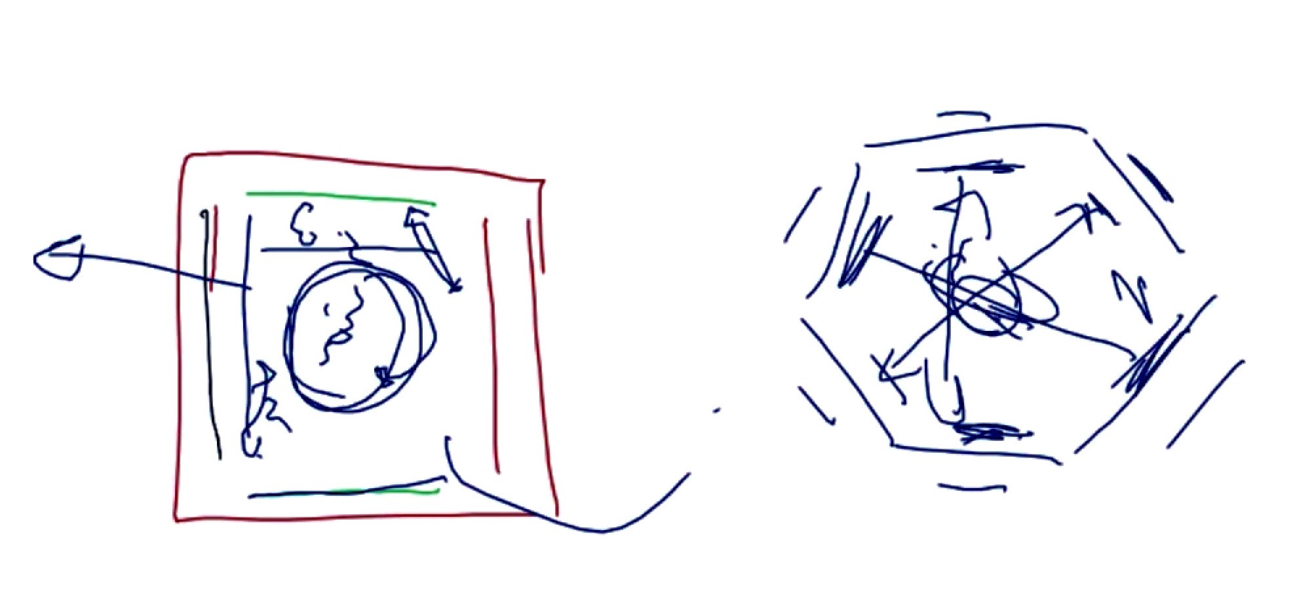

33112 K: this is more realistic and you can replicate it. I have done this and we did this with Marko whose unit still runs in Italy. We put magnesium, natural salt (sodium) and potassium and we put only zinc and nano coated zinc in the container and we are building a structure of the brain of the man and I have shown this in the teaching before. If you are looking for what you call the structure together it needs to be done. Most probably in this condition you will create a lot of water. This is how we absorb and change the energy of the water into our body. For example if you are looking to make things, take this a step further.

33210 K: don’t use two walls. Use 3 walls. In the factory now we don’t sit and just do one copper plate here (in the square box) and one nano coated copper plate here. We put a nano coated copper plate here and 2 copper plates here and we are increasing the production. We produce huge amounts of ZnO and CuO and CO2. You can do this continuously. Get a box and put one ZnO and one CuO and one nano coated zinc and one nano coated brass and what you collect at the bottom, and the attraction of the totality counts, it is something near enough to your body structure. You are bringing nickel and everything else.

33254 W: so in the battery there are different pairs of material without division?
K: of course. This is what we said.
W: so does this do the CO2 gans or other material?
K: anything; you connect the material like the copper in the level of the CO2 which are balanced with each other. It is the beginning of producing meat if you want to talk about that and you understand the science of what I have explained. You can produce anything.

33333 W: so the question is if we want to use the gans in the reactor for the rotation is it necessary to use the plasmatic measure of the gans?

K: you can use both. Let me explain something to those of you who work on the flight systems. Thank you for bringing this up. A lot of you created the ball and placed liquid gans of different materials to achieve free plasma. But there is a problem that has been overlooked and I am trying with different researchers like Armen, to put a gans outside in a ratio so that we start compressing these inner layers together (3.34.33 minutes). The ratio transfer of the gans can create a condition of the flow where now by compressing these gans together to create and release the energy back up. You can get the fields to expand out and this is why some people with the 3-ball system lost their ball.
W: compress the outside pressure?
K: yes, the magnetic field pressure. (3.35.07 Minutes).

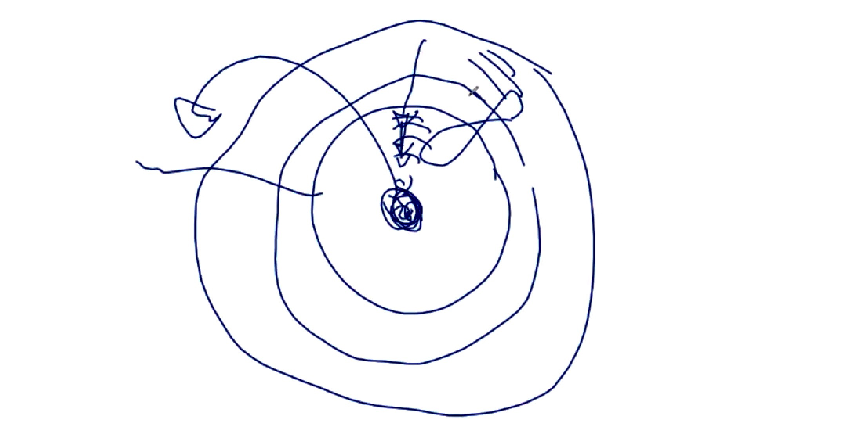

Let me explain please. This energy links up to the center and not to the gans. It is the center mass that gets pressurized and in that position it changes its energy transfer and in changing the energy transfer it opens up the ganses and increases more pressure on itself. And then you get flight. You can change the condition. At the moment Armen has built such a system and we have seen it and we see how the outside pressure goes to the inside pressure. People in the Philippines have done the same but they didn’t see it or understand it.

K: this is one of the reasons why people lose the center ball and cannot find it. Because the outside magnetic pressure on the inside does not touch the gans but it pressurizes the central core that we call the principal energy delivery. And it cannot hold it and it just escapes.

W: let me repeat again: the outside is the matter state.
33622 K: no, it is still the gans state. Let me explain something again to you because you have to understand the full physics of it. The diameter of the core that the inner ball is in, if you go to the volume of section 1, might look very big. Let’s say it is 2 centimeters. (3.36.46 minutes) The core above it is another ½ centimeter and the outer core is 1 centimeter. The mass of the material in the outer core is by volume maybe much bigger by the mass of the volume, but don’t look at the thickness of it because now it is 3 dimensional and the whole lot is one centimeter. The 2 centimeters by mass ratio is much smaller. So the transfer of the energies from the outside exerts higher pressure from outside to inside and then inside it squeezes tight and in this new dimension the inside ball disappears. It passes the matter state.

33730 W: so the question is how is the field outside of the gans ball?
K: the expansion is not towards the outside. The interaction is with the core that is matching inside. if you choose your material, for example CuO and ZnO in the 1st core and put the same thing in the outer third core but use the ration of 2:1 or 1:2, then you decide if you are going in or putting pressure out. But your outer core is ½ centimeter. Do a small calculation of the volume of the sphere and you will find the ratio. In that ratio you have to load up the outside core and the inside core. The center core between the inside core and the outside core has to be a transition and is non interactive. It is there with a very small amount and it creates the flow. Then you will find the center core will move and start rotating in its given direction. If the speed goes up it might not move but the field interaction is so high that the ball just creates a field beyond the matter state and it moves out of the core. We saw that with the video that Arizona just showed and the field was 200 feet away.

33858 W: okay, maybe we need more understanding after the teaching.
K: this was explained in early teachings but people didn’t understand it. so that is why after 3 years I said maybe it is time to clean up a lot of these things we have explained.
W: so, the fields collide with each other so they ….
K: yes, it is possible they can even create rotation in one of the other cores. You are squeezing the center ball. You are delivering huge amounts and there is something hidden in this system. Here in the center of the inner core, this is the principle area of the first core. (3.40.24 minutes).

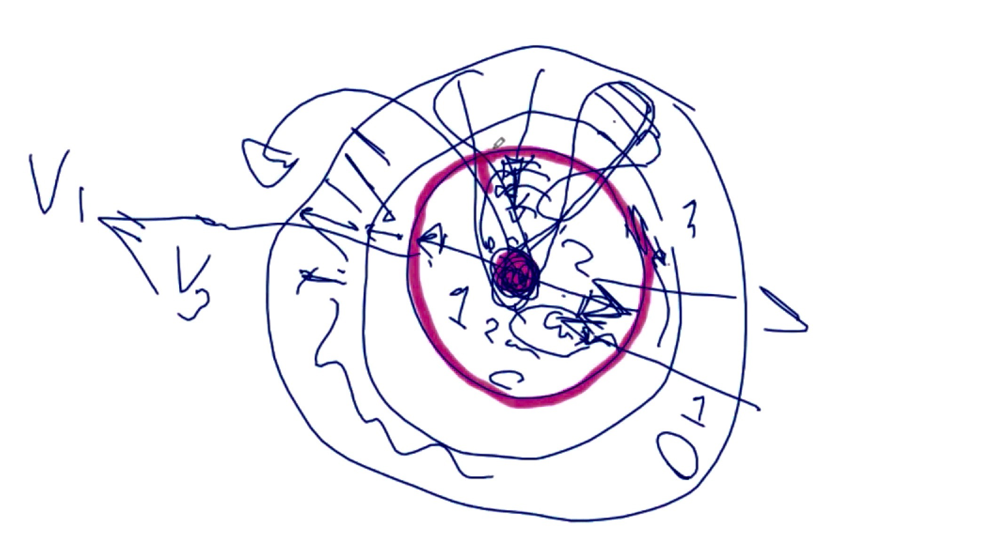

But interestingly enough the center core in the center it is the center core of the outer core too. Now do you understand? You transfer energy directly into the center of the ball and get the interaction. That is how it works. You don’t need rotation or create any rotation. If you get the ratio right so much energy is delivered from the outer core to the inner core that in the interaction you get the rotation. That is how planets and stars rotate. The interaction does not only come from the center core fields created, the outside boundary has the same power. You see the galaxy’s influence.

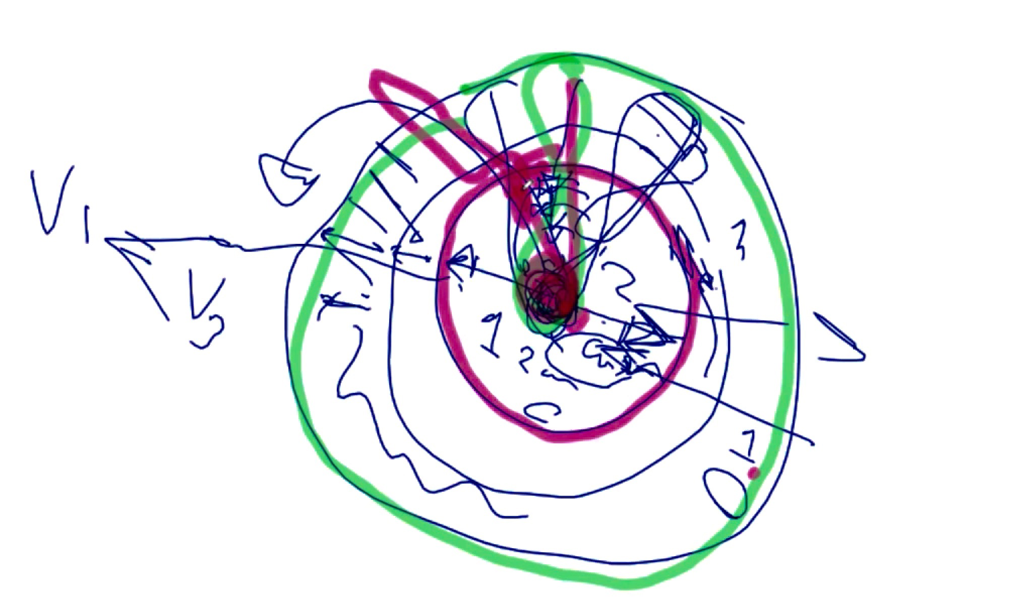

34135 W: so the center core and the third core showing the same green color should by the same mixture of gans.
K: yes, but it has to be the mass ratio difference. Why not? At least find a common denominator of something extra. You are not working in the matter level you are working in the gans level. Everything is in a plasmatic condition.

34204 W: I have another question: we need to understand more about the rotation after the teaching. Another question is about the field and the plasma. I am confused about the fields. When we are talking about the fields sometimes we are talking about nano materials field or gans fields.
34148 K: a field to us is the magnetic field motion and its thickness and strength in respect to the others of its environment. A plasma is the totality of all the fields within the same entity. Let me explain this is a very open way so let me show it. If you look at the plasma (3.43.31 minutes) the strength is very much like a ball in the center. The field strength is like another ball around the first inner ball with some space between. It is like tubes on tubes on tubes. When you look at the planetary system the fields that come in go according to the field strength of their channel and they don’t all go through the center (3.44.06 minutes). They get spread according to the layers of the fields that have built. The interaction of these layers and the center creates the field forces of the interaction. Not every position has uranium; not every position has gold.
So when the strength of the field of the gold comes it follows the pattern of the gold. Whatever increased inside adds to it higher strength in the north and the south (3.44.41 minutes). If you look at this and understand it in another way it is a field path. It’s like tubes or like the neuro system. I think we have to stop or we will lose our Facebook channel.

34520 W: maybe we have another question next week. Thank you Mr. Keshe.
K: thank you very much for the Chinese continuing work in the background.

Worries from the Japanese group about contamination of the ocean at Fukushima

34540 R: one quick question from the Japanese group.
J: I am worried about a message about Fukushima that still 300 tons of contaminated water is flowing daily into the ocean. Is this to keep us in fear? Do you know about this? I have faith in your work; please clarify if you can.

34610 K: At the moment with the technology used by Tepco, you know we ran into a problem with Tepco. Let me explain very quickly what has happened. Tepco with what they have done and they way they treated the KF, when we started opening the channels of talk, in our writing to them we informed them that we know they are on the breach of an international embargo on the Iranian side. So a criminal offense has taken place.

34636 K: So Tepco has taken a position of silence to see if we pursue the case through the international courts. This is not our job and we explained to them that is what we see and that is what it is. It is very rocky ground at the moment. For that reason we got some information from inside Tepco from those who still have some connection with us. As far as we understand that not all the water discharged is contaminated. The new filter system allows them to do what they used to do in the tanks and now that they use our technology they are filtering a lot of the radioactive material out of the conversion. Very little radiation goes out.

34725 K: There is still some radiation going into the sea but maybe we understand more about the reactors and how they operate. They are filtering a lot of earth materials in this process and they have learned what to do with the help of a company we gave the rights to instead of going back to the KF. The process is that they are extracting a huge amount of radioactive materials in a very simple way. One of the concerns that we have and that we see is if they are selling the material to the tanks and filtering it and it’s the tank water that are extracting the gold and everything else from, the way we taught them. And maybe they are taking a certain amount of the radiation.

34824 K: what we think is happening in Fukushima is that yes, a huge amount of water is leaked back out. But it is not the first circulation. They are using the existing tanks to fill up to extract and decontaminate and they are feeding back low level if any radiation back into the sea. Because they understood and they have shown it that the tritium in these tanks is a gold resource. They are extracting gold and they have shown that. We don’t think this is first hand water (being expelled) directly from the reactors. They have built the filters that they are using which make it much easier. So this is the secondary going to the tanks for the second time and they decontaminate most of it.

34931 K: We delivered enough technology that they do not need to be putting contaminated water in the ocean. And they confirmed this themselves. If I went public with this I could literally create havoc with Tepco. But this is not our job. I don’t think there is high-level contamination going out. These are cleaned up waters or passed through the filters which are creating a lot of acids.
R: thank you Mr. Keshe.

35008 K: thank you everybody and happy birthday to all of you for the third year. I ask you to please keep in touch with the police in Germany and Austria. We have to stop this man as he is making a bigger fool of himself for a prison sentence. The threats and the contacts have been given to contact the Austrian and German police. These are the nearest police stations to these people and they are debriefed about the situation that is happening. They need to create a file. In a few months’ time we will see the outcome because we speak with the governments in how to handle these guys. Threatening children is a pedophile offense. A man who threatens children is a man who has abused children for several years. This is why these men work together because they understand each others’ immorality. Thank you very indeed and I thank you for being here. Hopefully we will serve you for another three years.

35126 R: thank you very much Mr. Keshe and it’s been an honor to work with you for these 3 years; you haven’t missed a single workshop during that time and we have had a workshop on every holiday in every country including Christmas and New Years, Easter and Halloween.

K: We have done the workshop on the Chinese New Year and we have celebrated a lot of knowledge with a lot of people. Thank you very much Rick for your support.

R: this ends the 156th Knowledge Seekers’ Workshop on January 26, 2017. Thank you everybody for attending and bring any questions to next week’s workshop.

